6. HSBC Small Cap Dir-G: 17.8k , 0.77, -39.50 , all have seems same pattern 10y fantastic, 7y ast last reducing this seems to be good just find our reason of last 5 y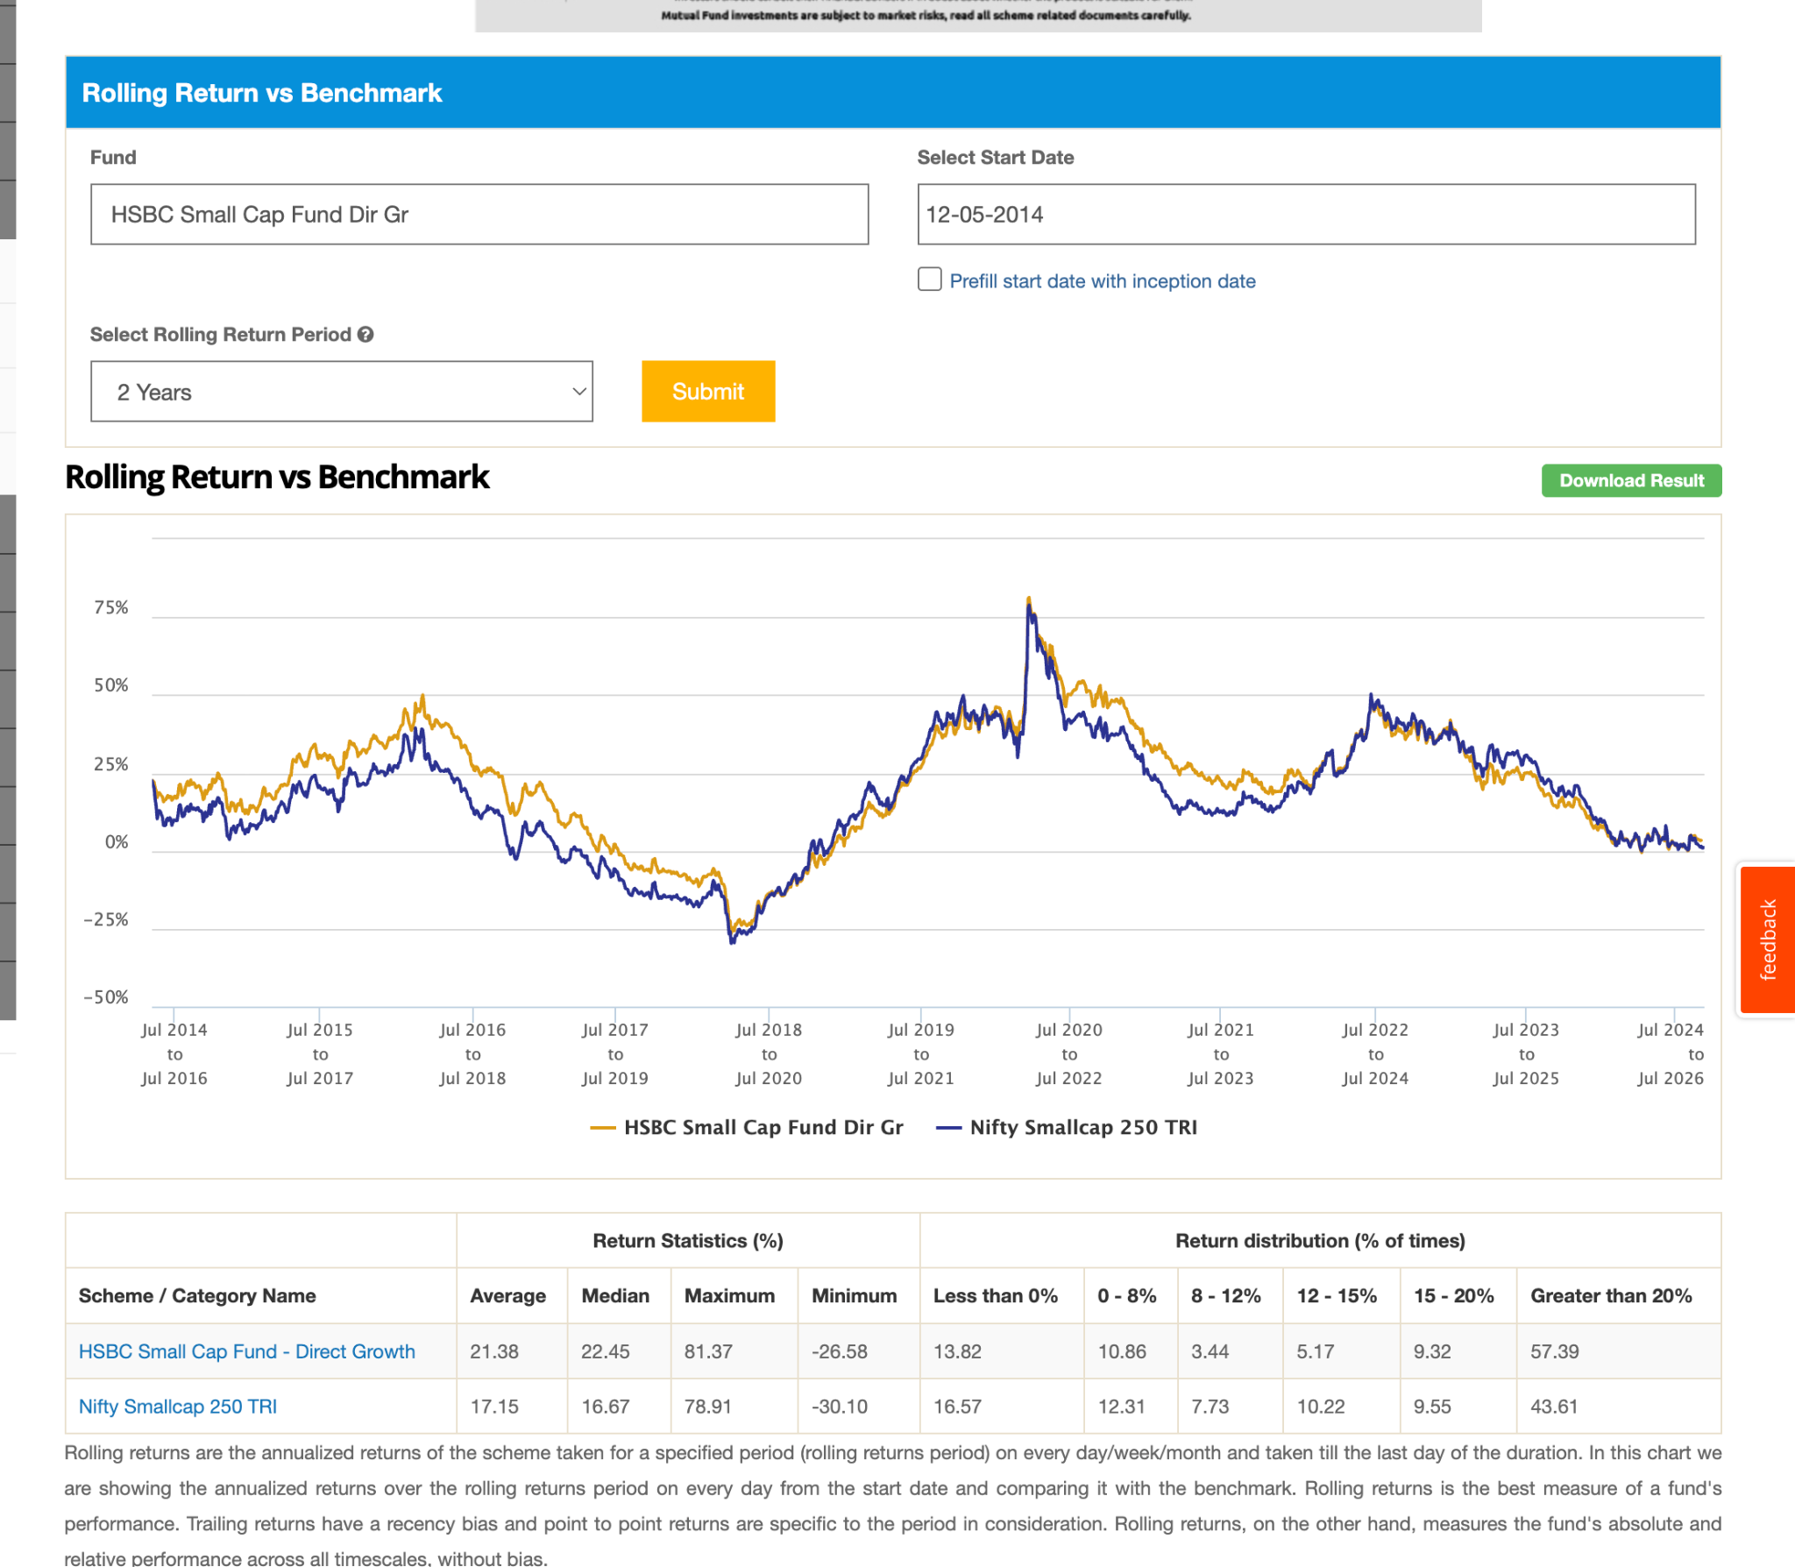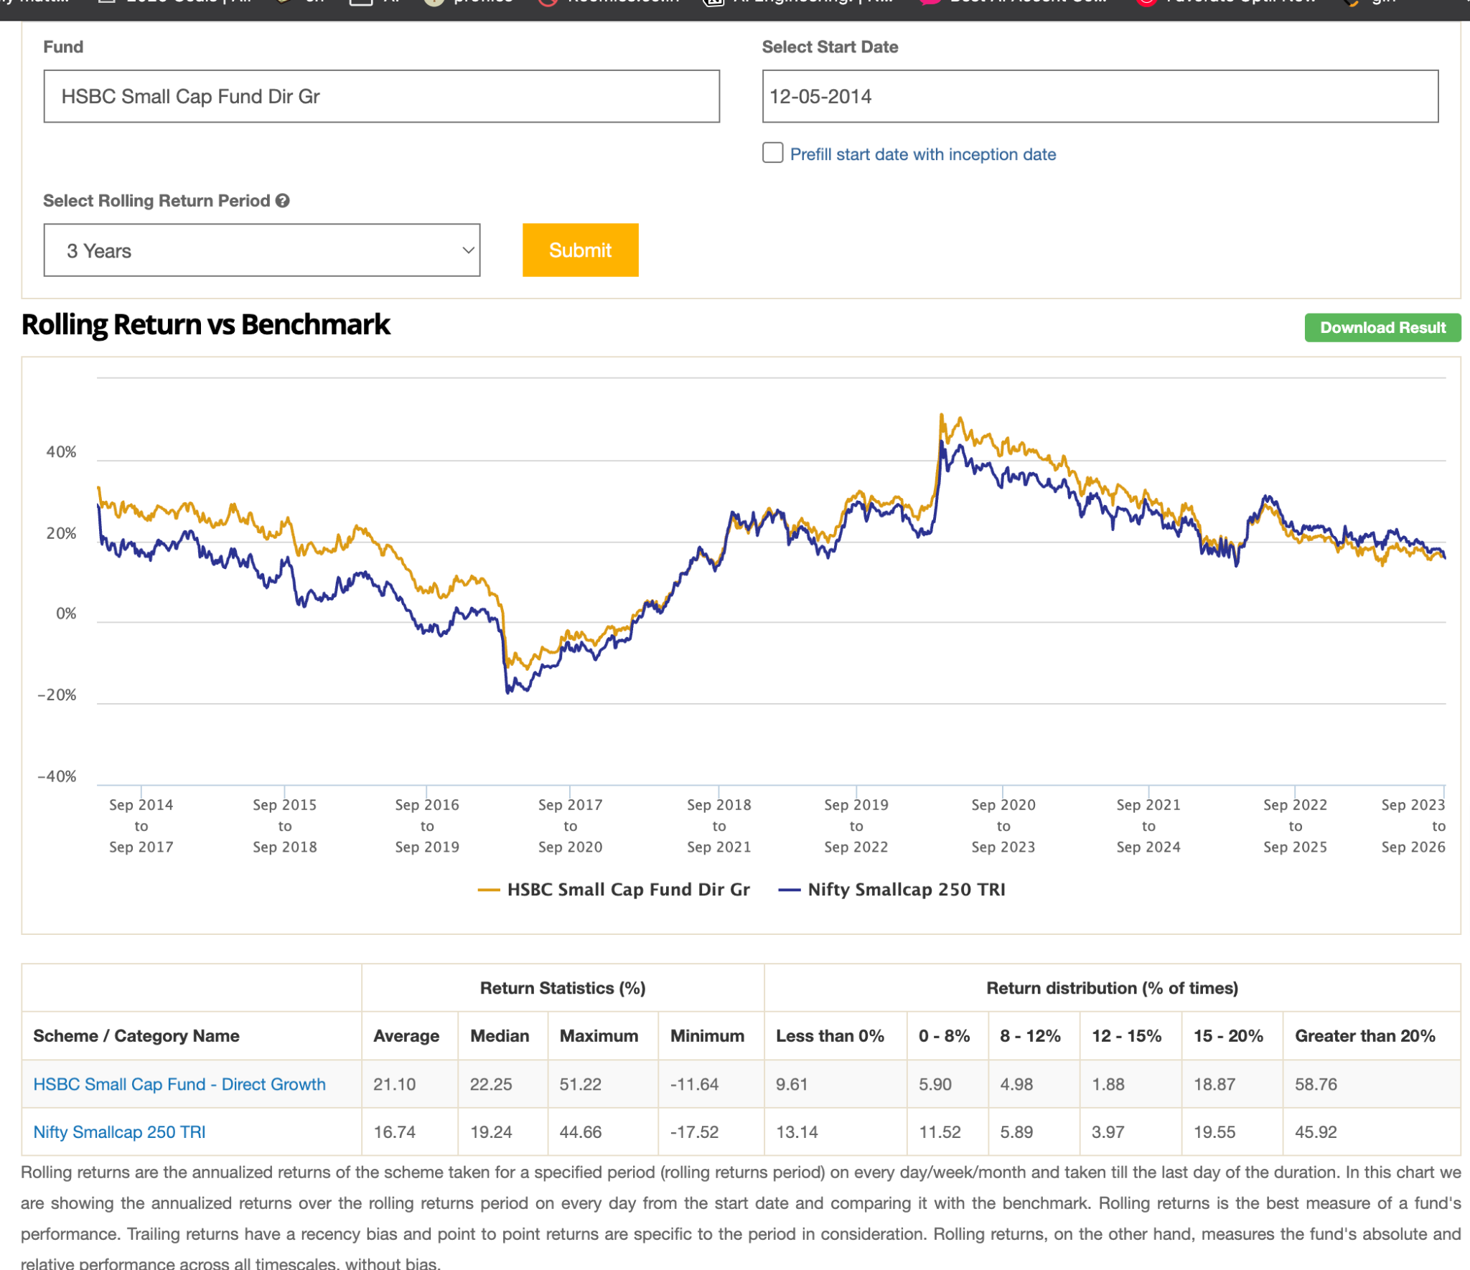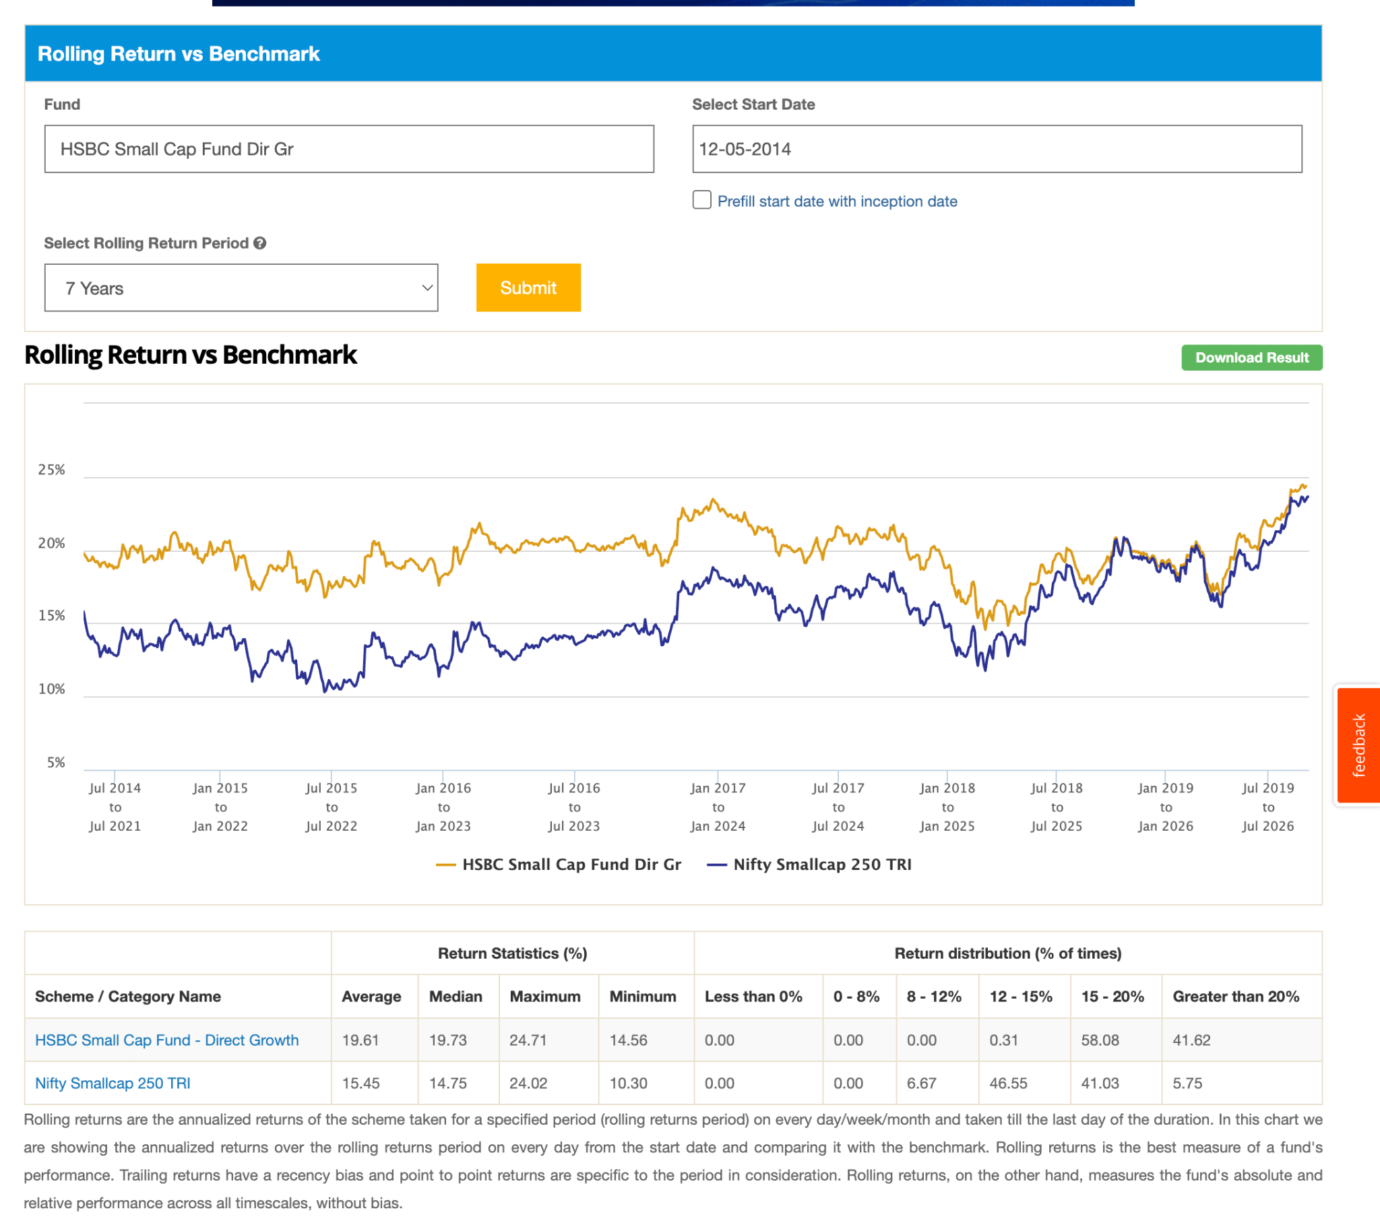
7. ICICI Pru Small Cap Dir-G: 9.5k , -38.99, 1.18, this is bit fluction, 10 y is fear of this.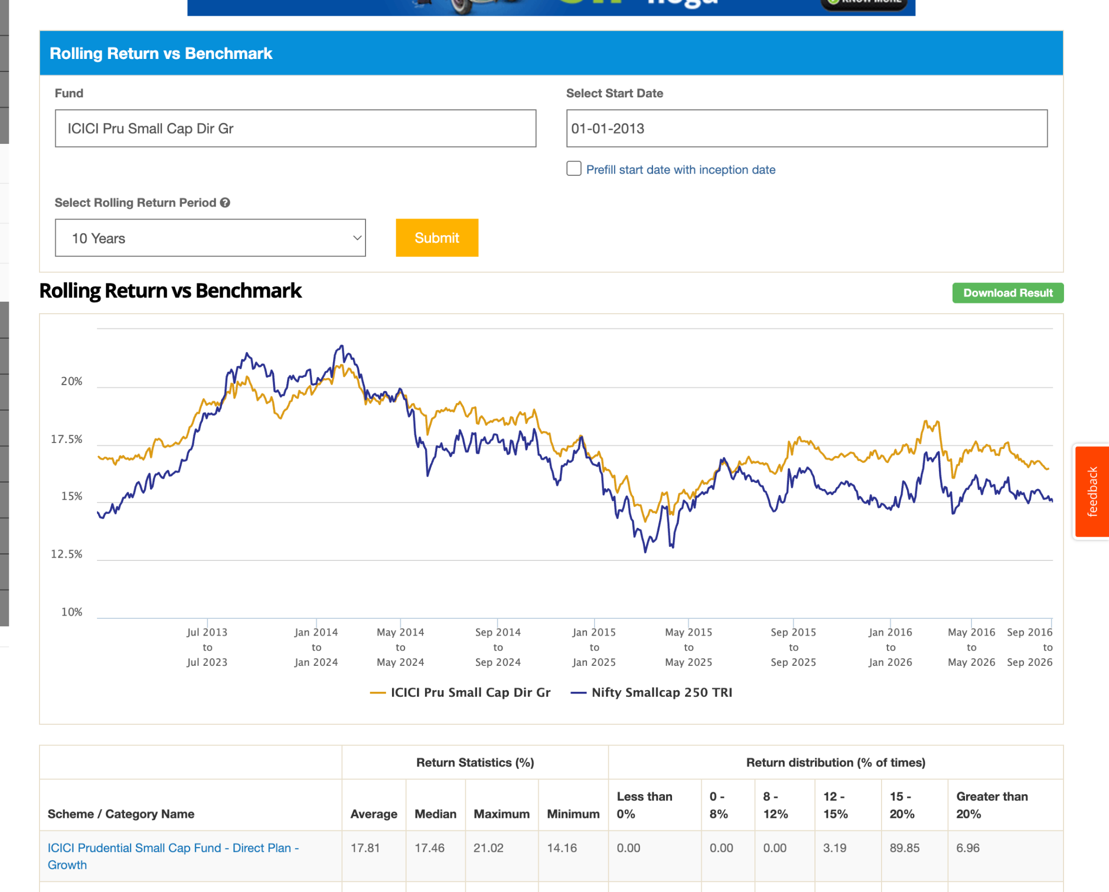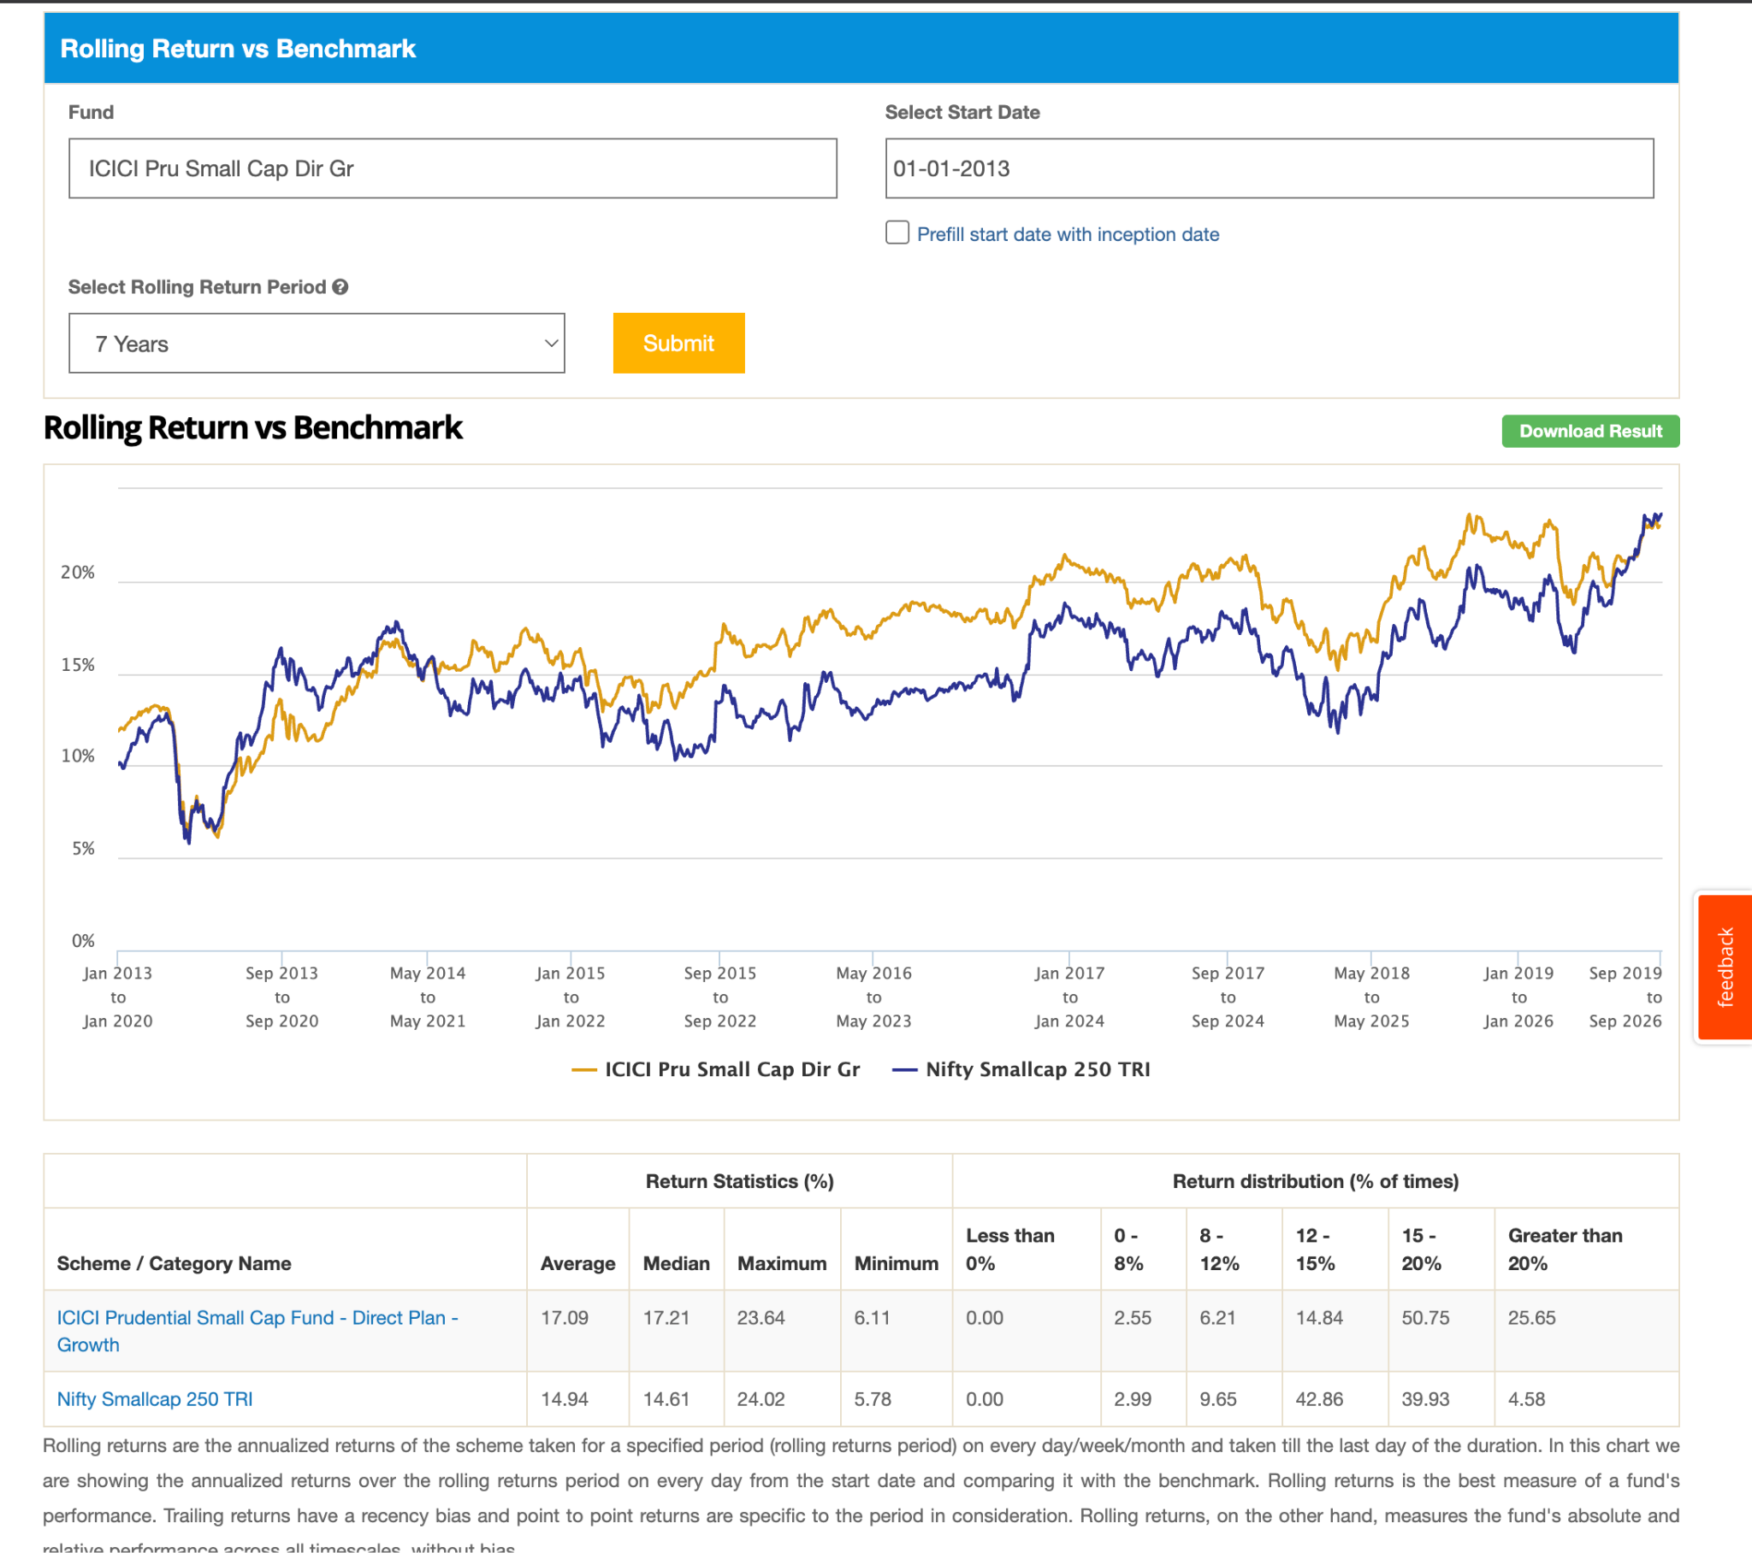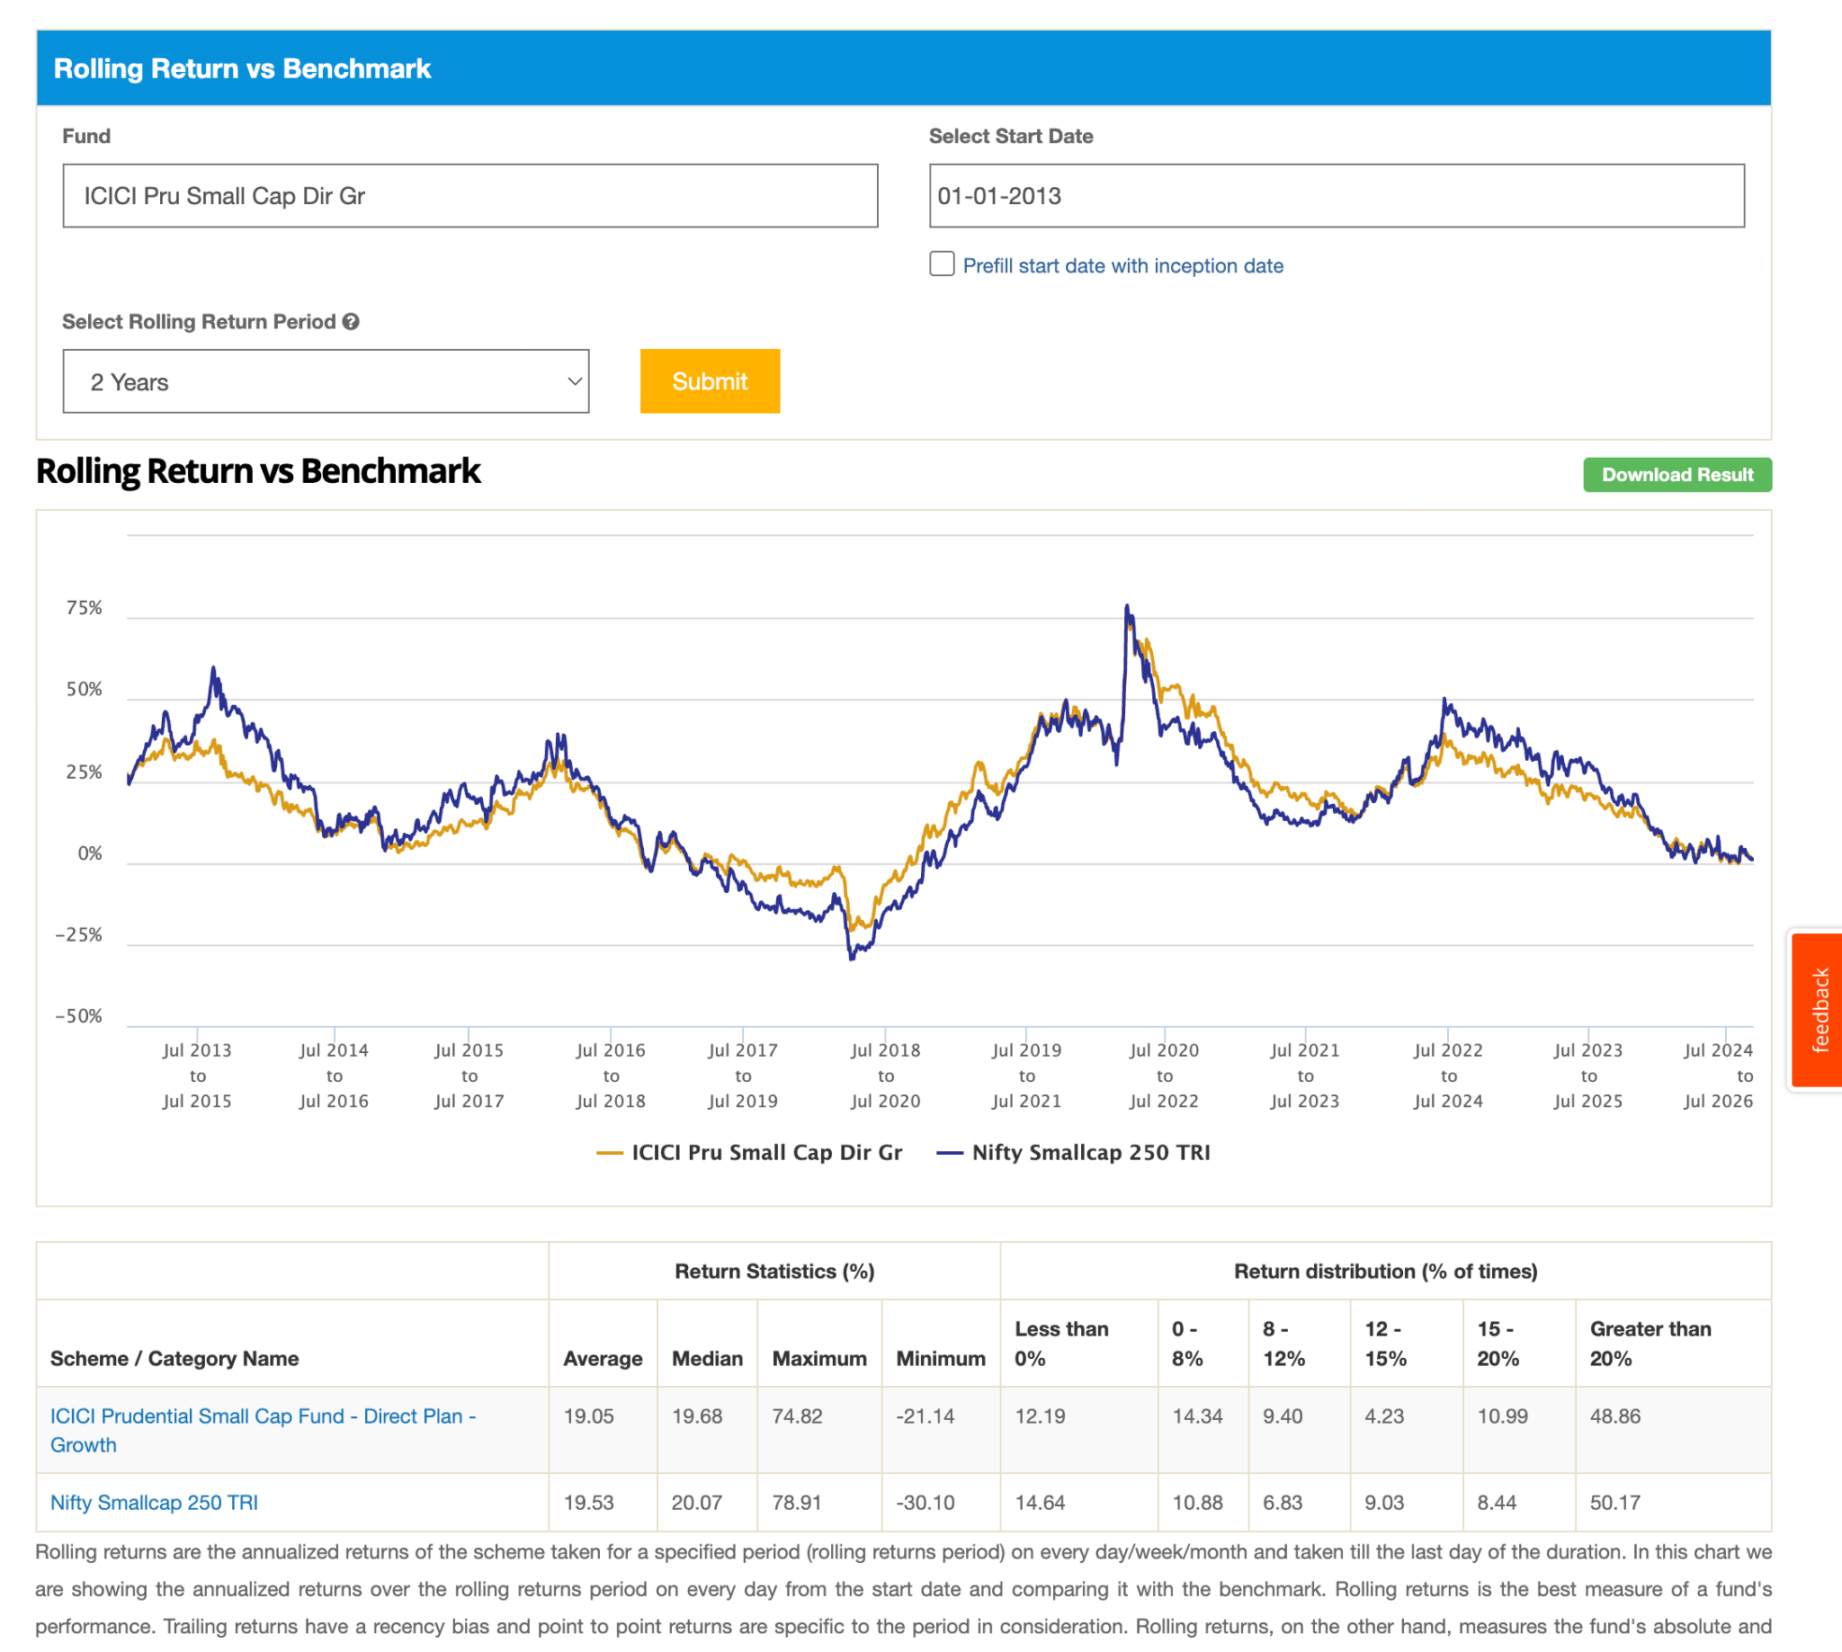
8. ITI Small Cap Dir-G: 3.5k 6y old beating index in5y, in 3y its falucting, observe this fund. this starting working in lasr 3y , check why this happened. https://www.valueresearchonline.com/stories/227173/how-iti-small-cap-fund-gone-from-worst-almost-best/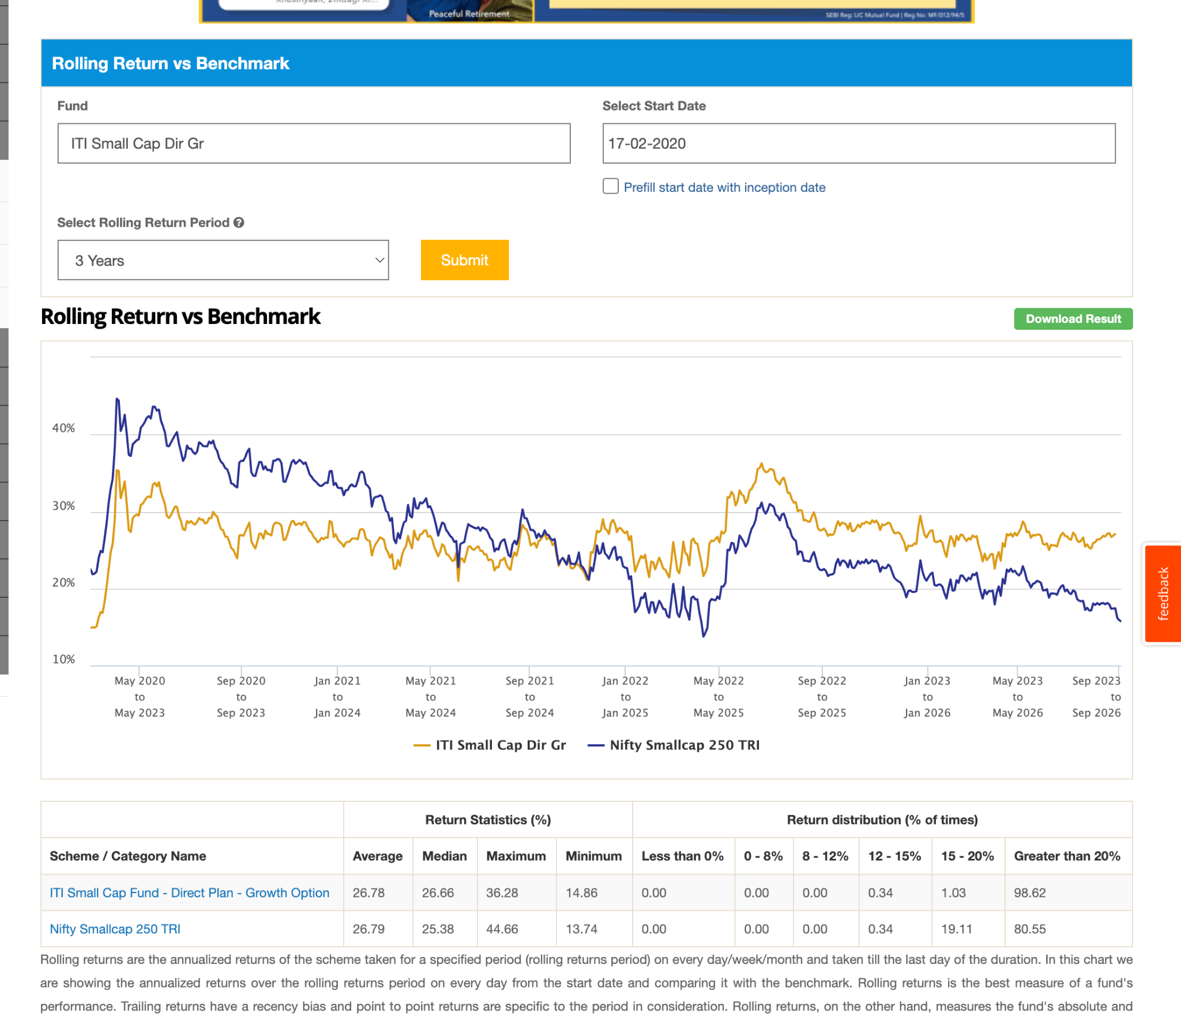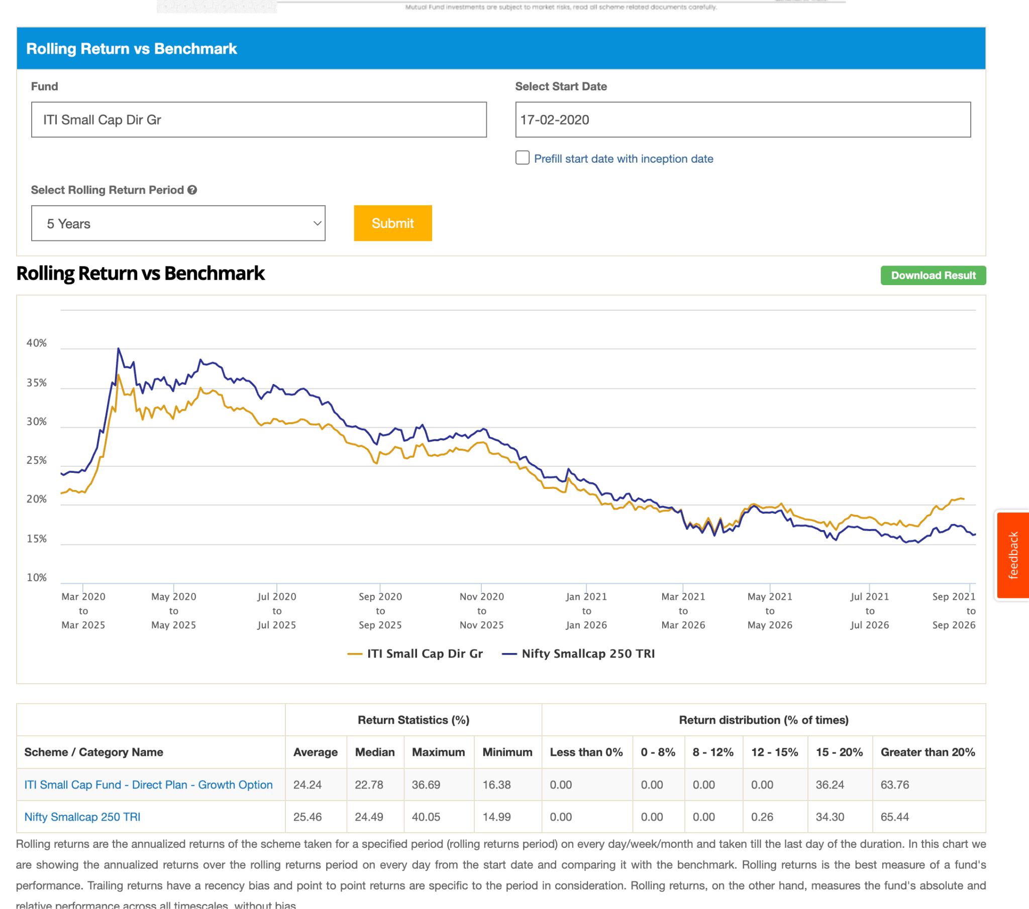
9. Kotak Small Cap Dir-G: 19k , 0.64, 2013,-37.30, similar here 10, 7beating, in 5 last 3-4 year is touching+down, try to find reason of this pattern. 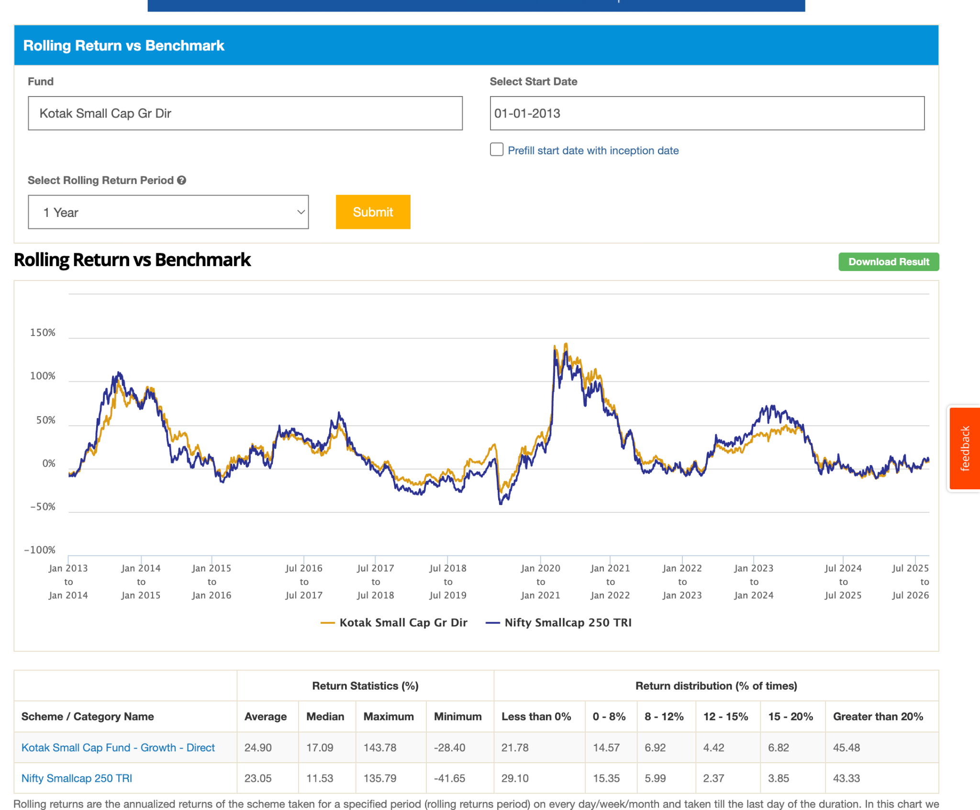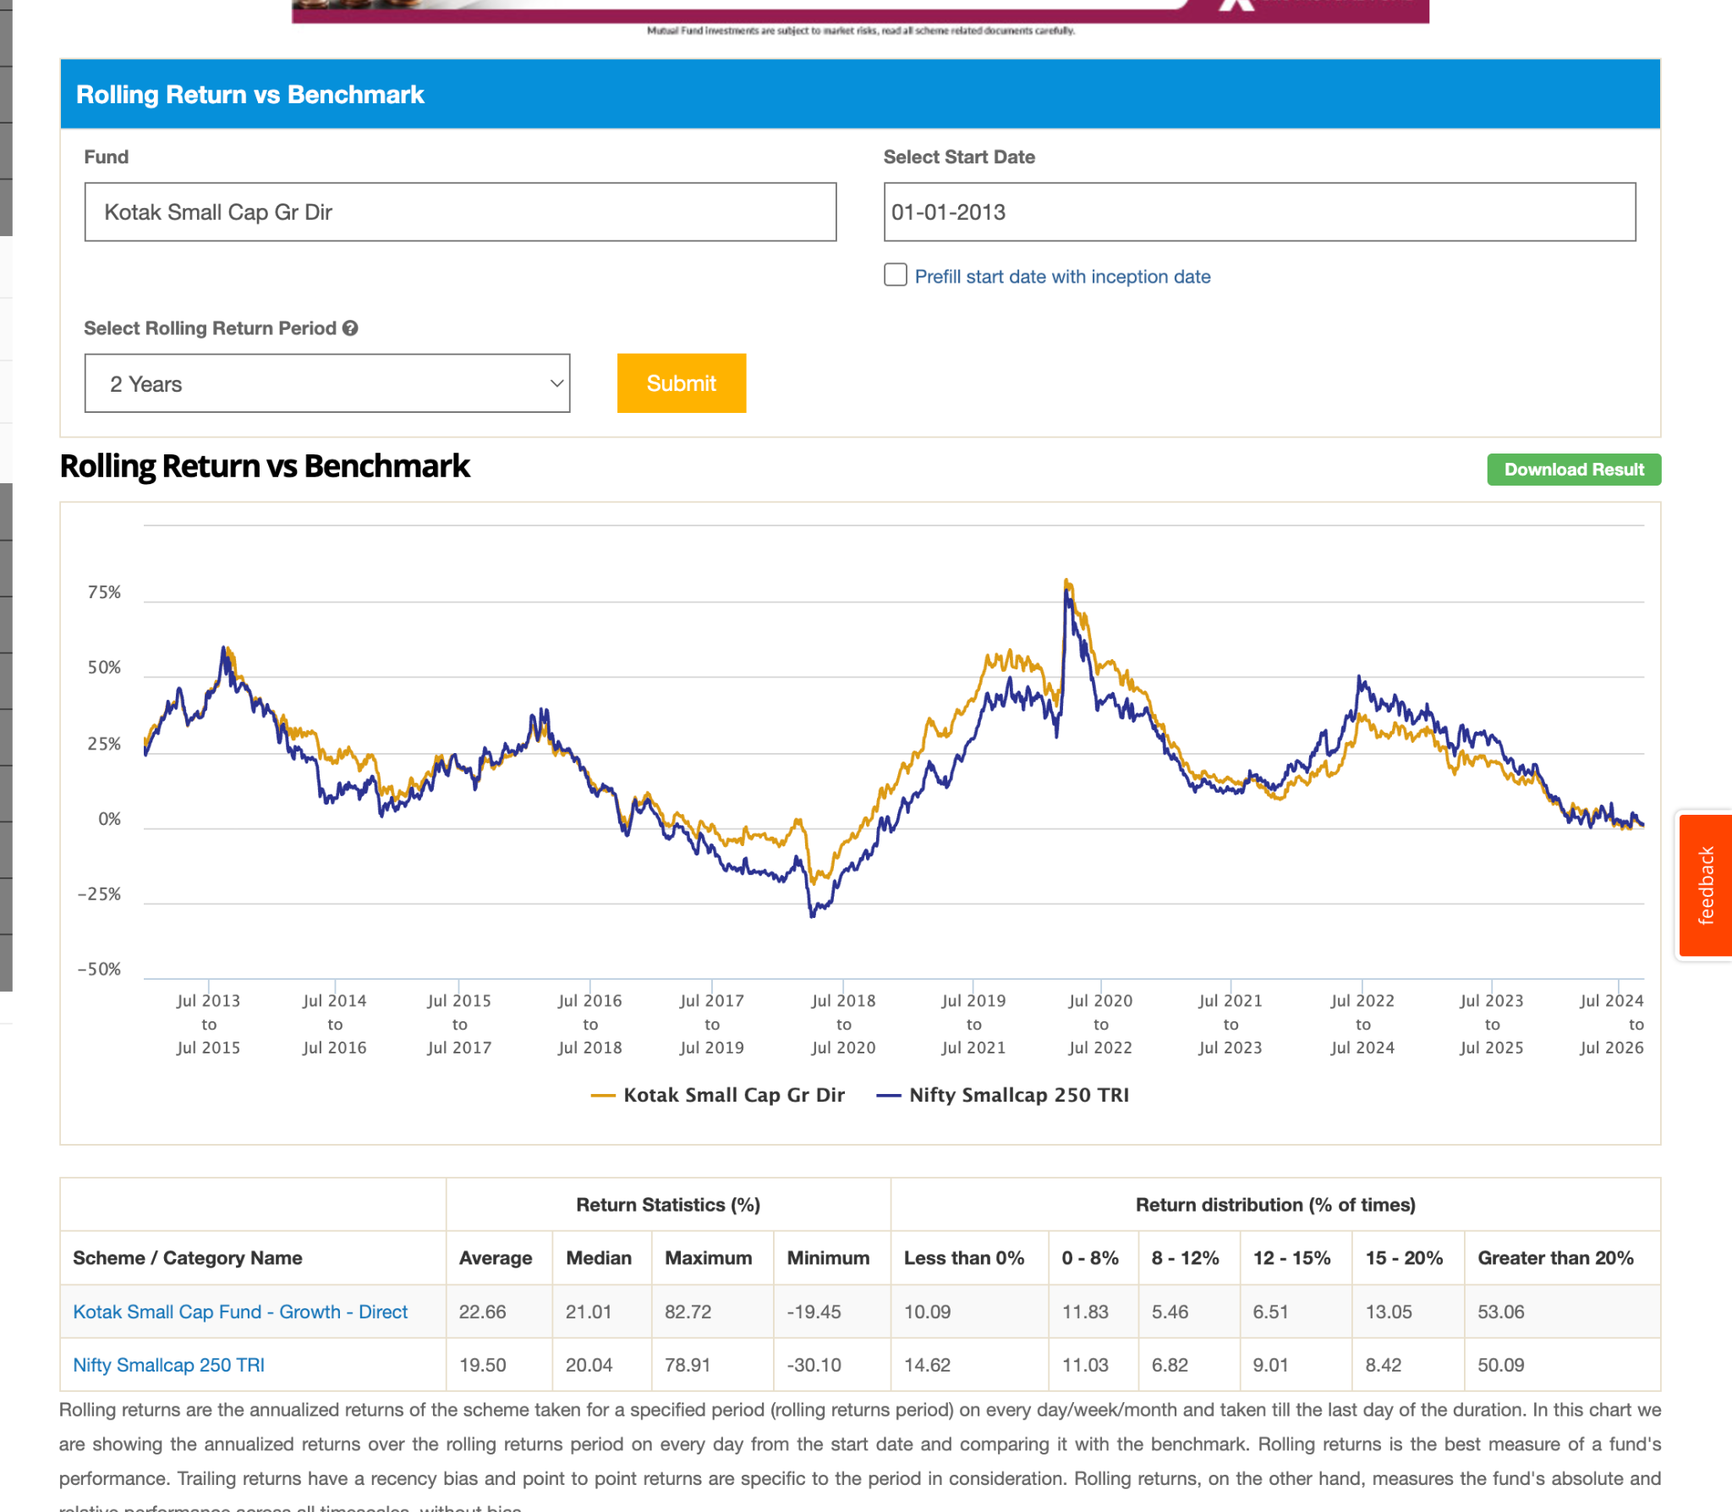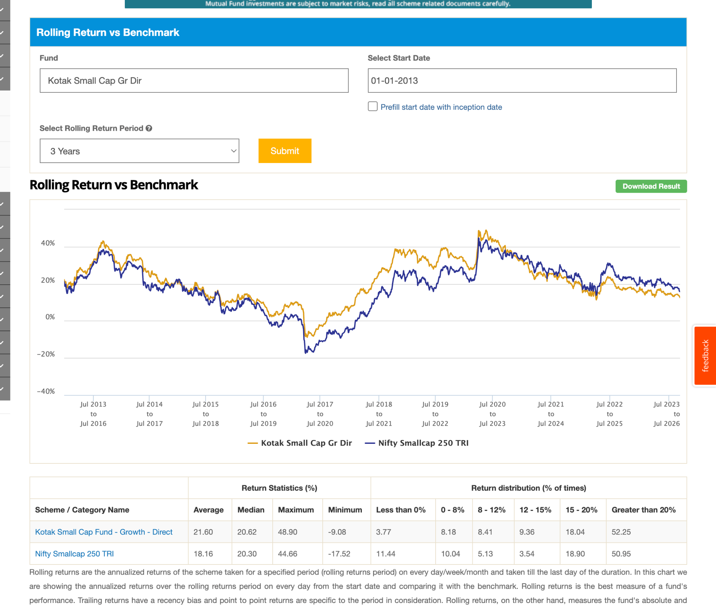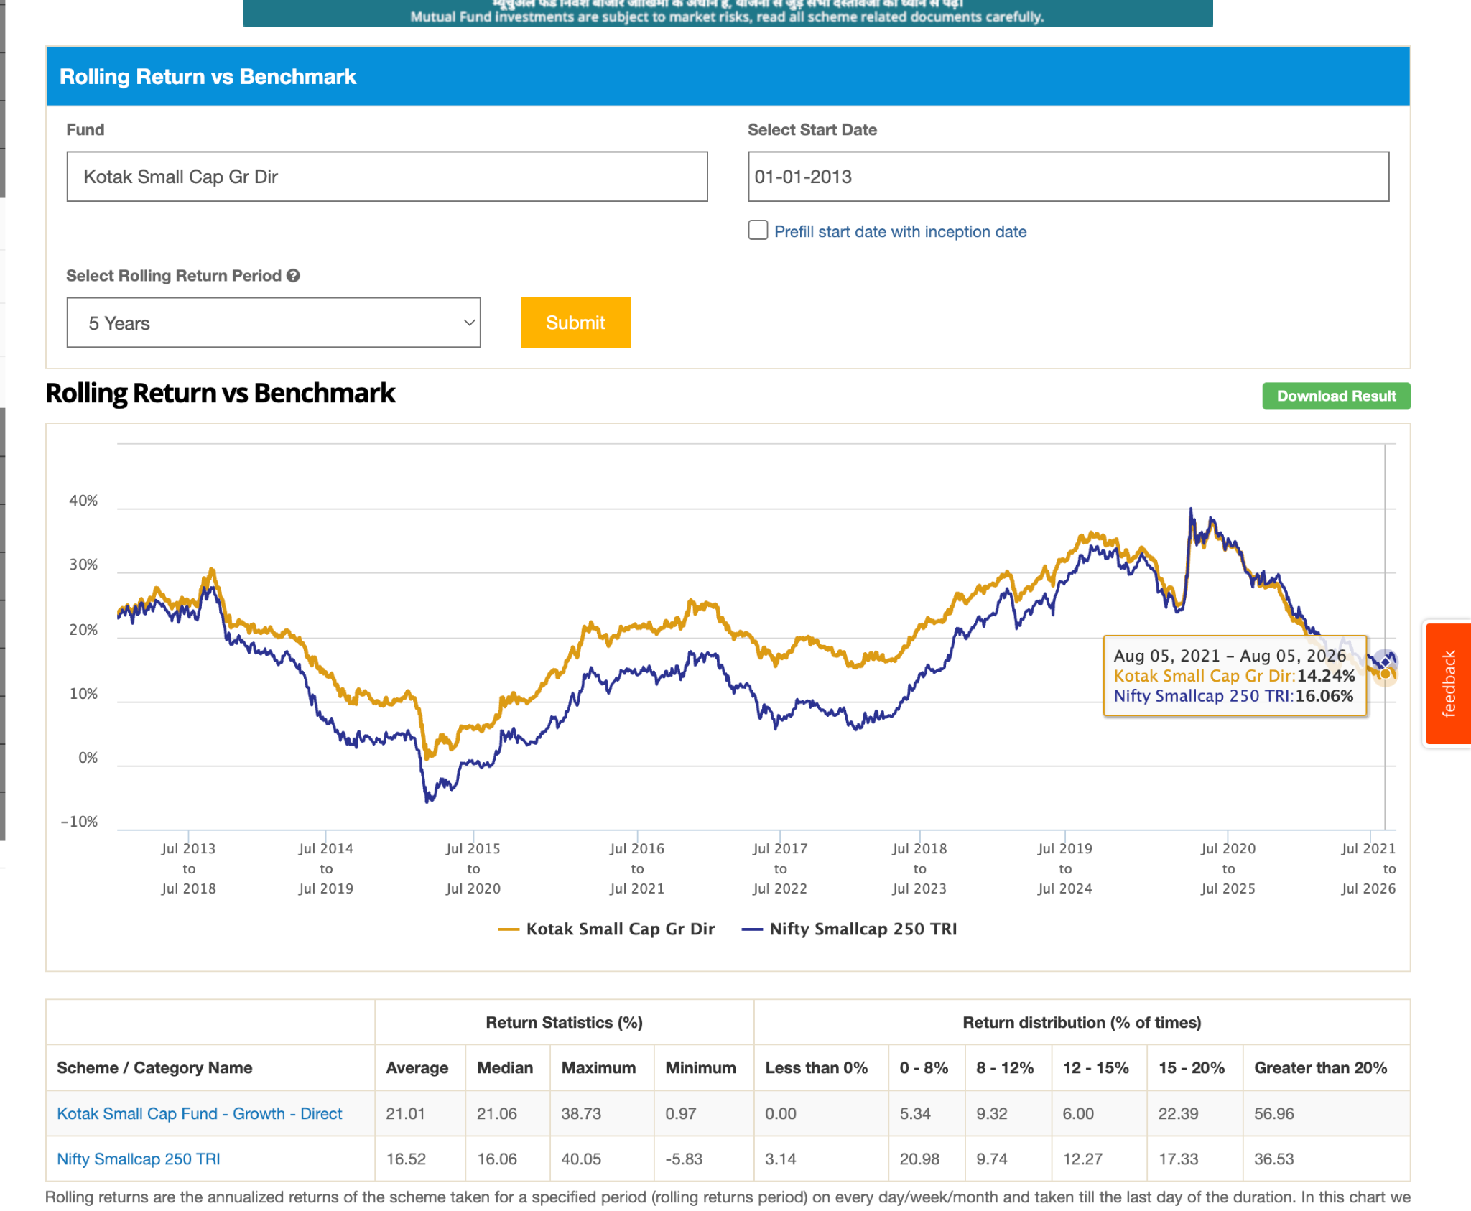
10. LIC MF Small Cap Dir-G: 2017, 758, 1.32, might ignore this less aum. in 7y beating majorly 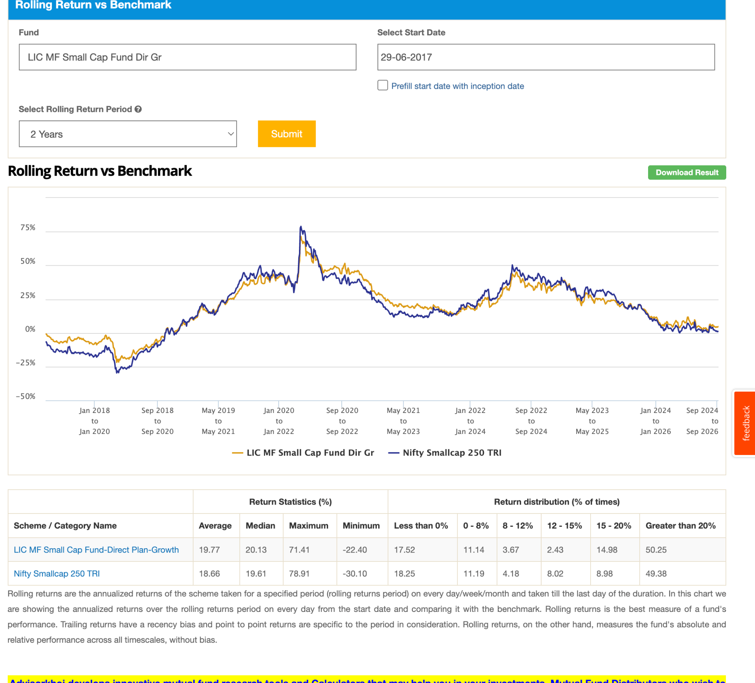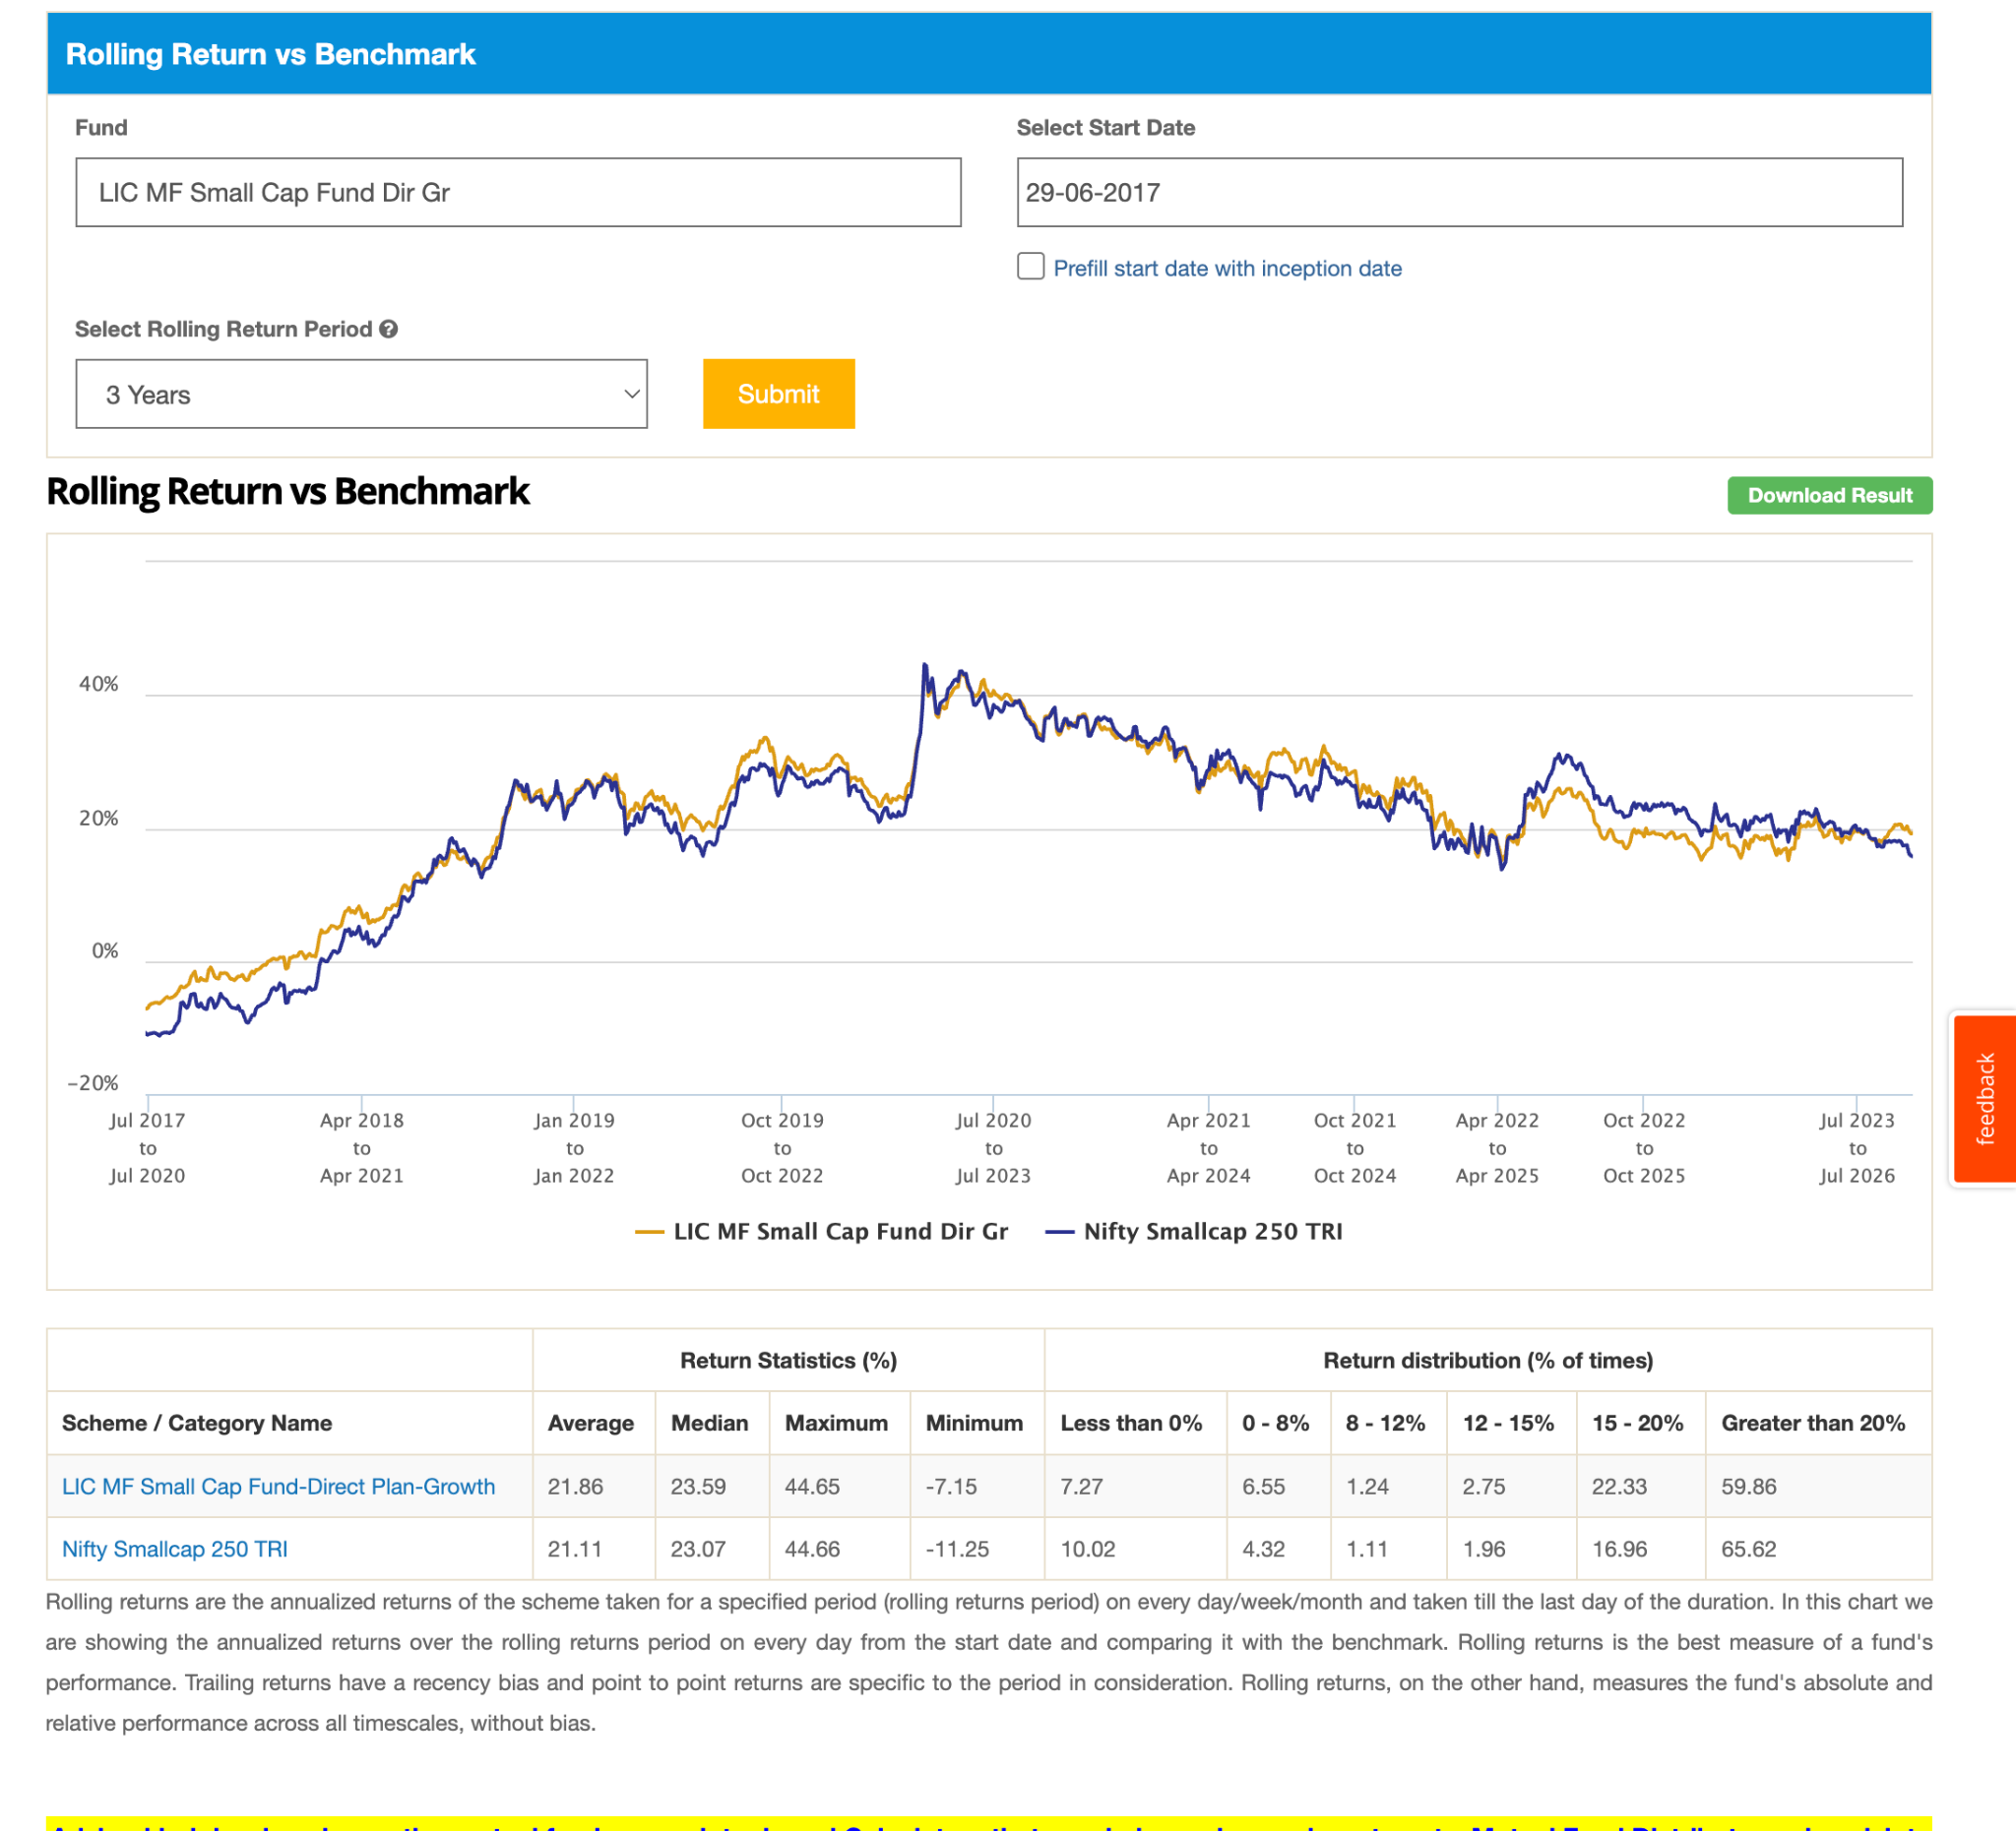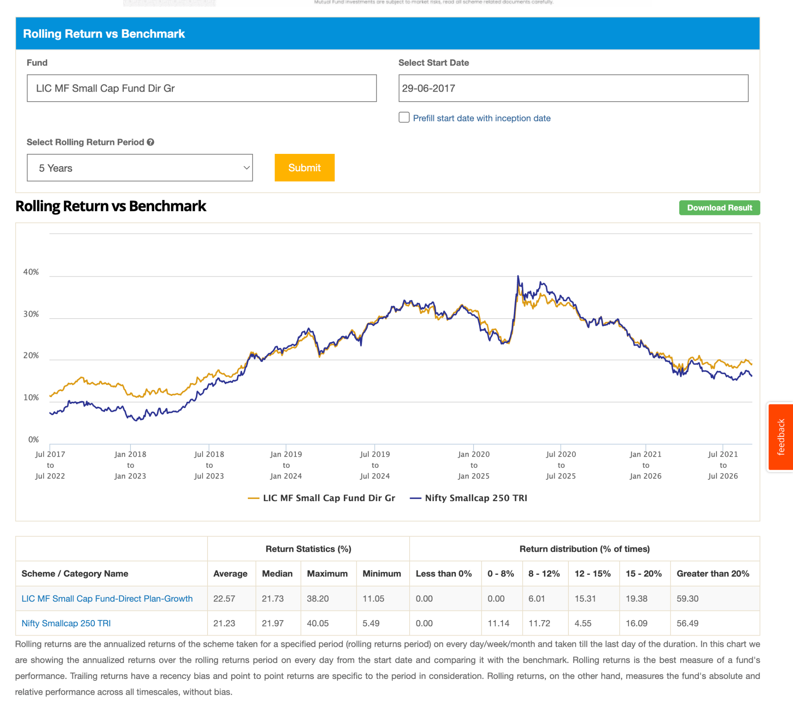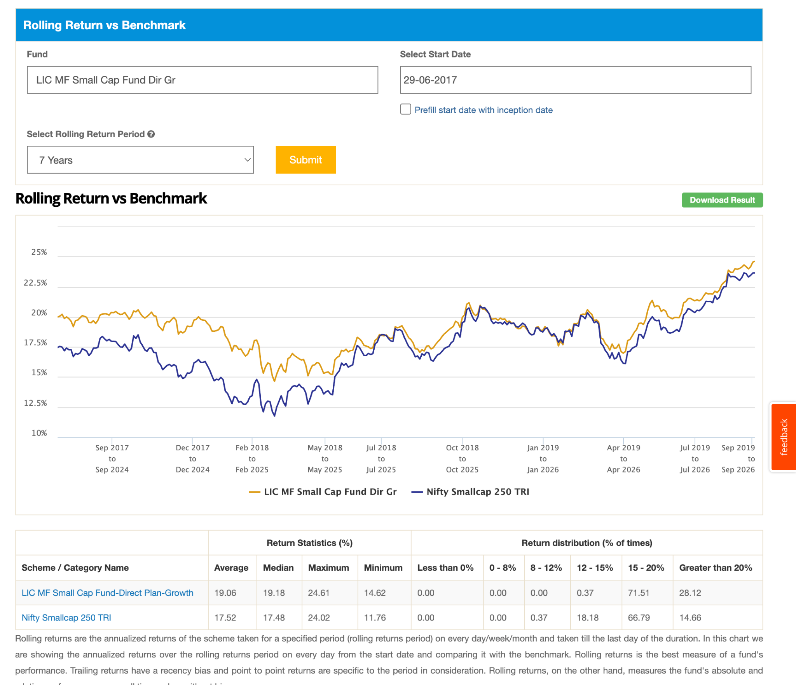
11. Quant Small Cap Dir-G: 2013, 34k, 0.93 -35.93, it has bit different graph initial was very below with benchmark , now beating in 10y, 7y, 5y seems like value invest. again same patter last 2-3 yera touch index. less believer of buy and hold : https://upstox.com/news/upstox-originals/investing/how-quant-small-cap-fund-traded-its-way-back-to-new-highs/article-198327/
https://www.valueresearchonline.com/stories/227433/why-top-performing-small-cap-fund-hit-wall-late/
the consequence is straightforward. When sector calls align with market leadership, returns accelerate. When leadership fades or reverses, performance cools just as quickly. The outcome of this behaviour is a fund whose relative performance can swing meaningfully. There will be phases when it moves well ahead of peers, and phases when it trails them, sometimes without any obvious change in portfolio construction. Can its Momentum Strategy

This is a high-beta, high-activity fund. Its journey is not designed to be smooth or predictable. Investors should expect periods of discomfort, especially when sector calls take time to play out or when leadership shifts abruptly.
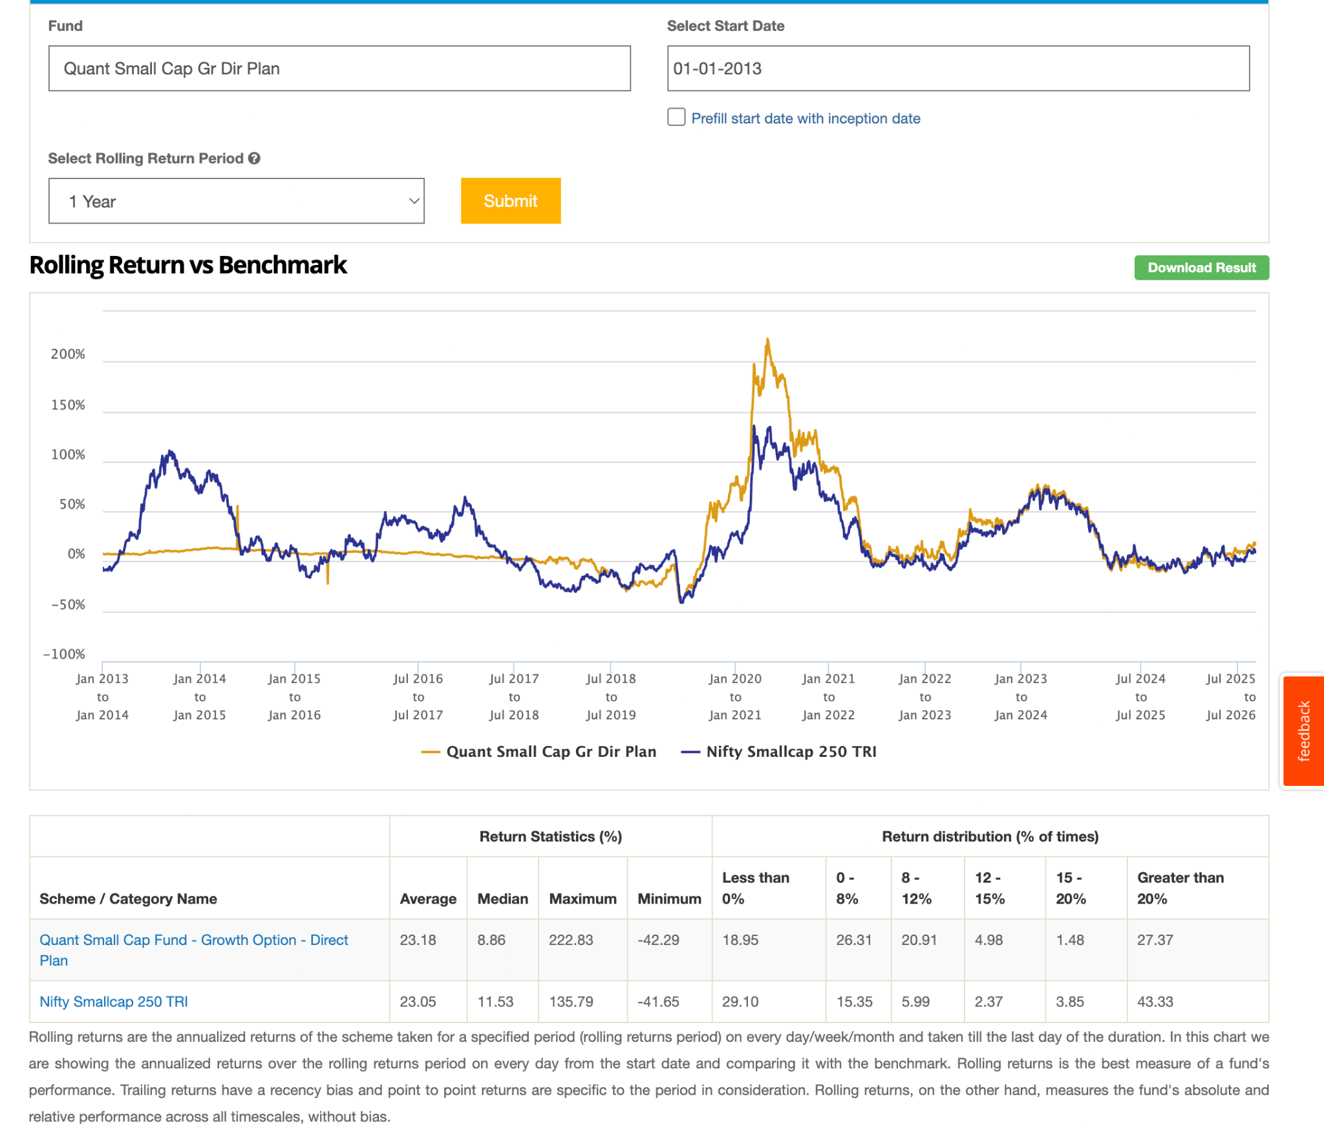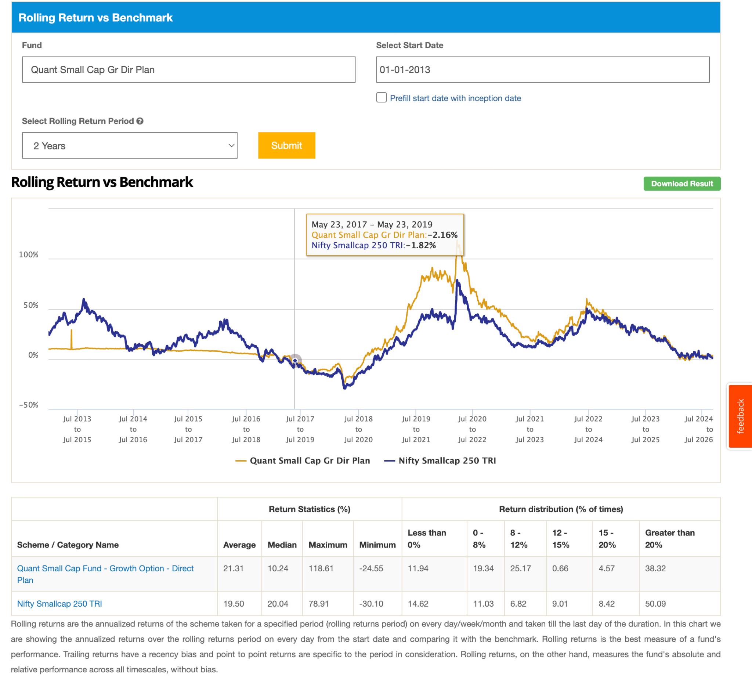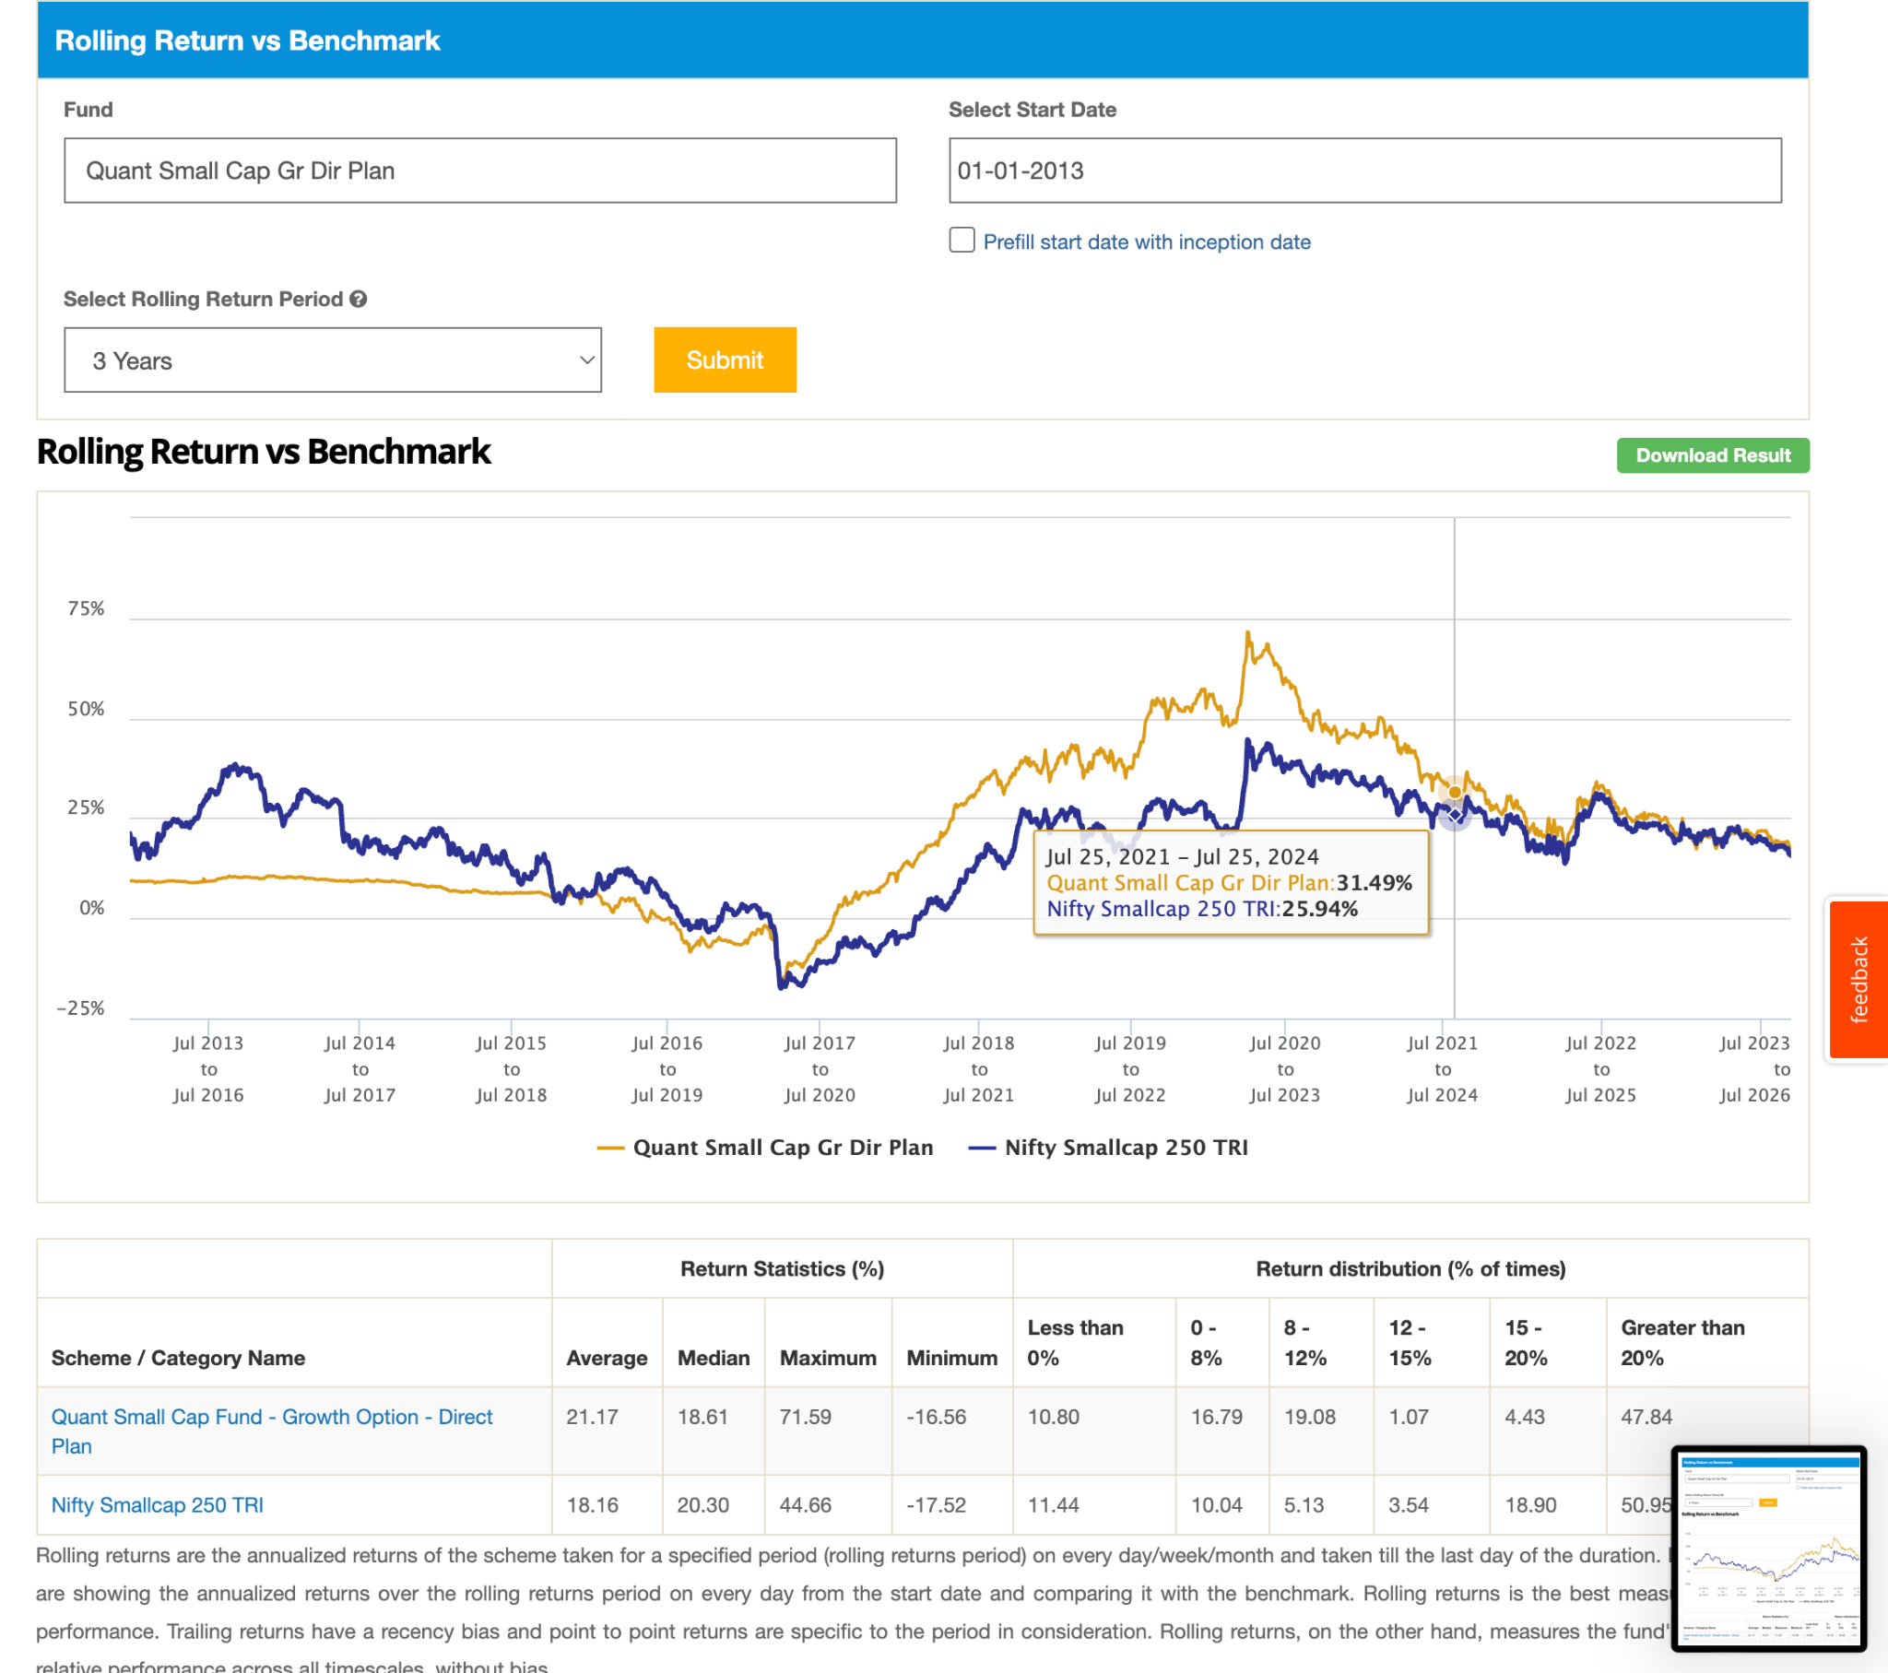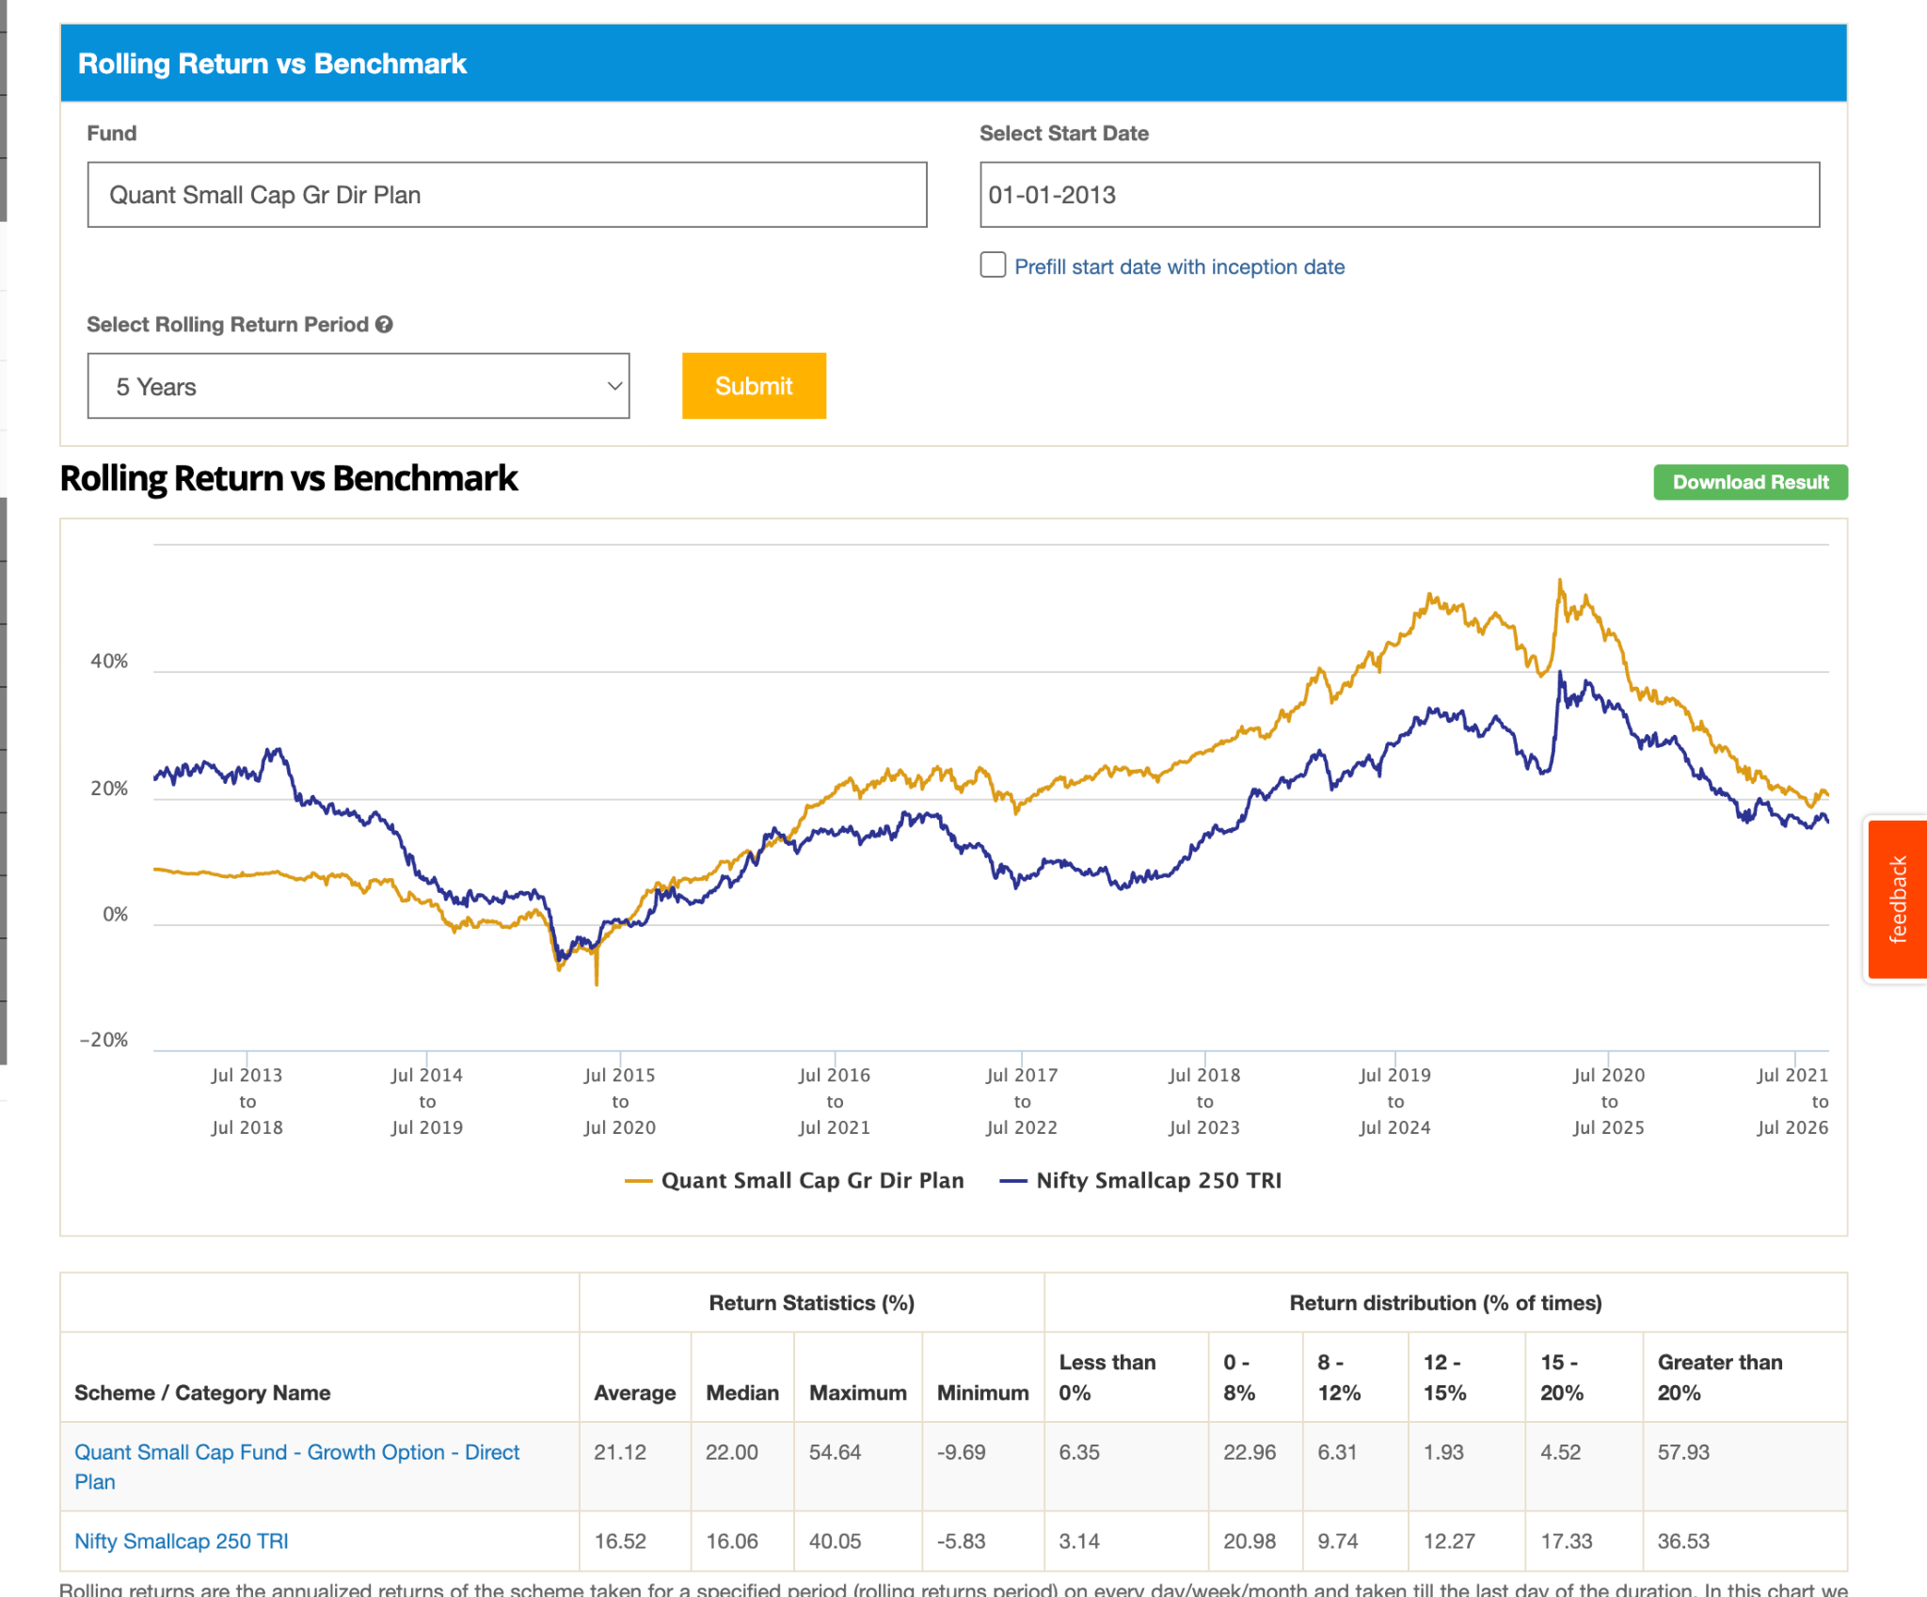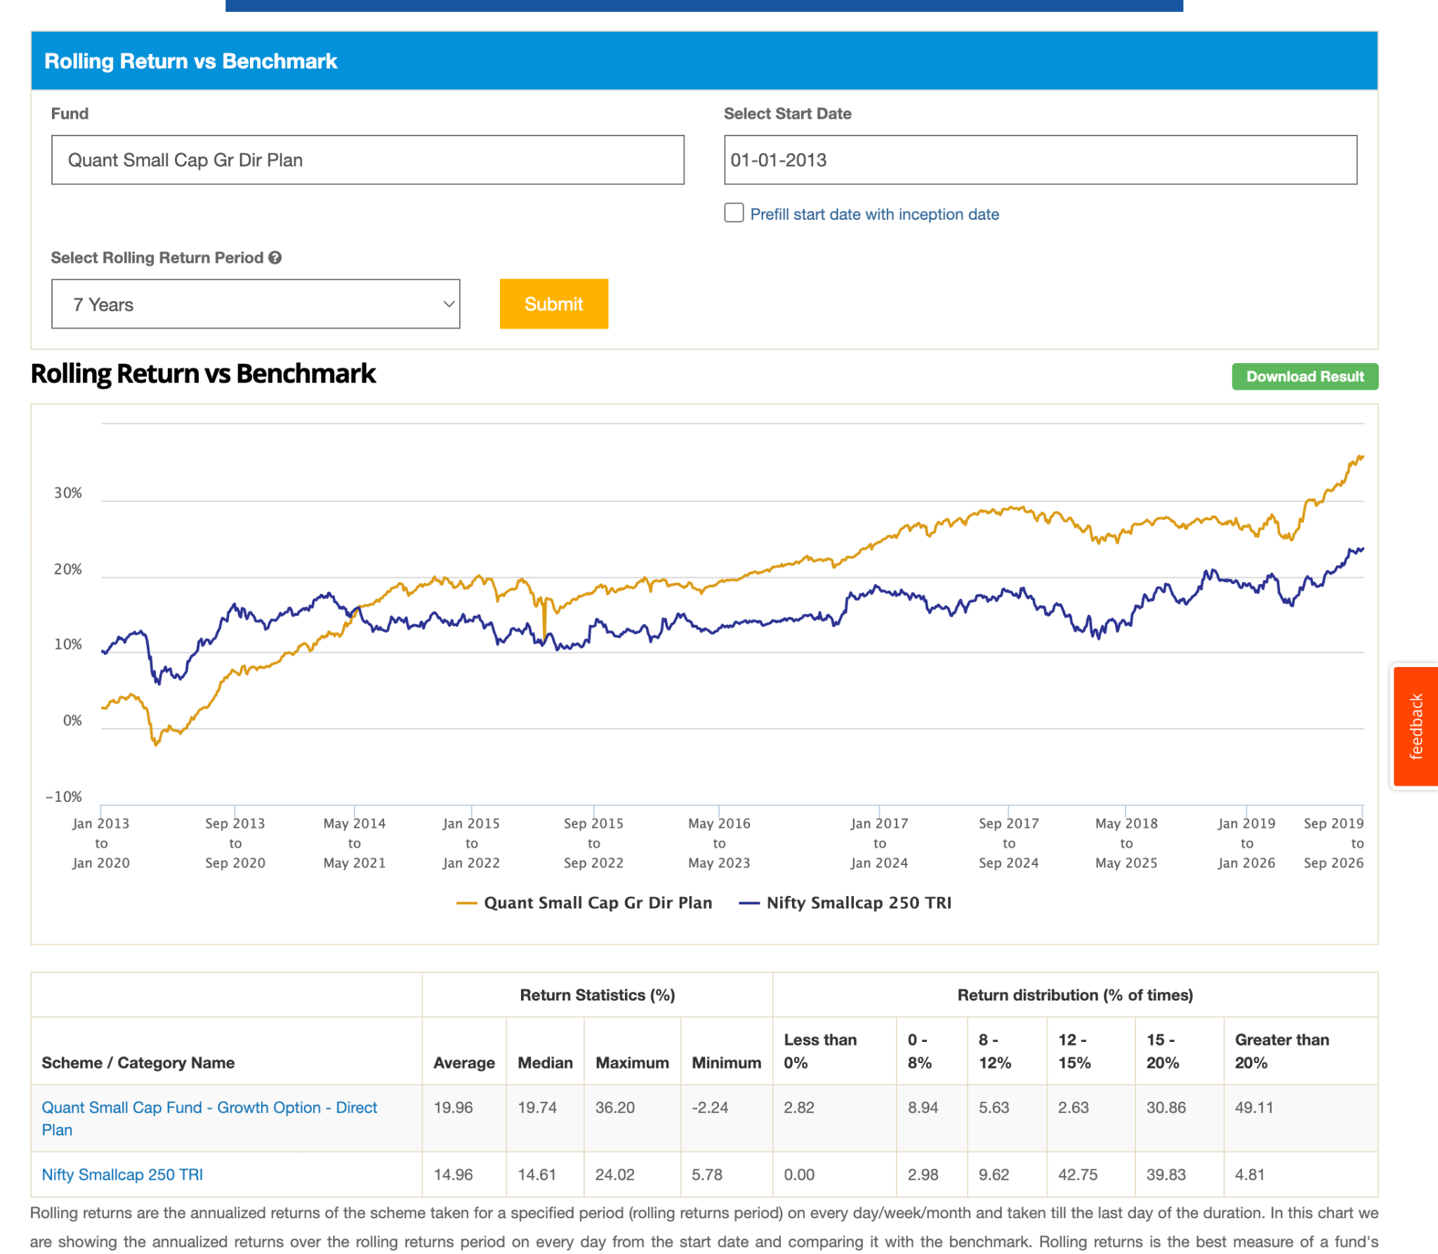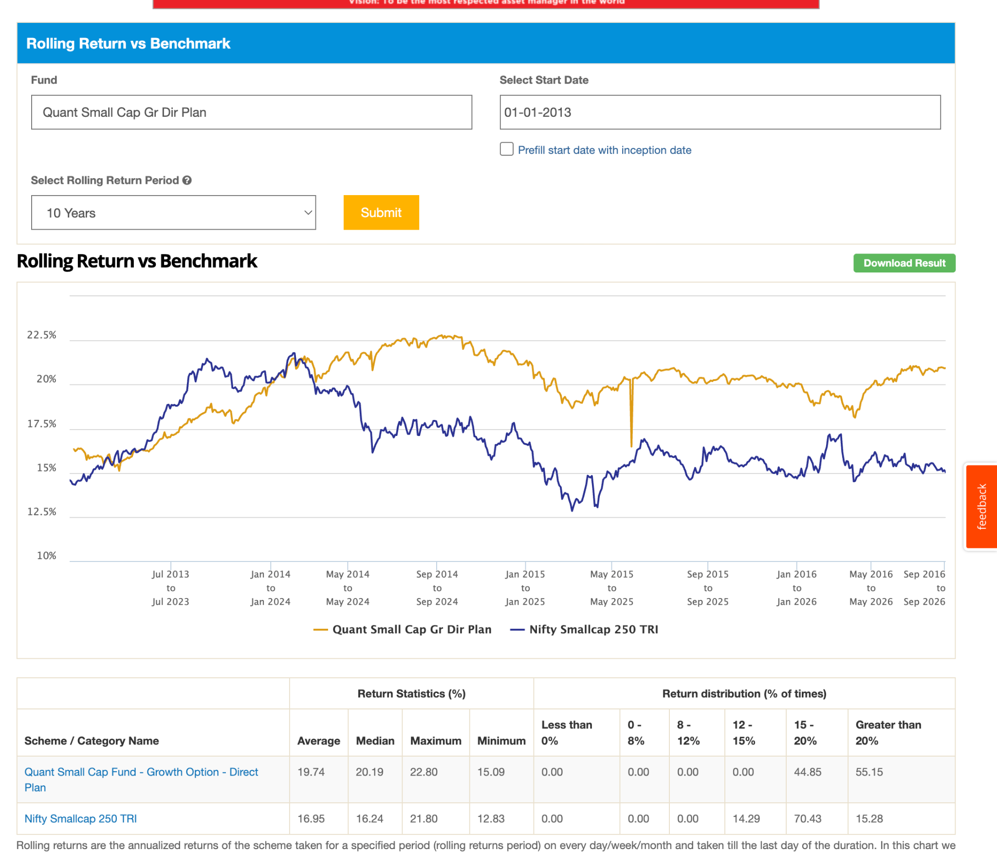
12. SBI Small Cap Dir-G: 12y , 40k, 0.79, why the heck all funds are getting touched to below bench mark in recent year ? this in 7 started touching and 5 loosing essese. in 3y lot of diffent 7-10% fuck need to be studied and with so high AUM. seems it recovering in 1-2 year not sure.
- https://www.indmoney.com/blog/mutual-funds/sbi-small-cap-fund-underperformance-explained
- What SBI does: SBI follows a "Value" strategy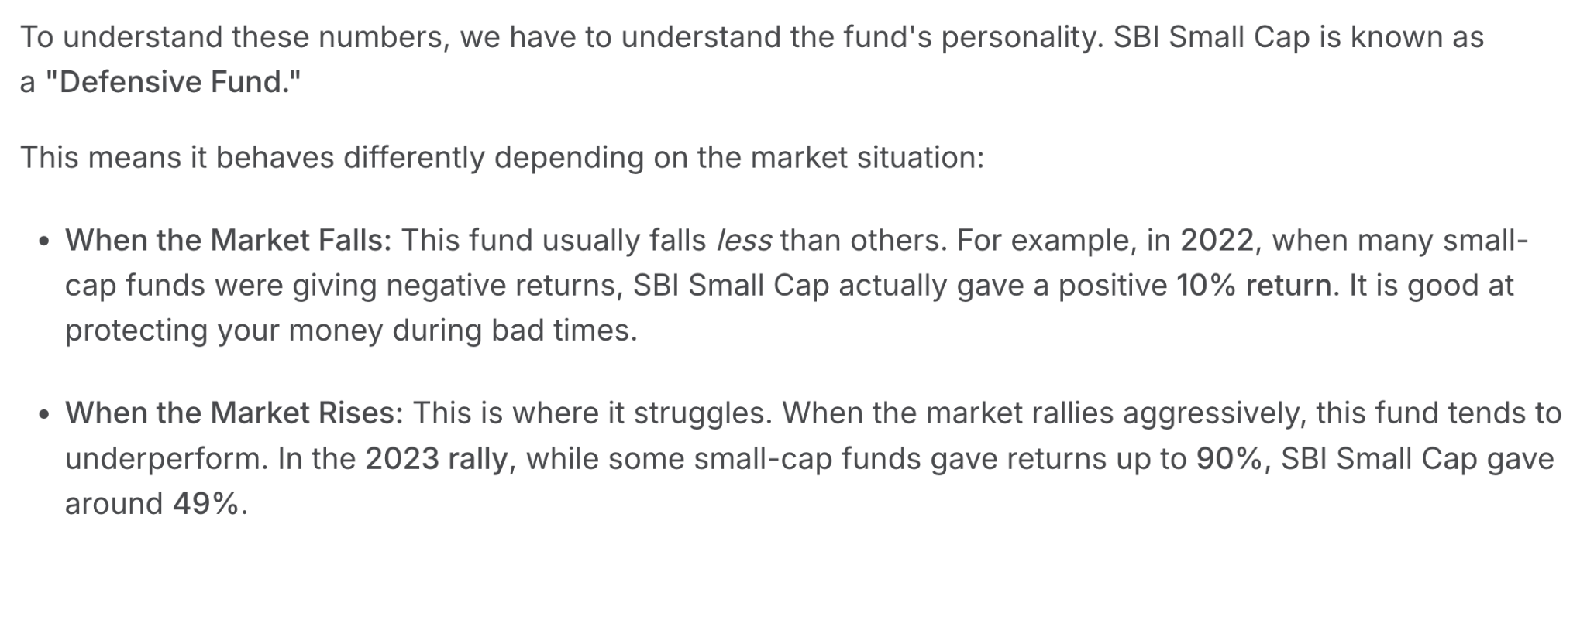
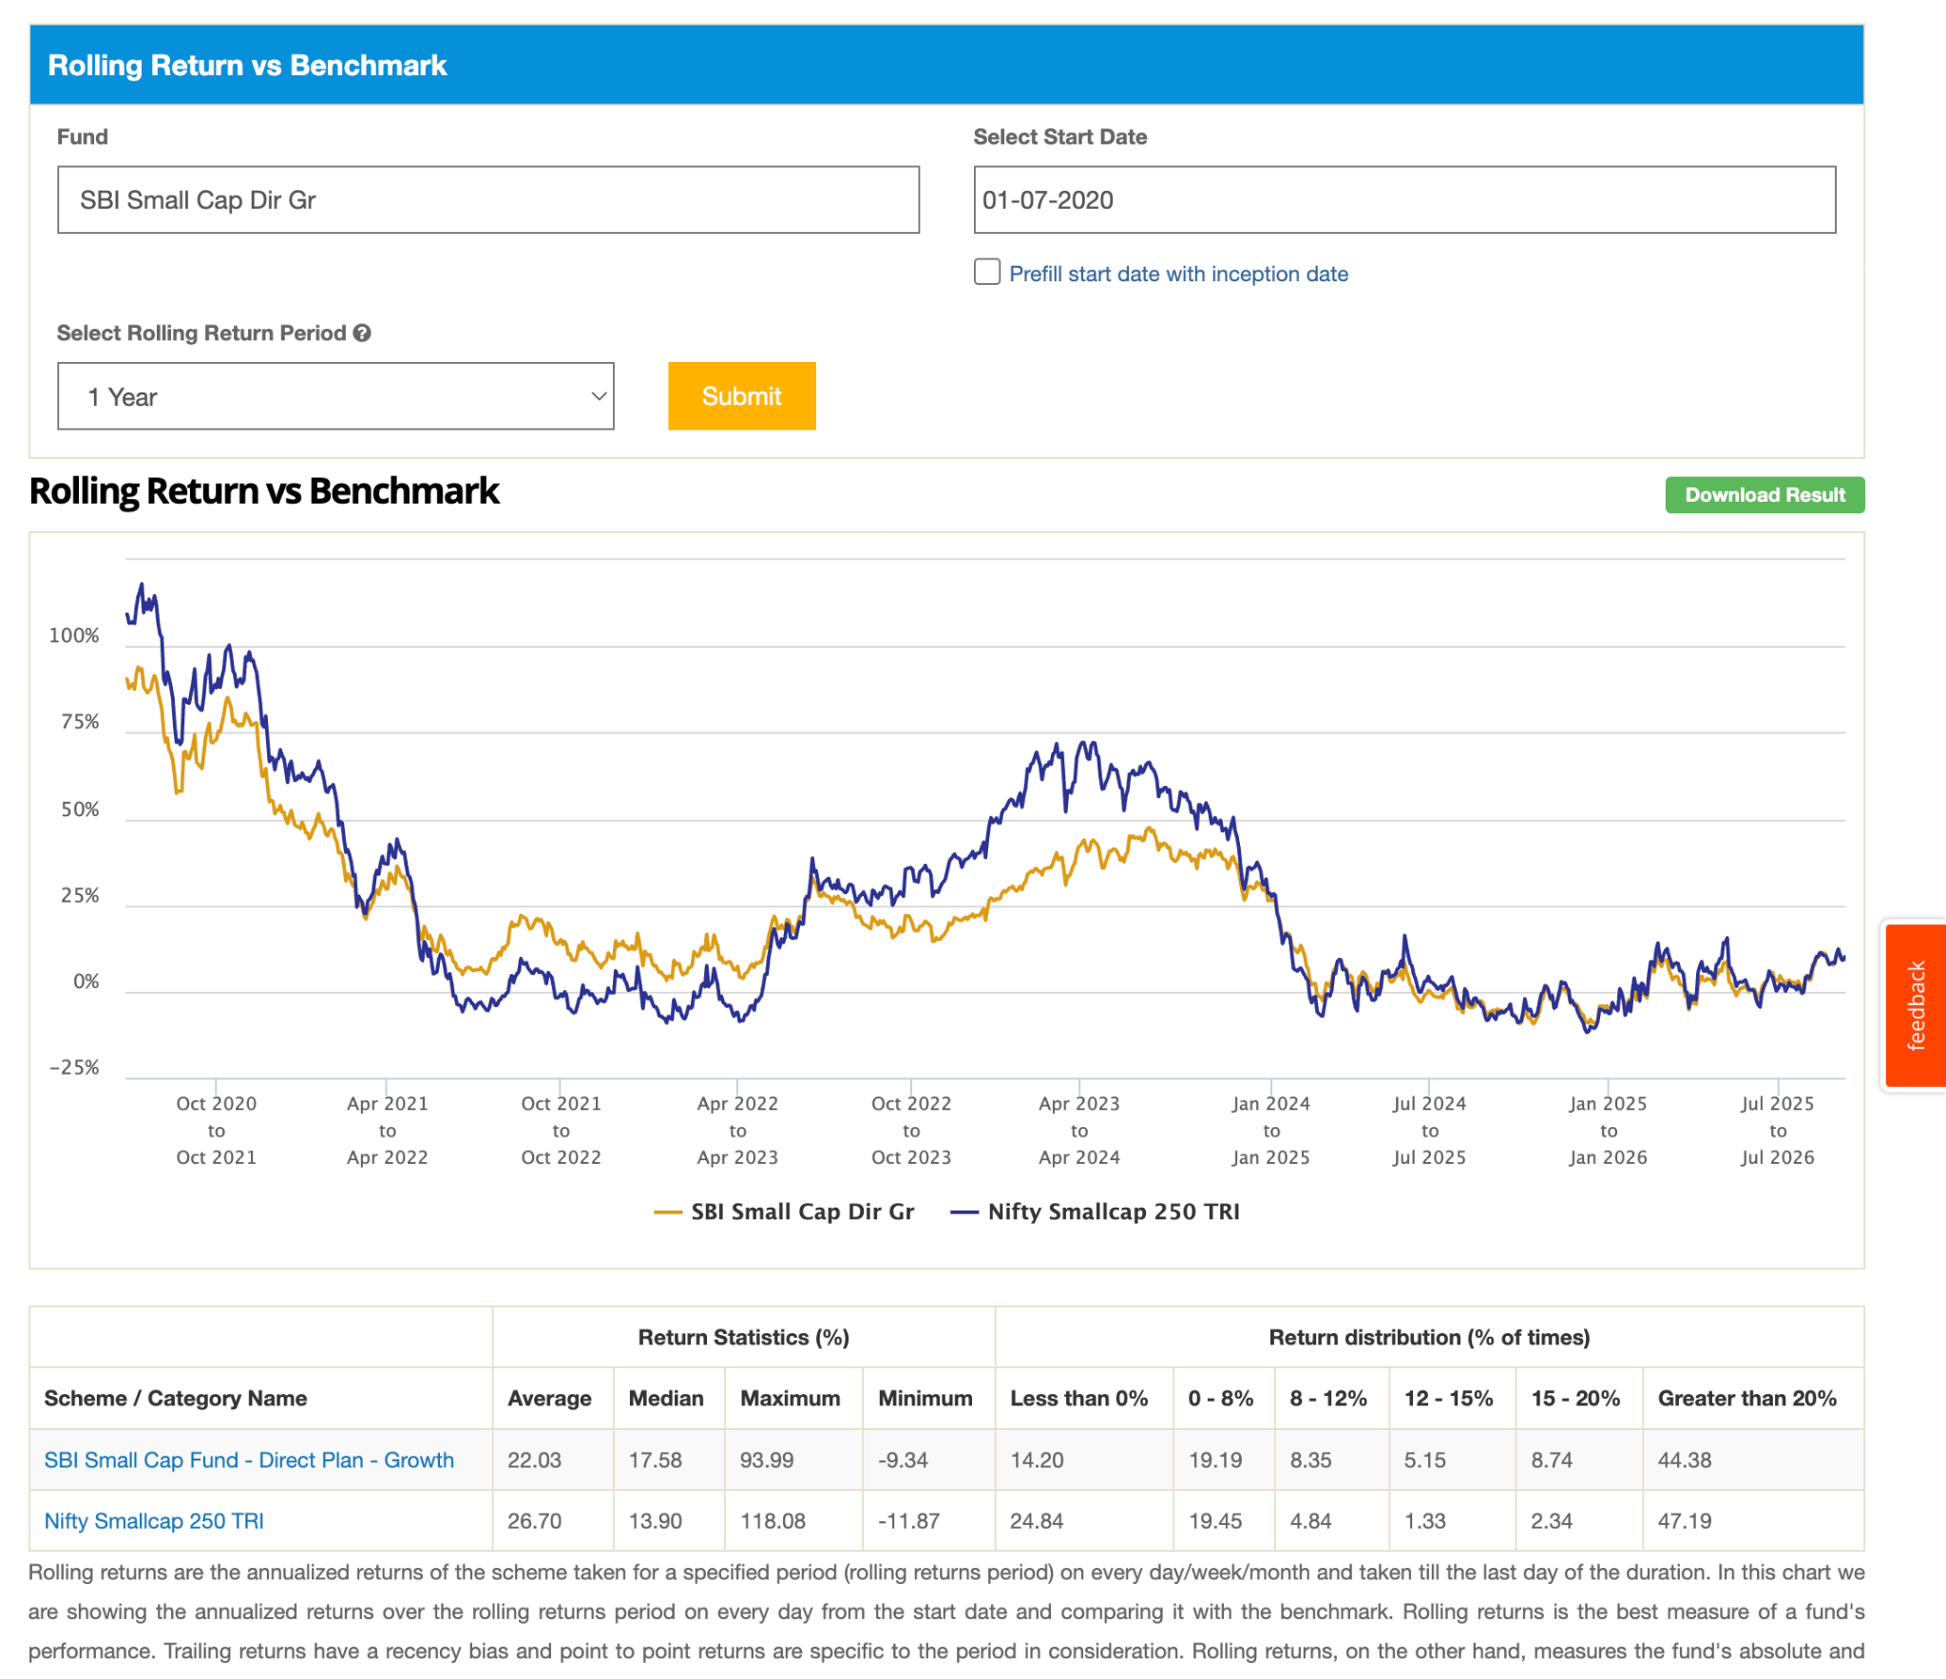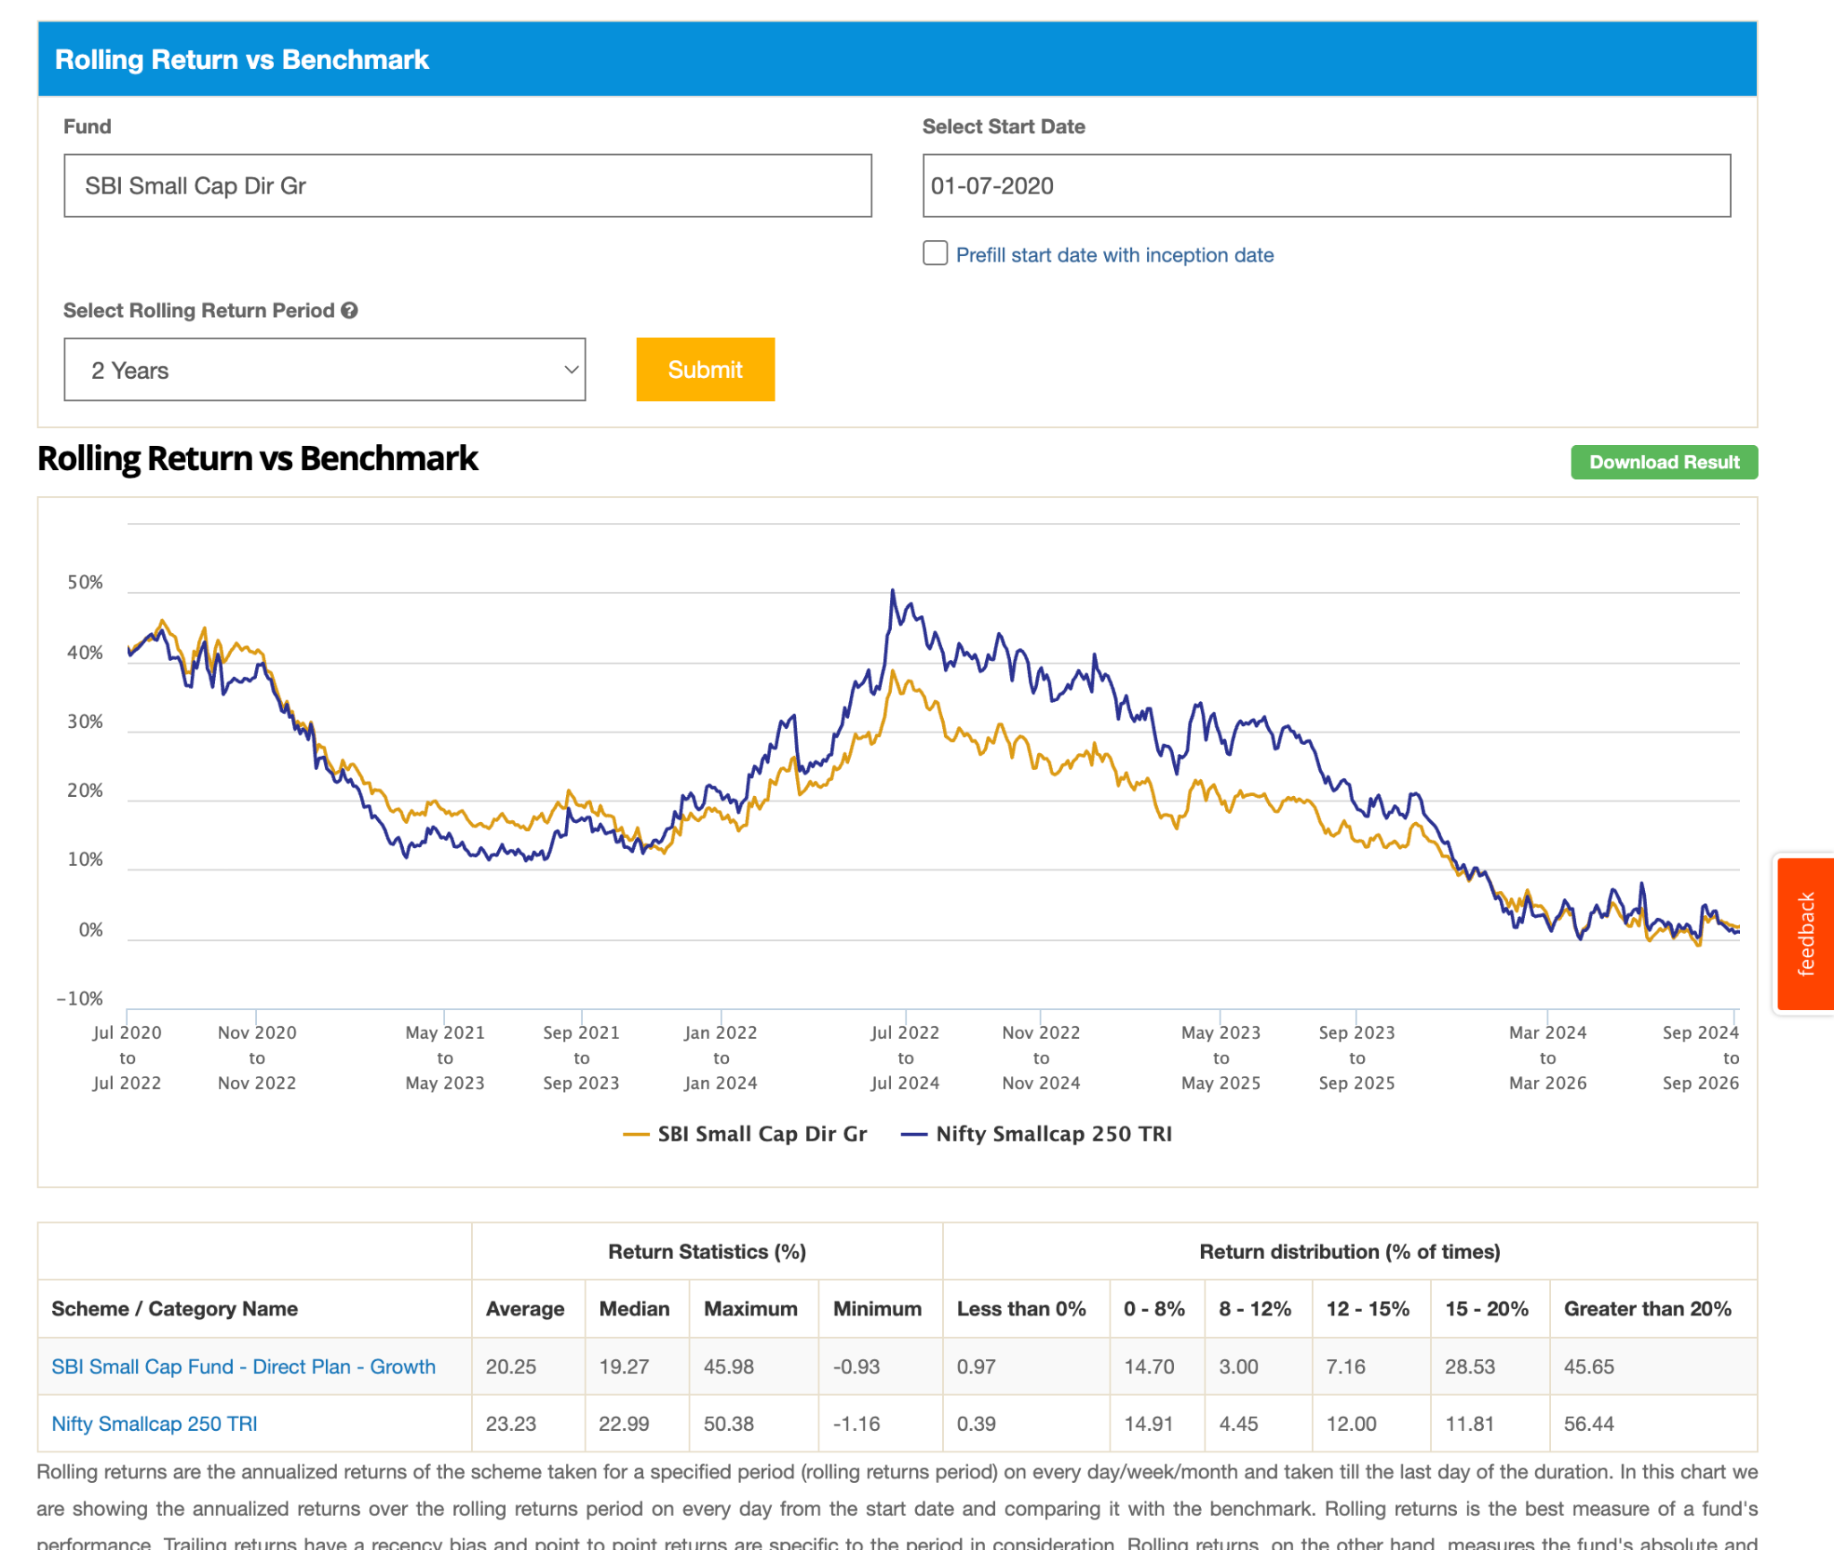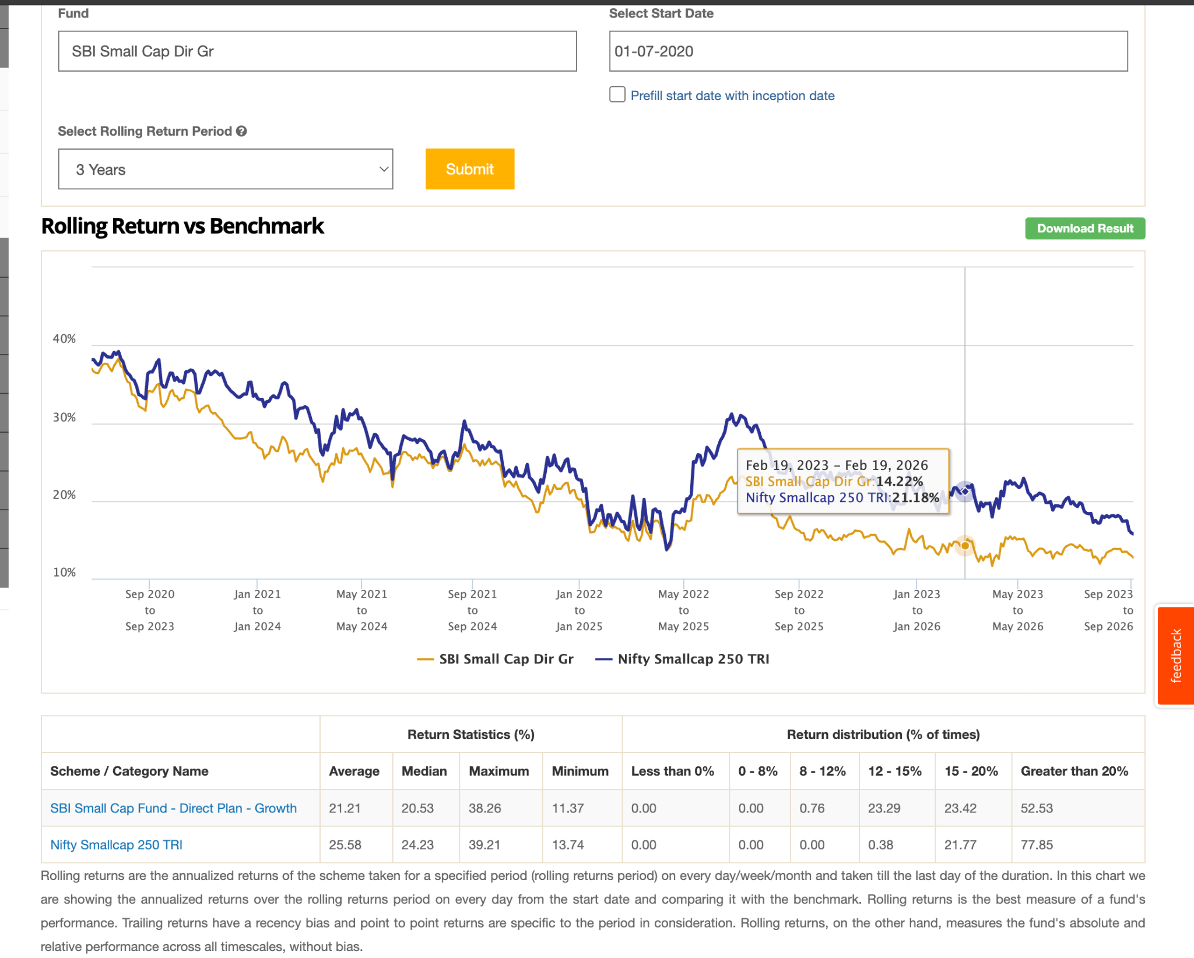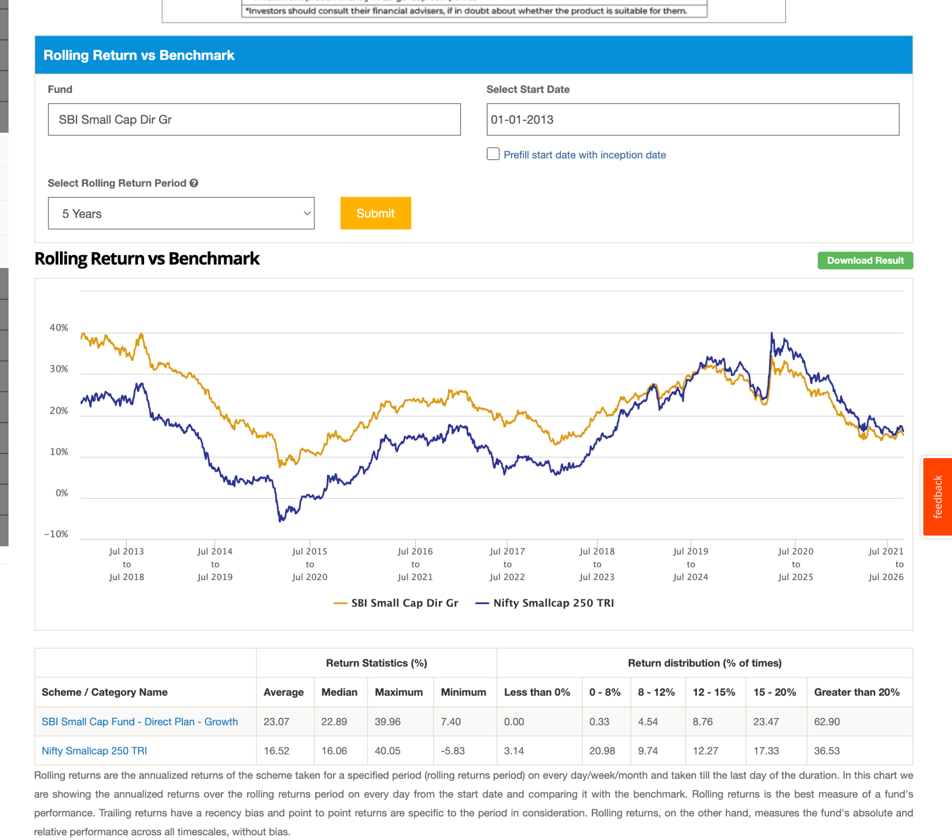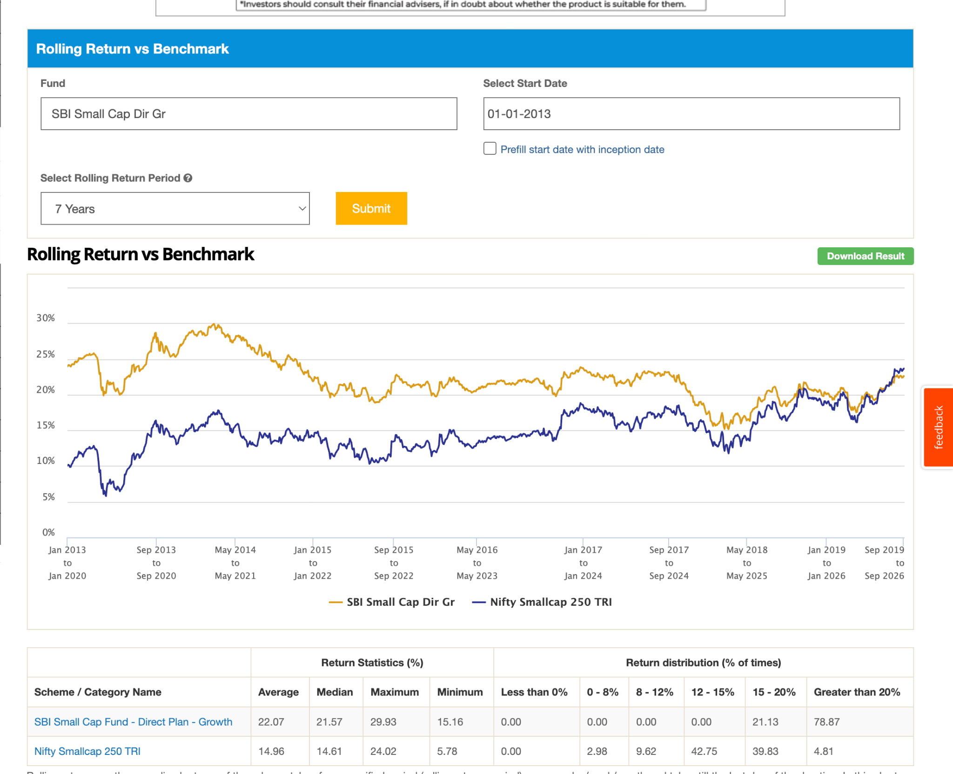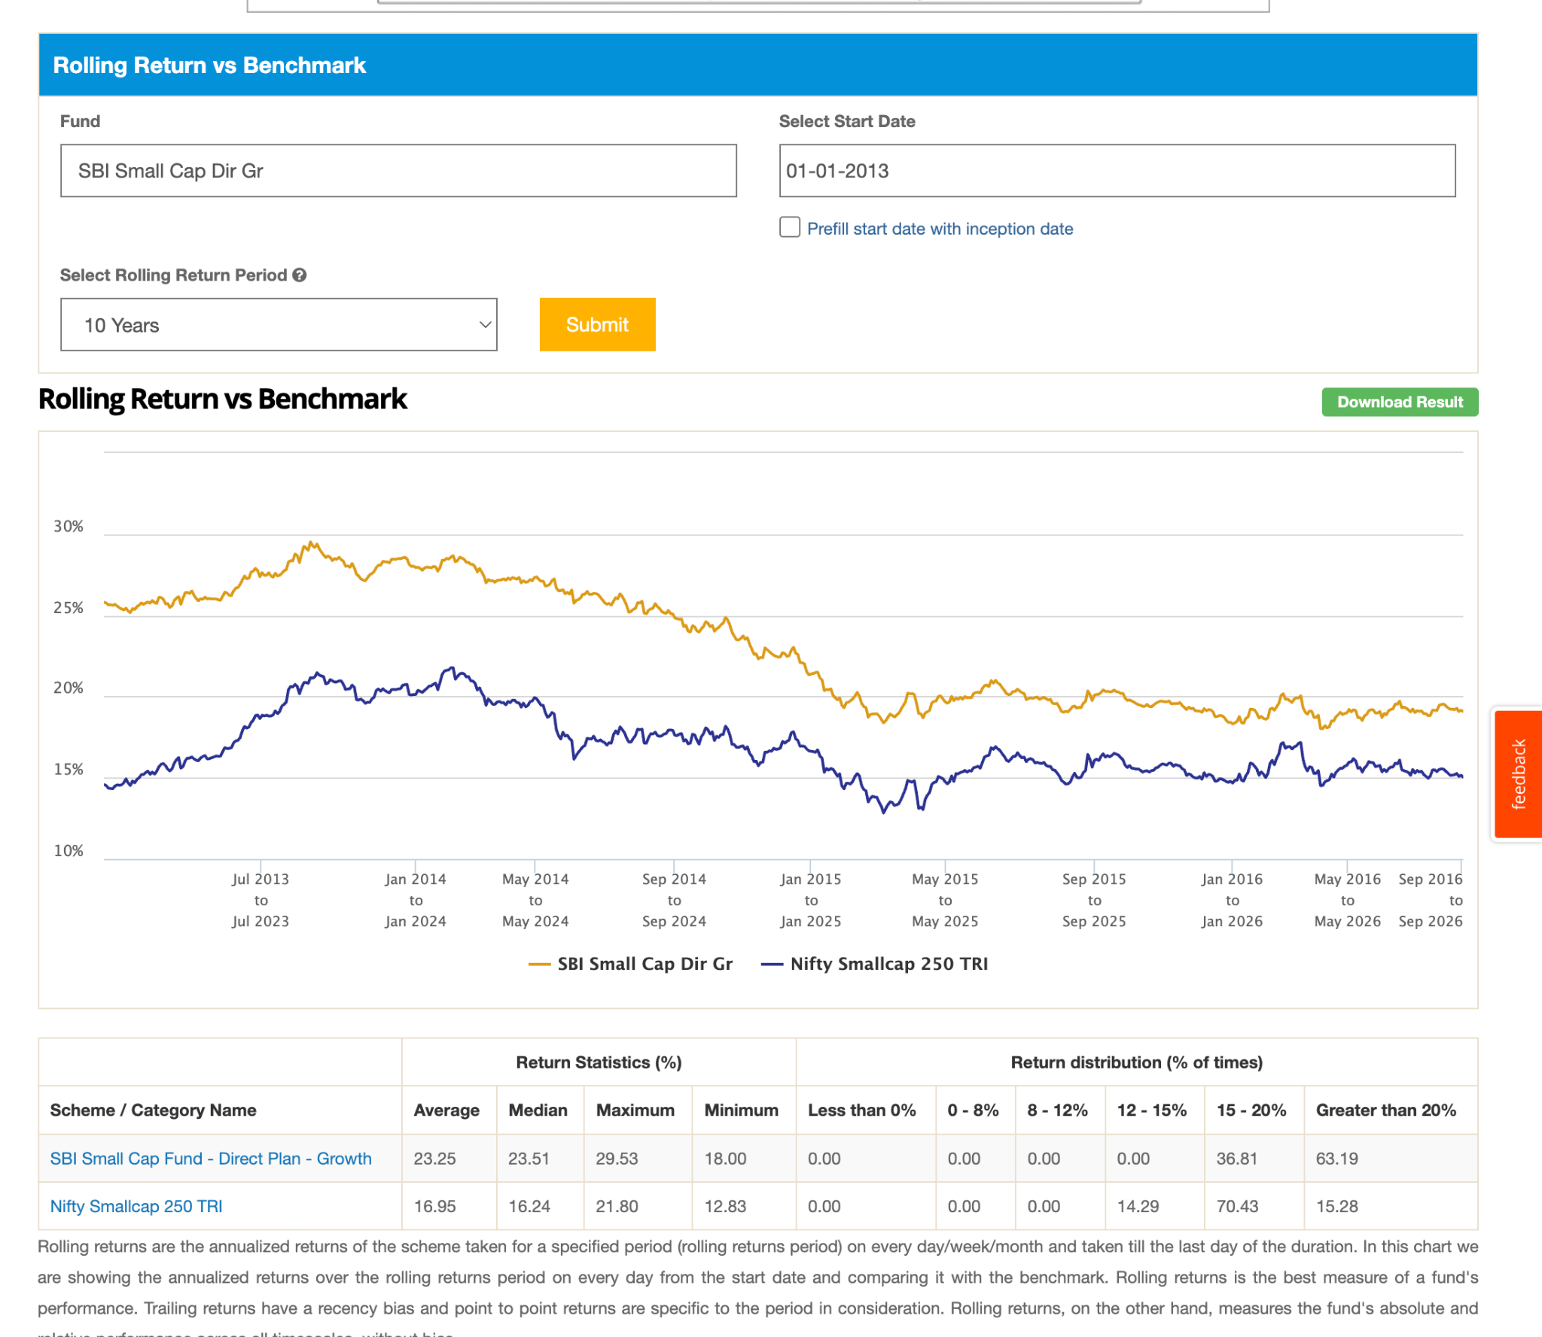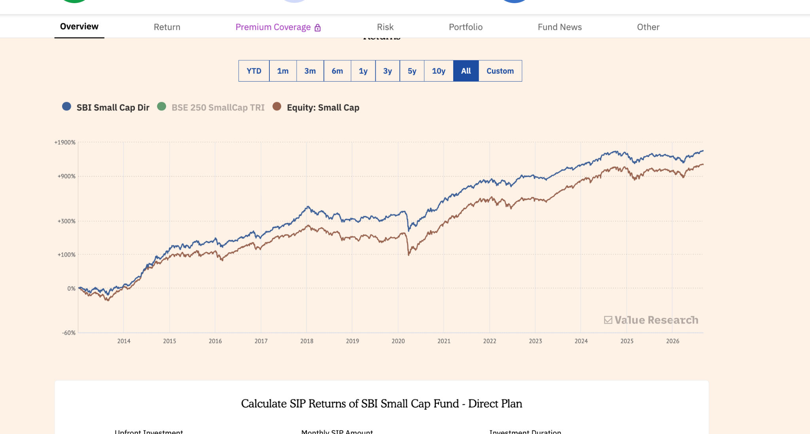
13. Sundaram Small Cap Dir-G: 4k, 0.98, 12y, 10y record is ok not that good not not able to beat in last 4-5y , but start beating 1-2y. 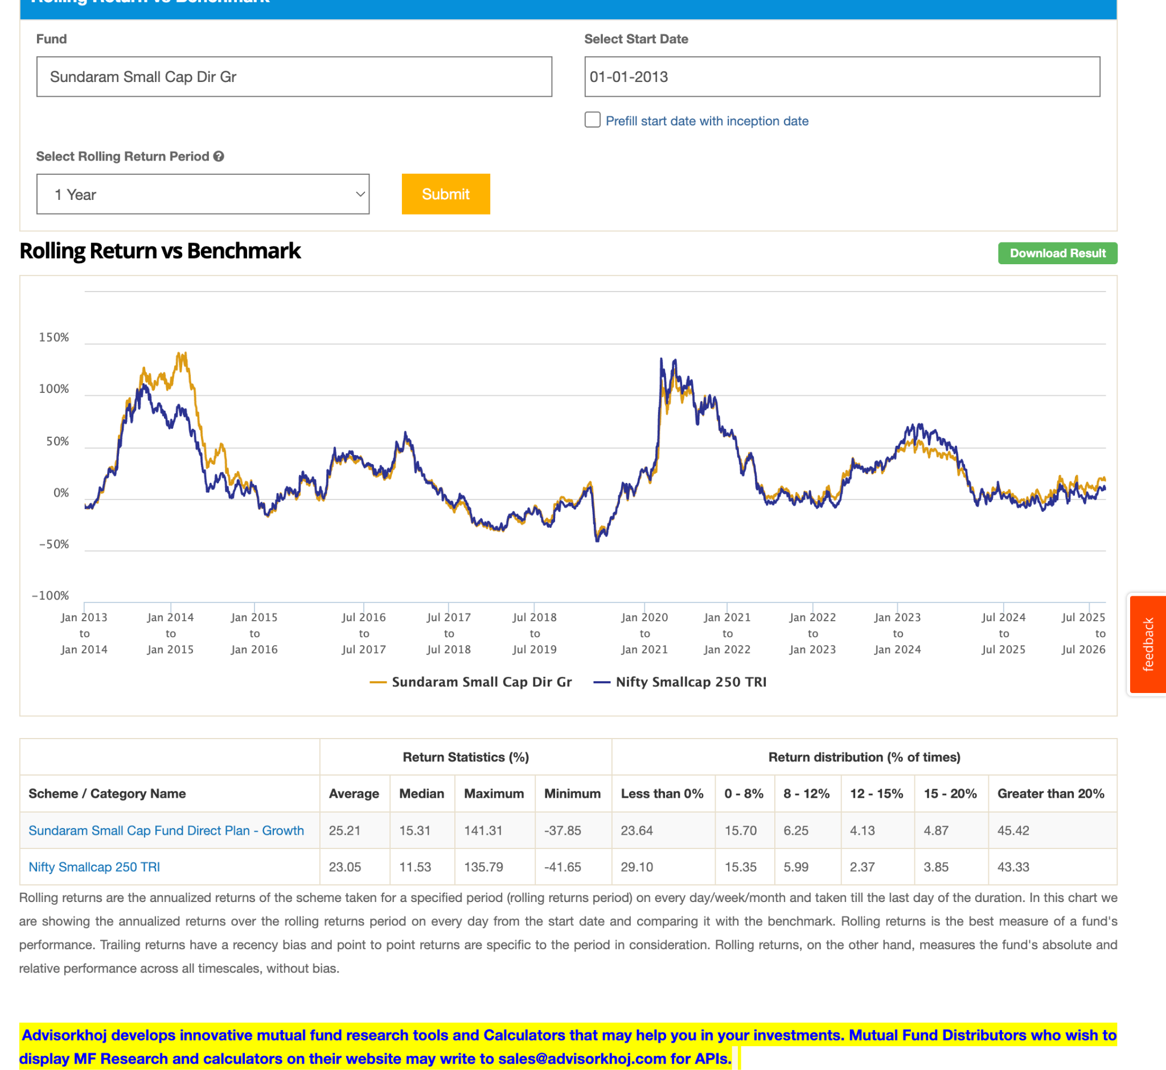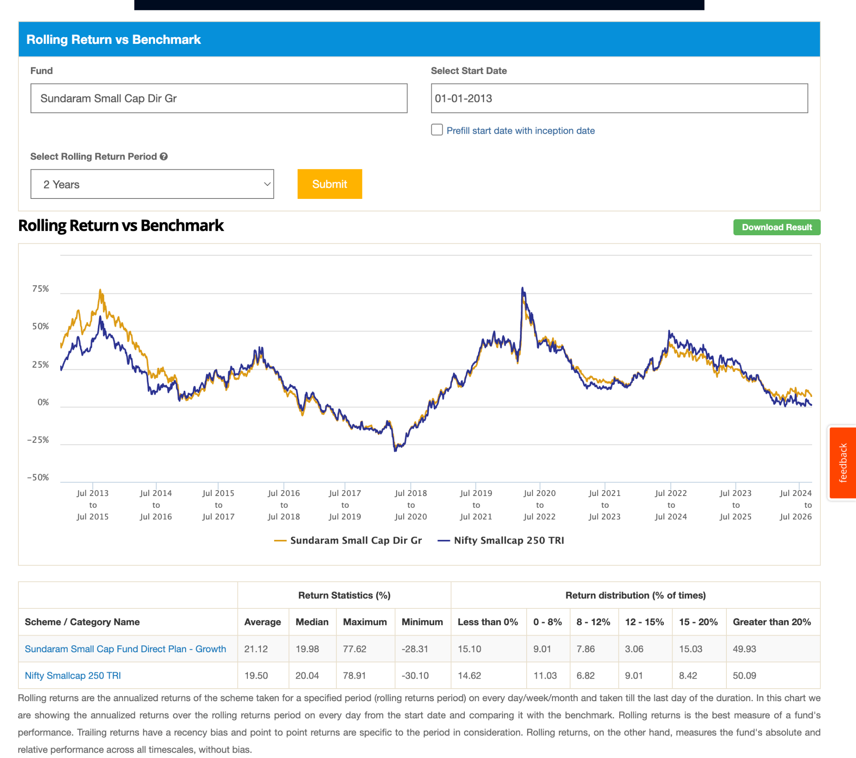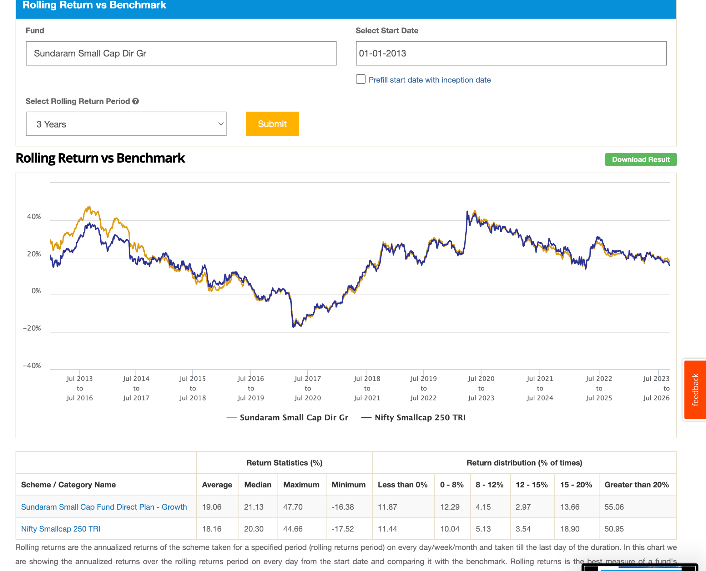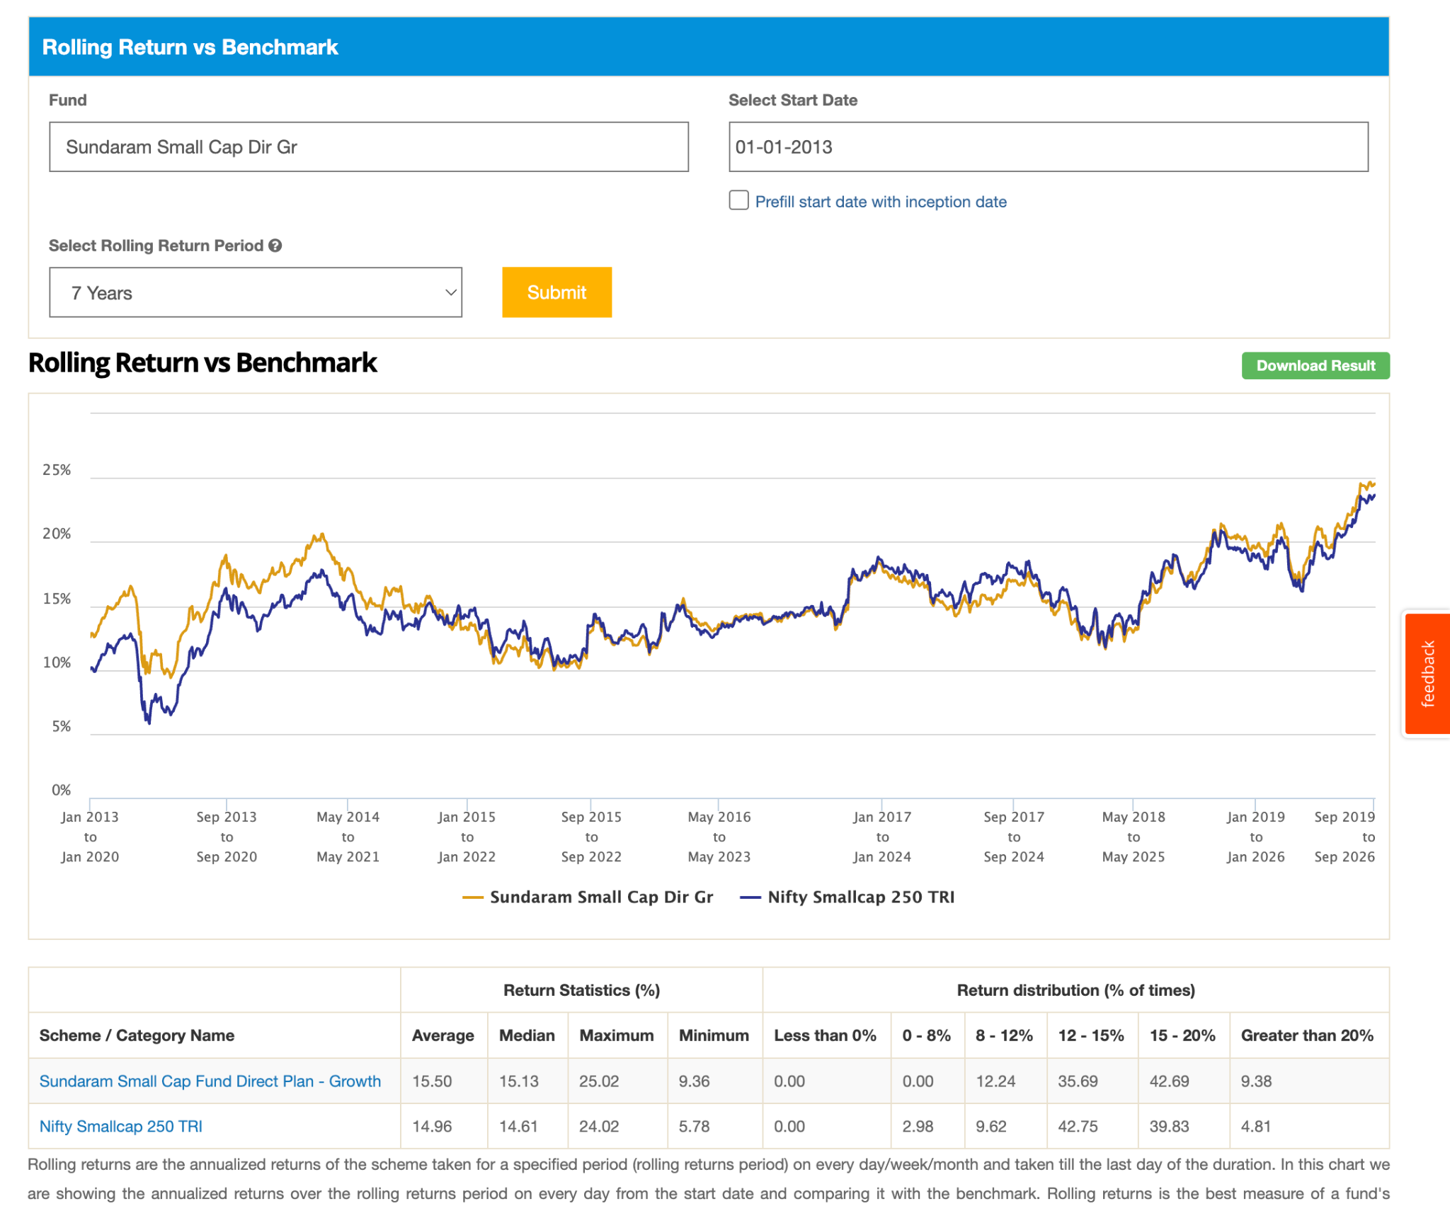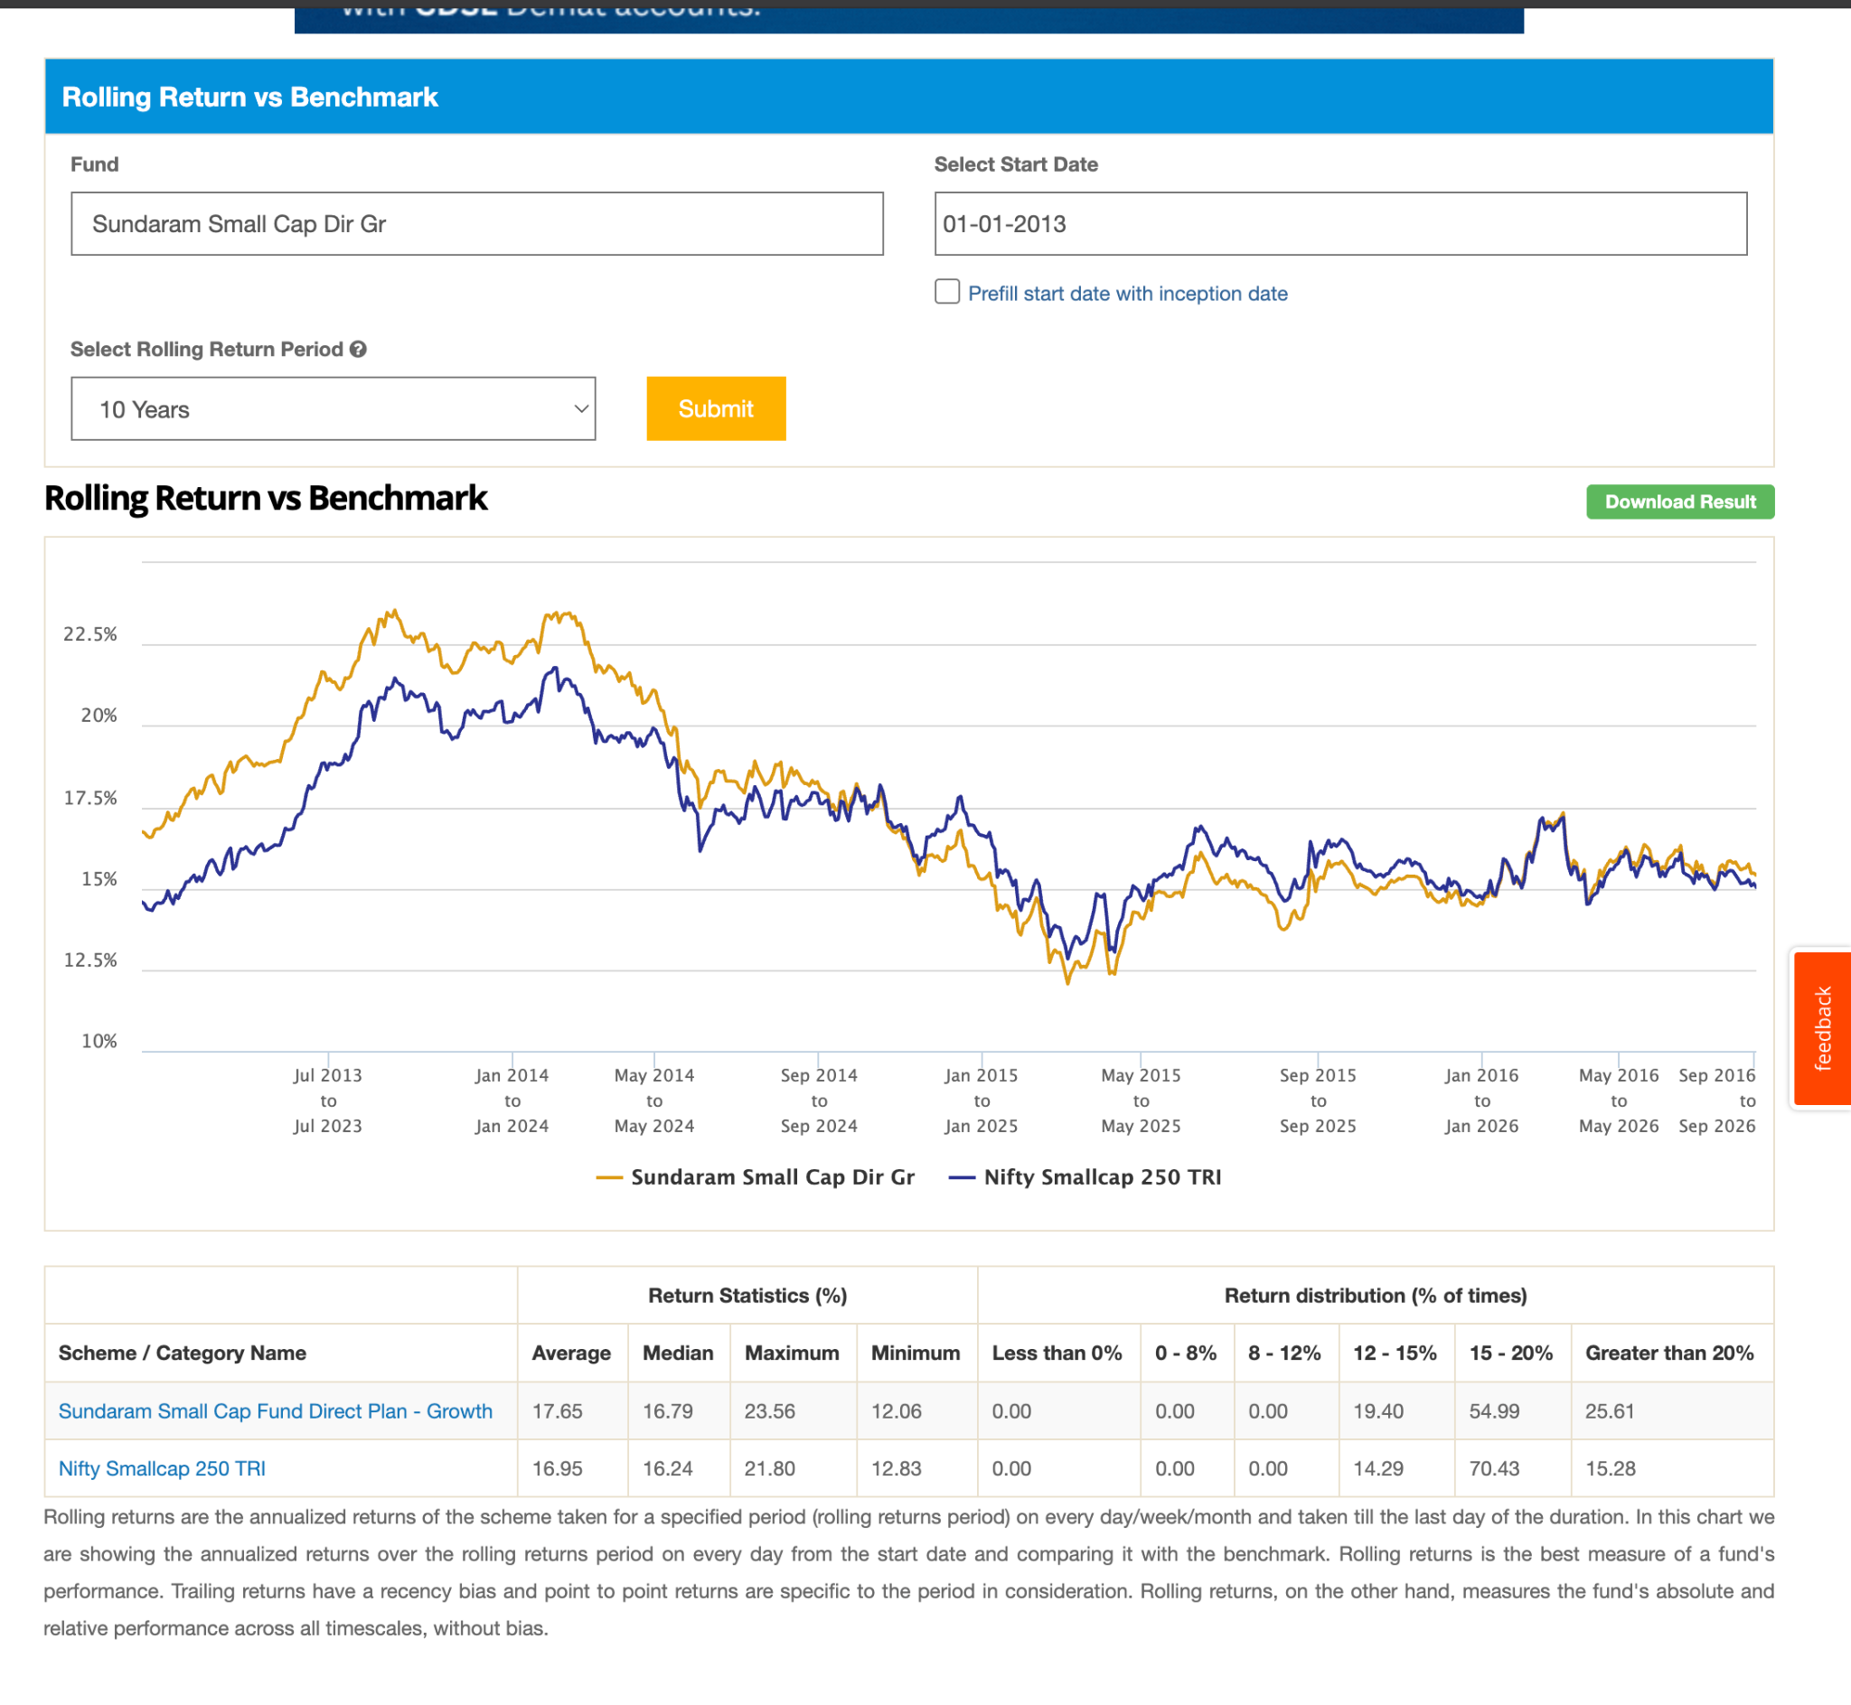
14. Tata Small Cap Dir-G: 2018, 12.5k, 0.51. 7y is beating handsome, again smae pattern. 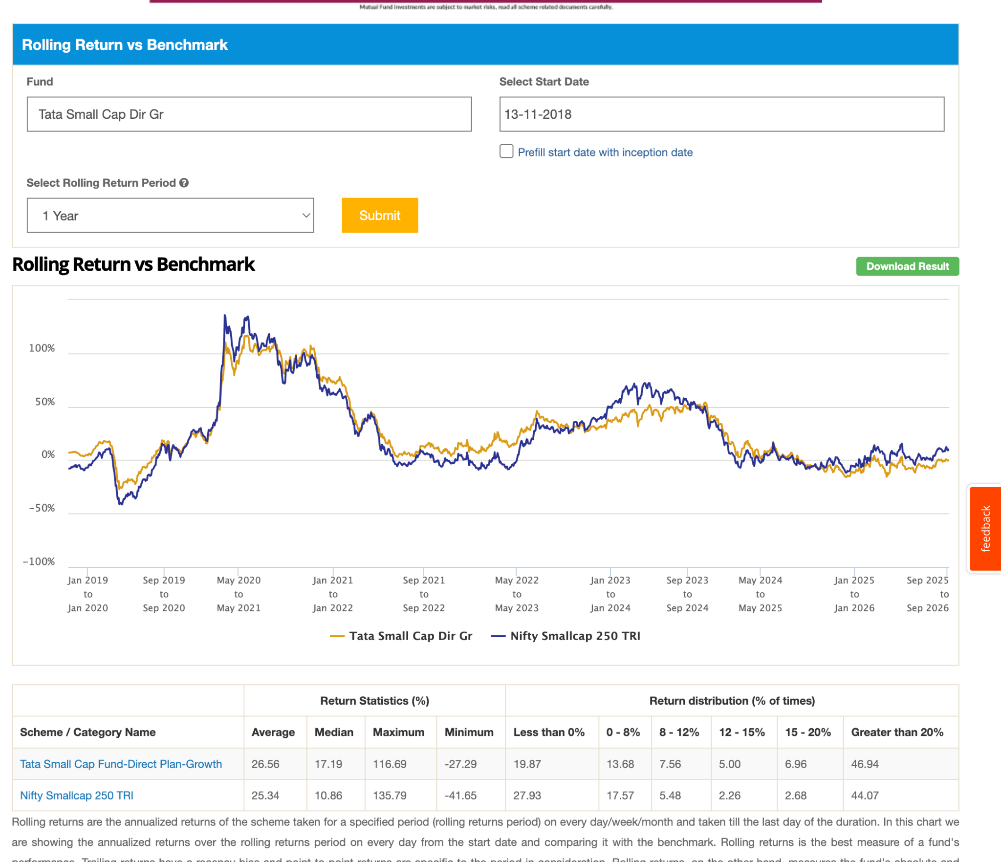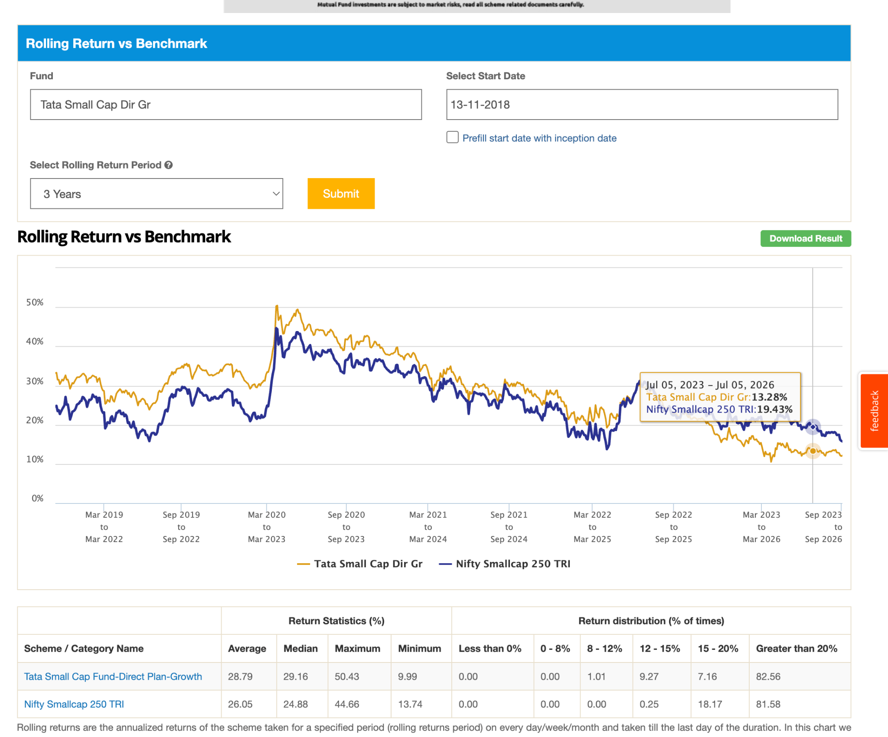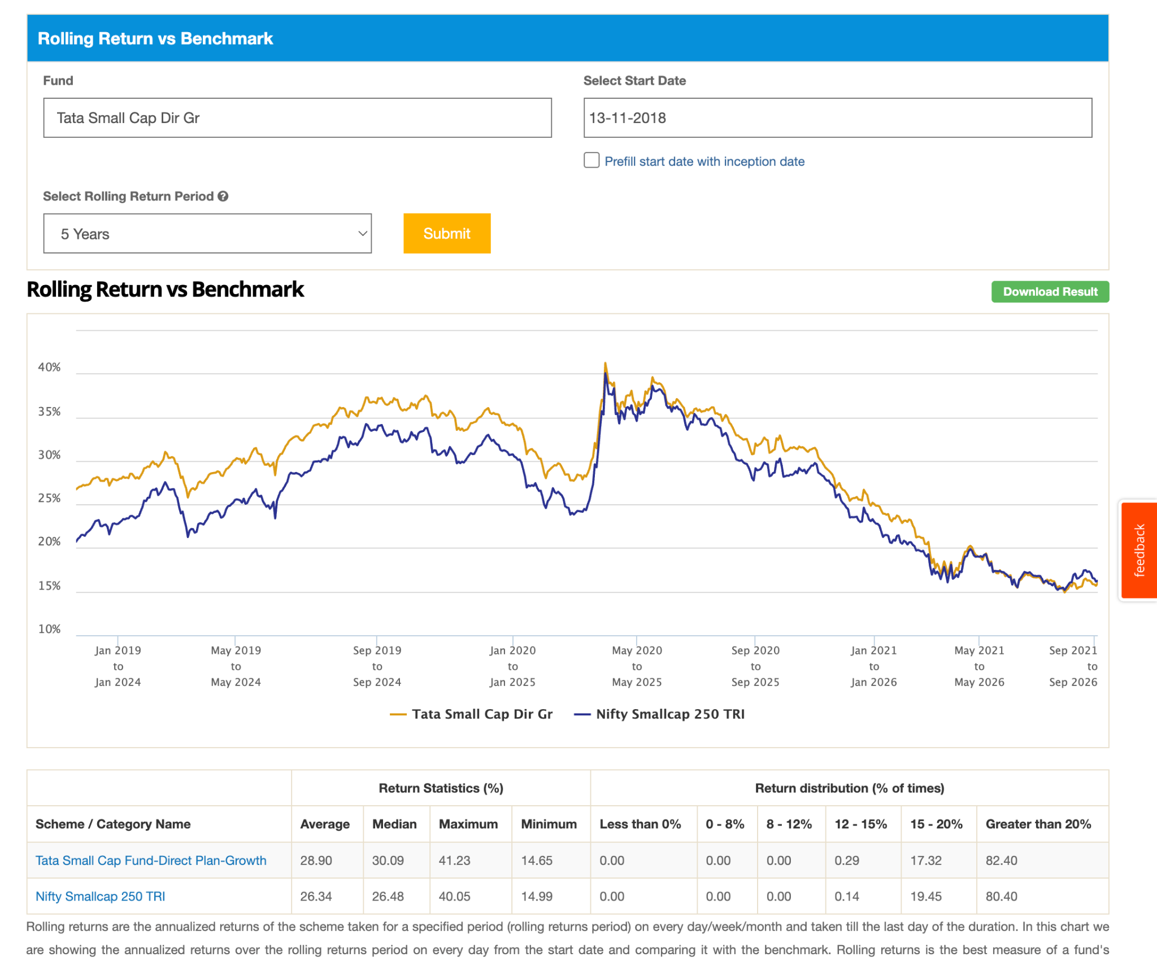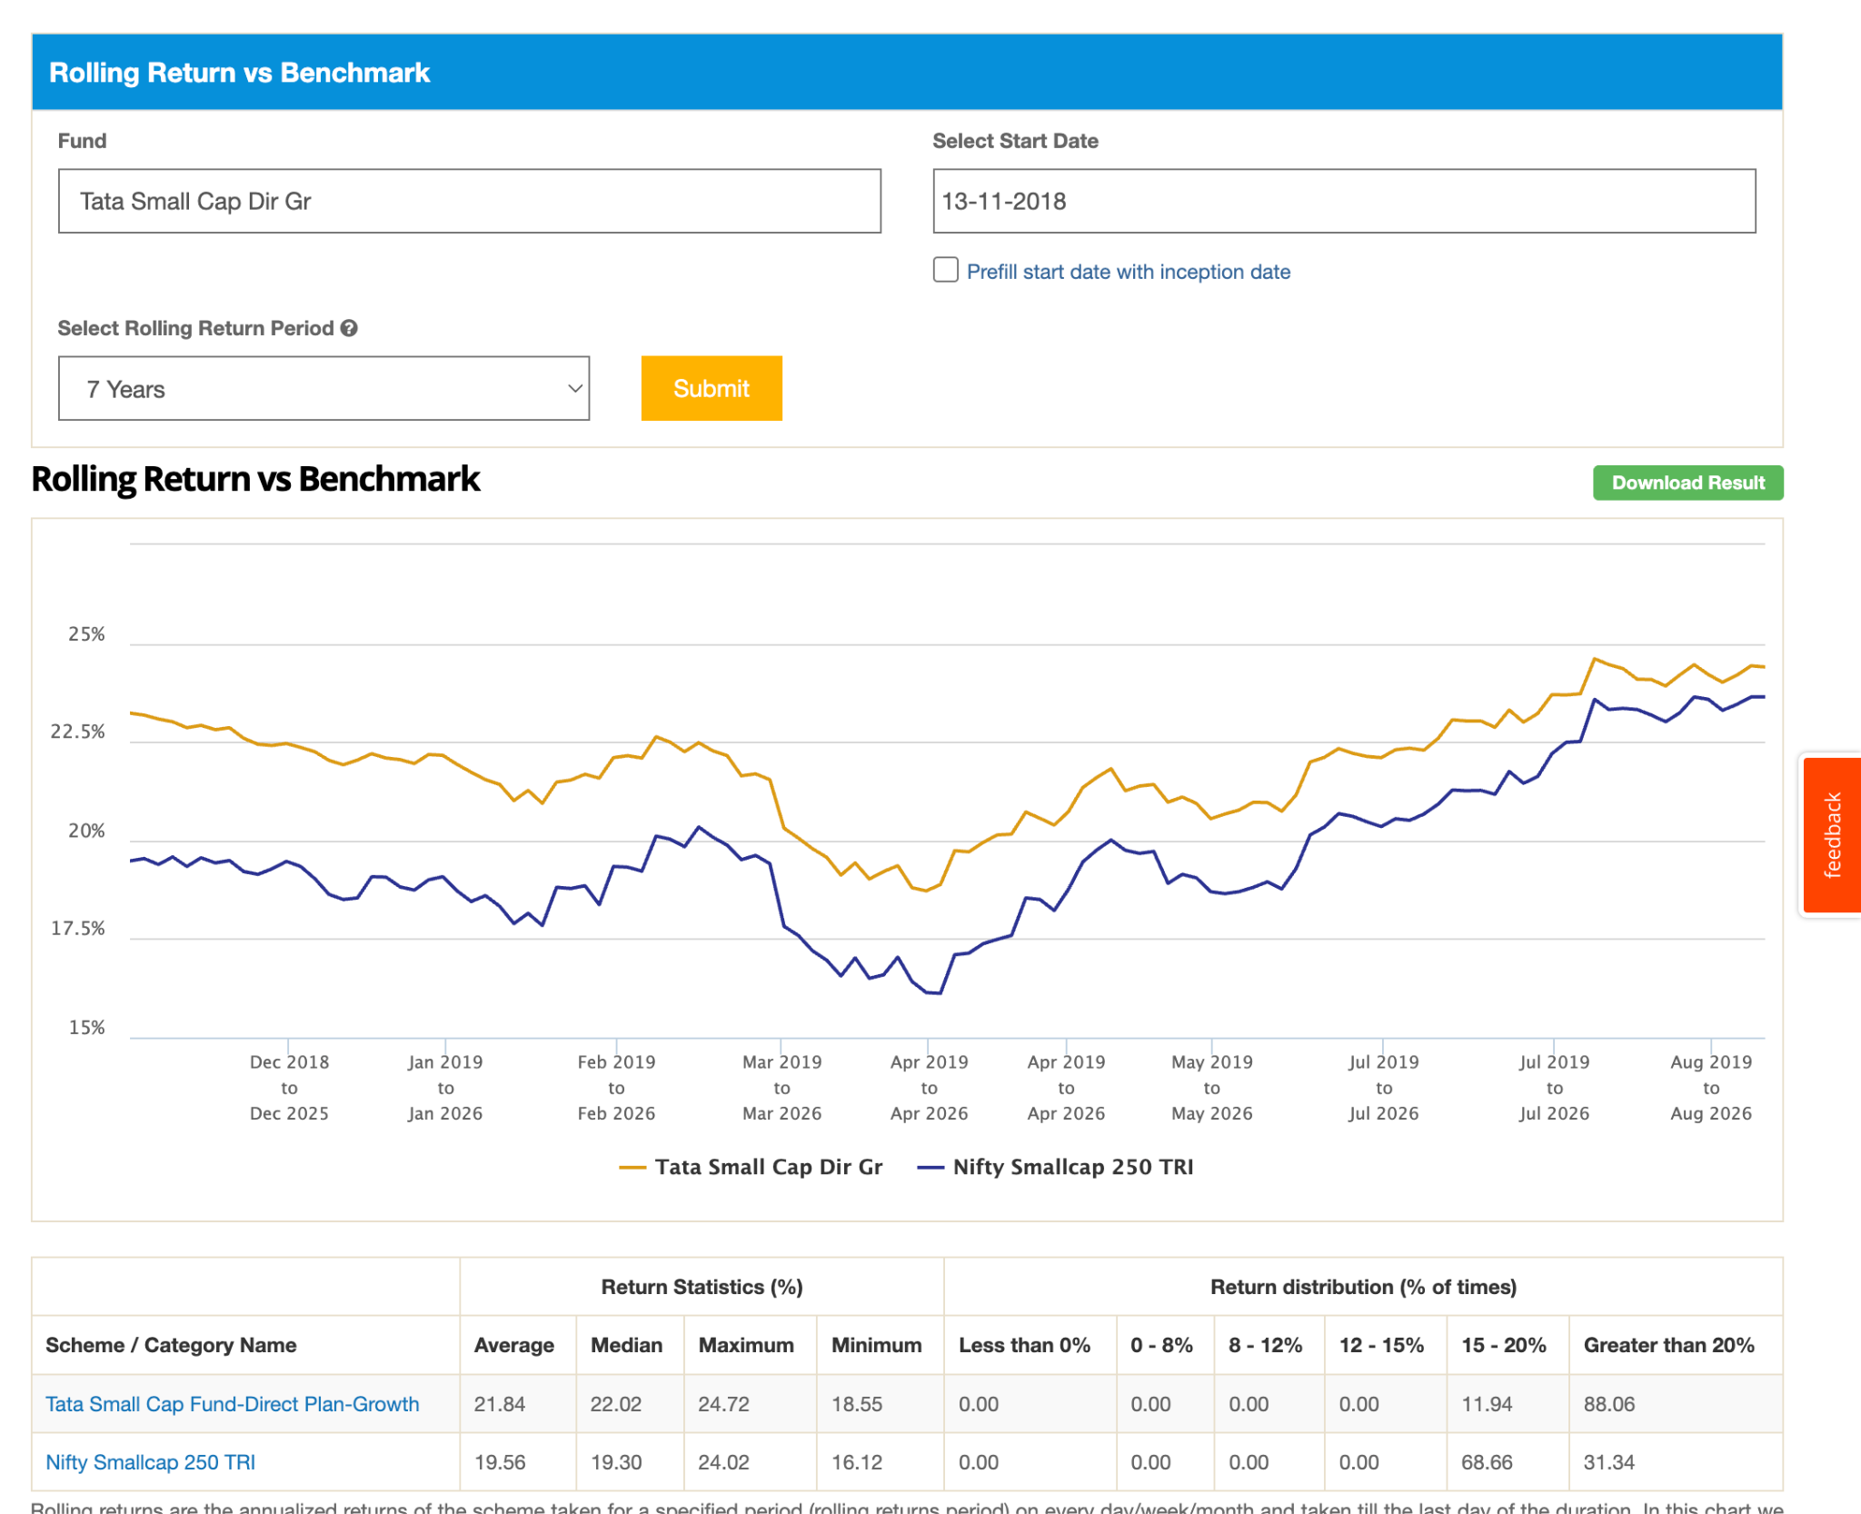
15. UTI Small Cap Dir-G: 2020, 5y just beating index, 5.2k, 1.05, not doing well in last few year looks, 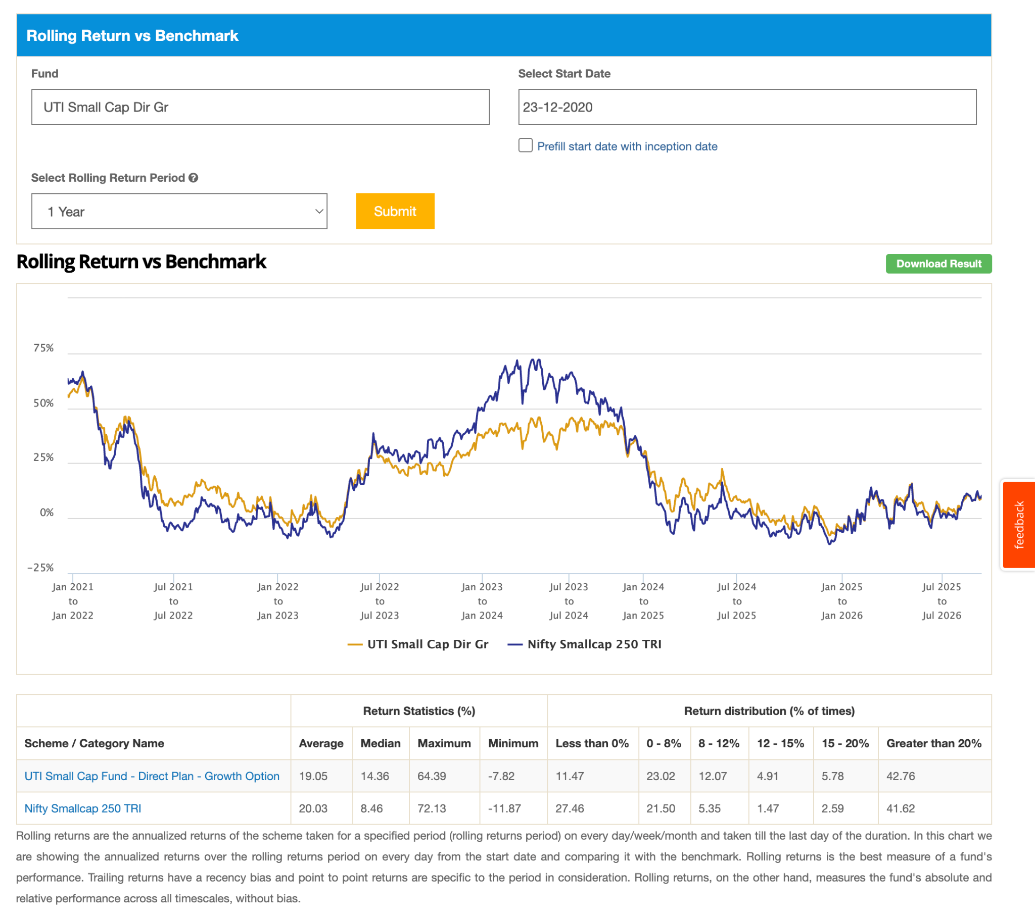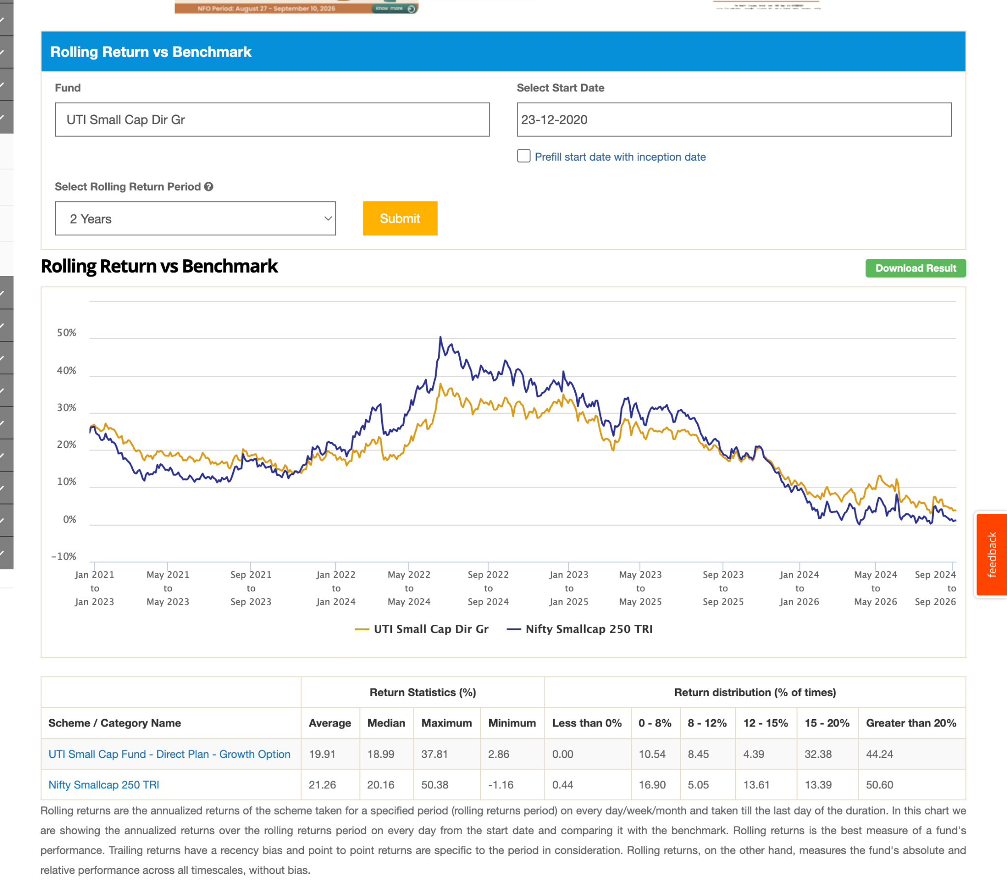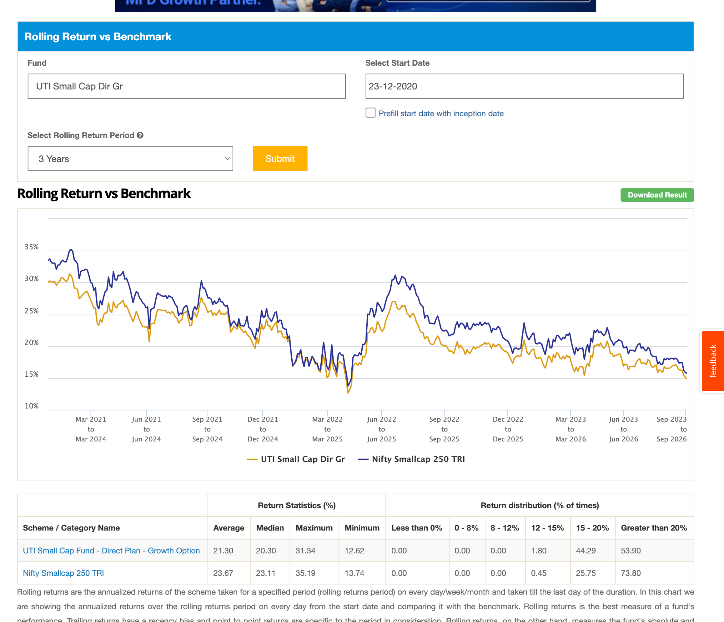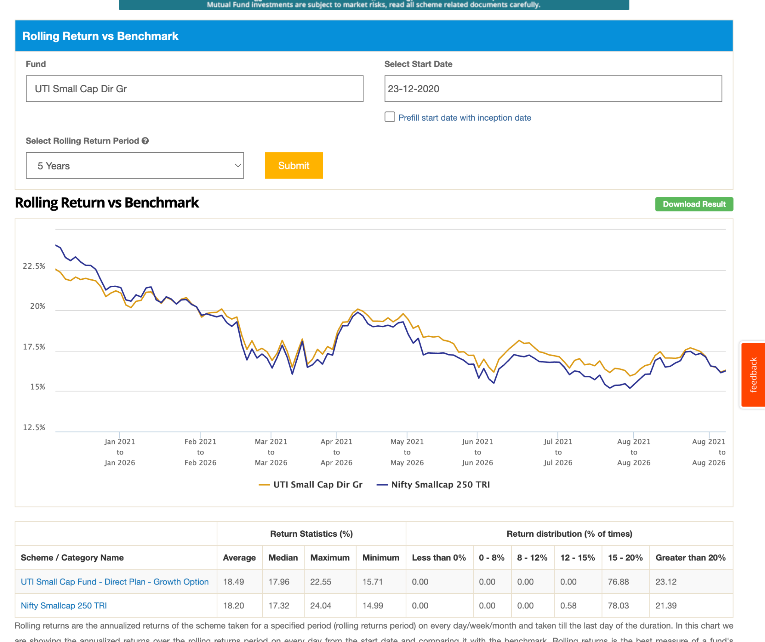
16. Union Small Cap Dir-G: 2.4k, 1.10 , 2014, bit up and down. 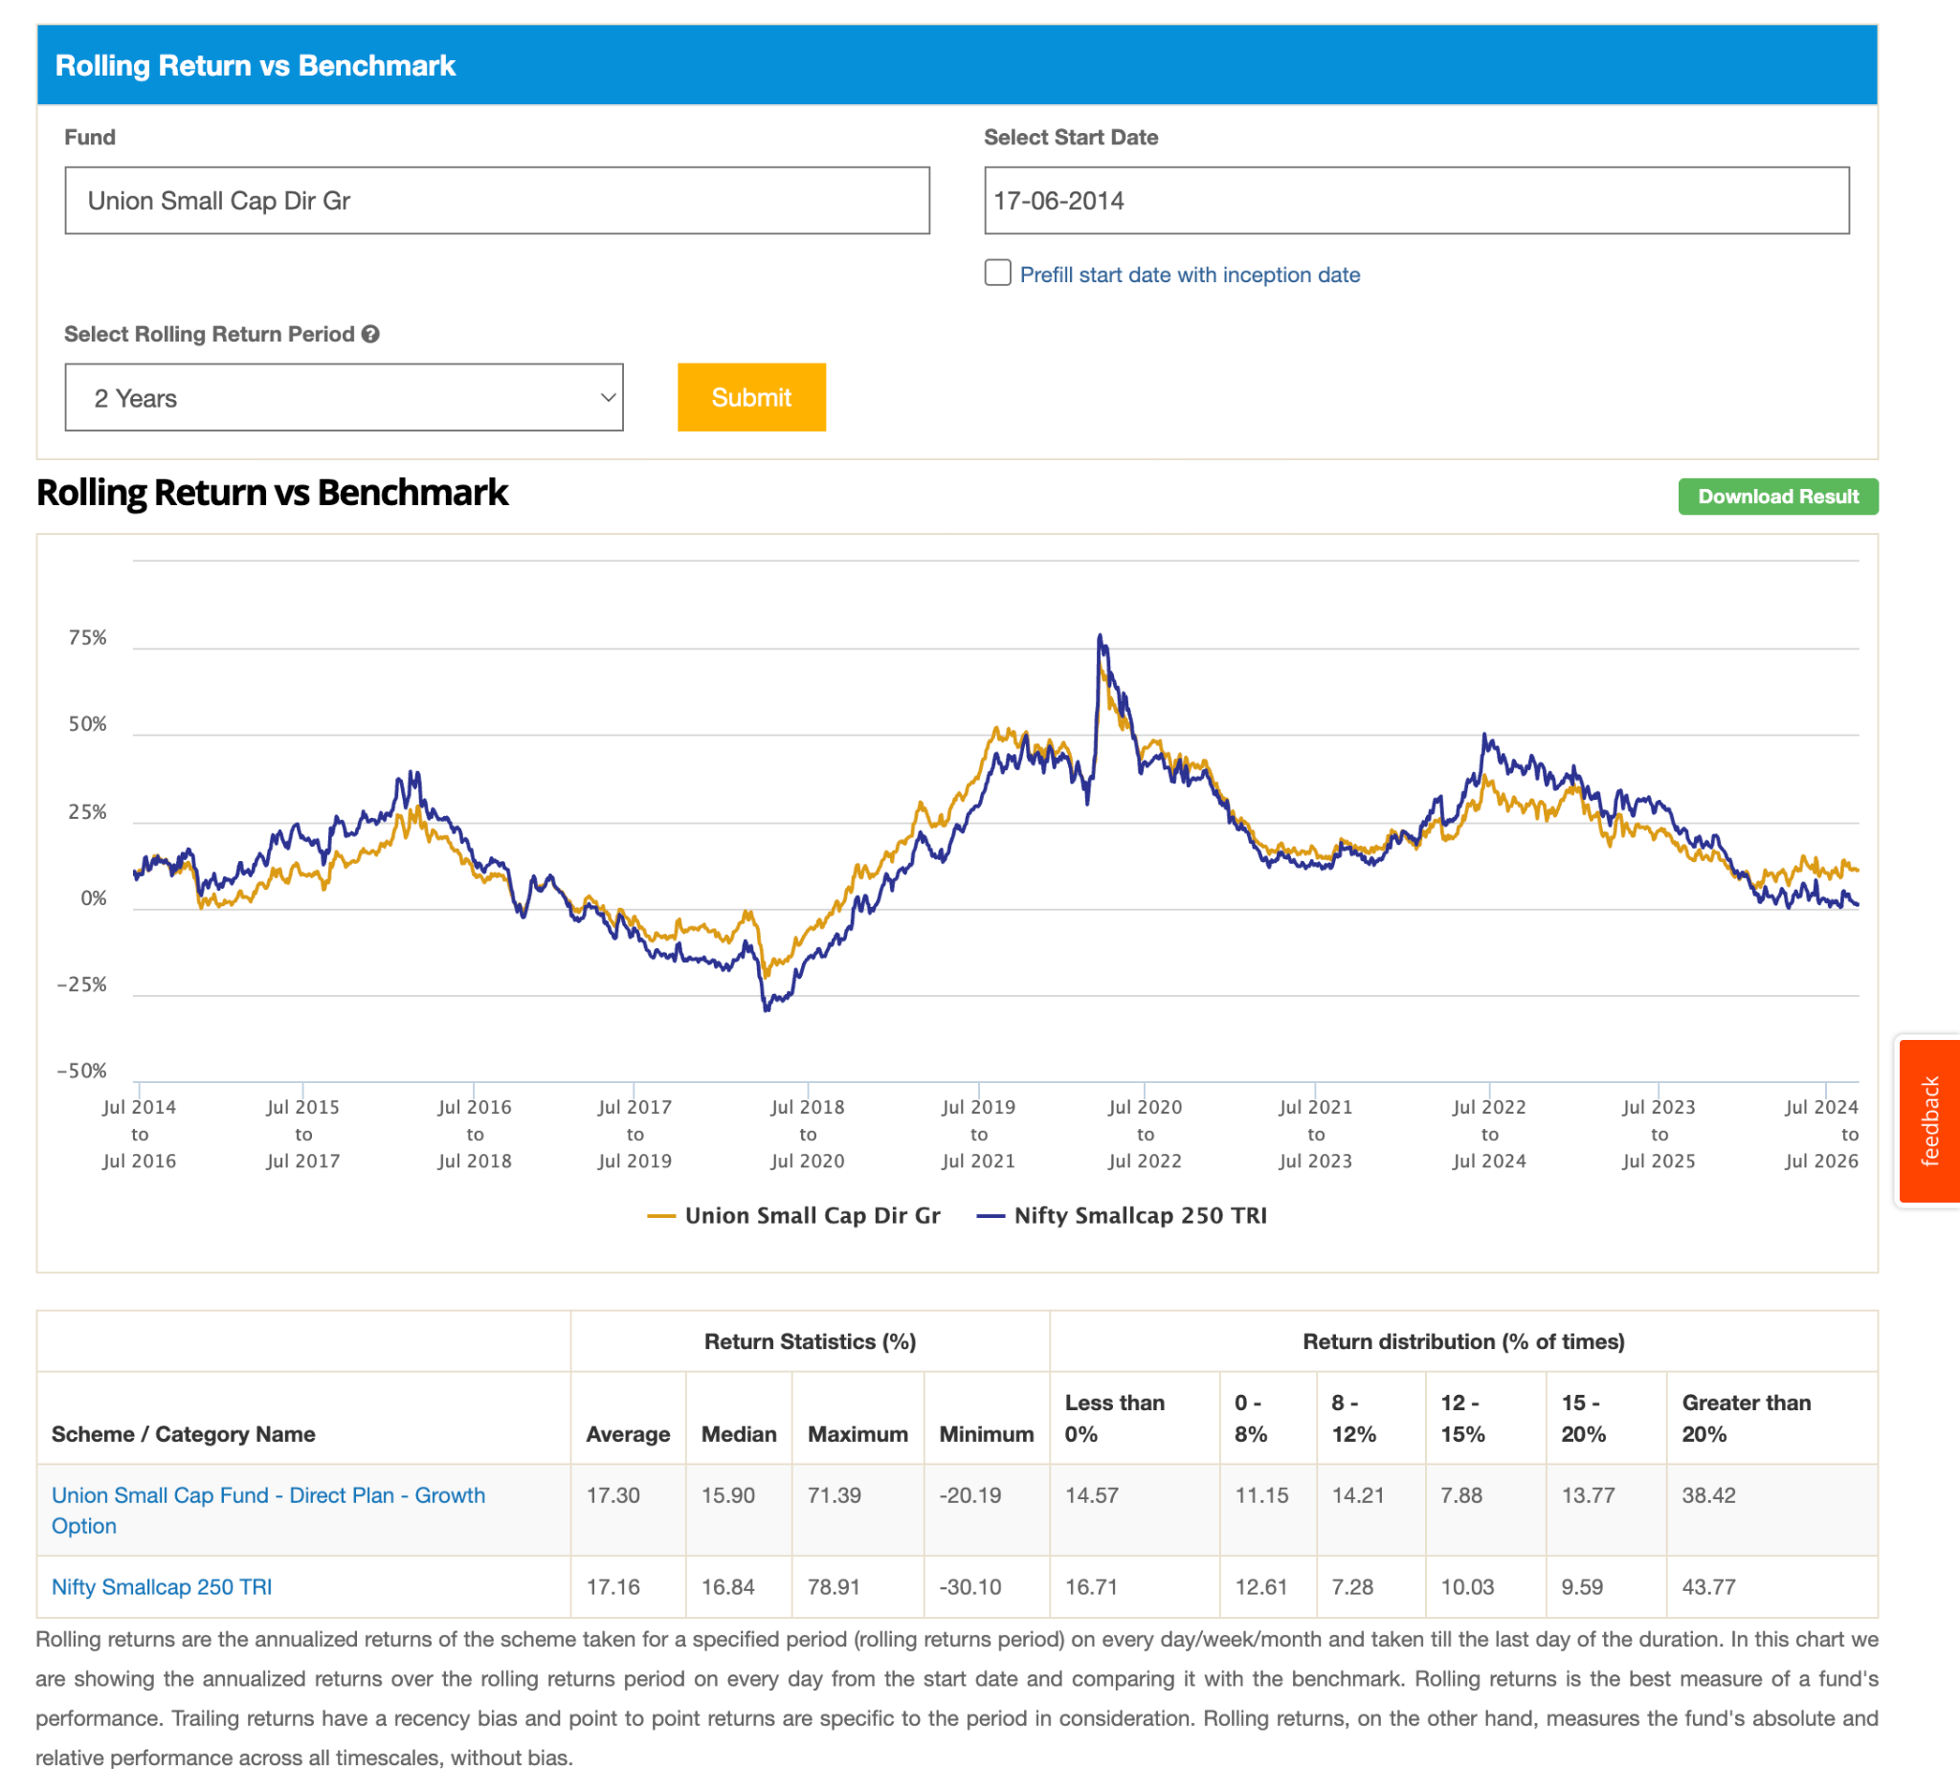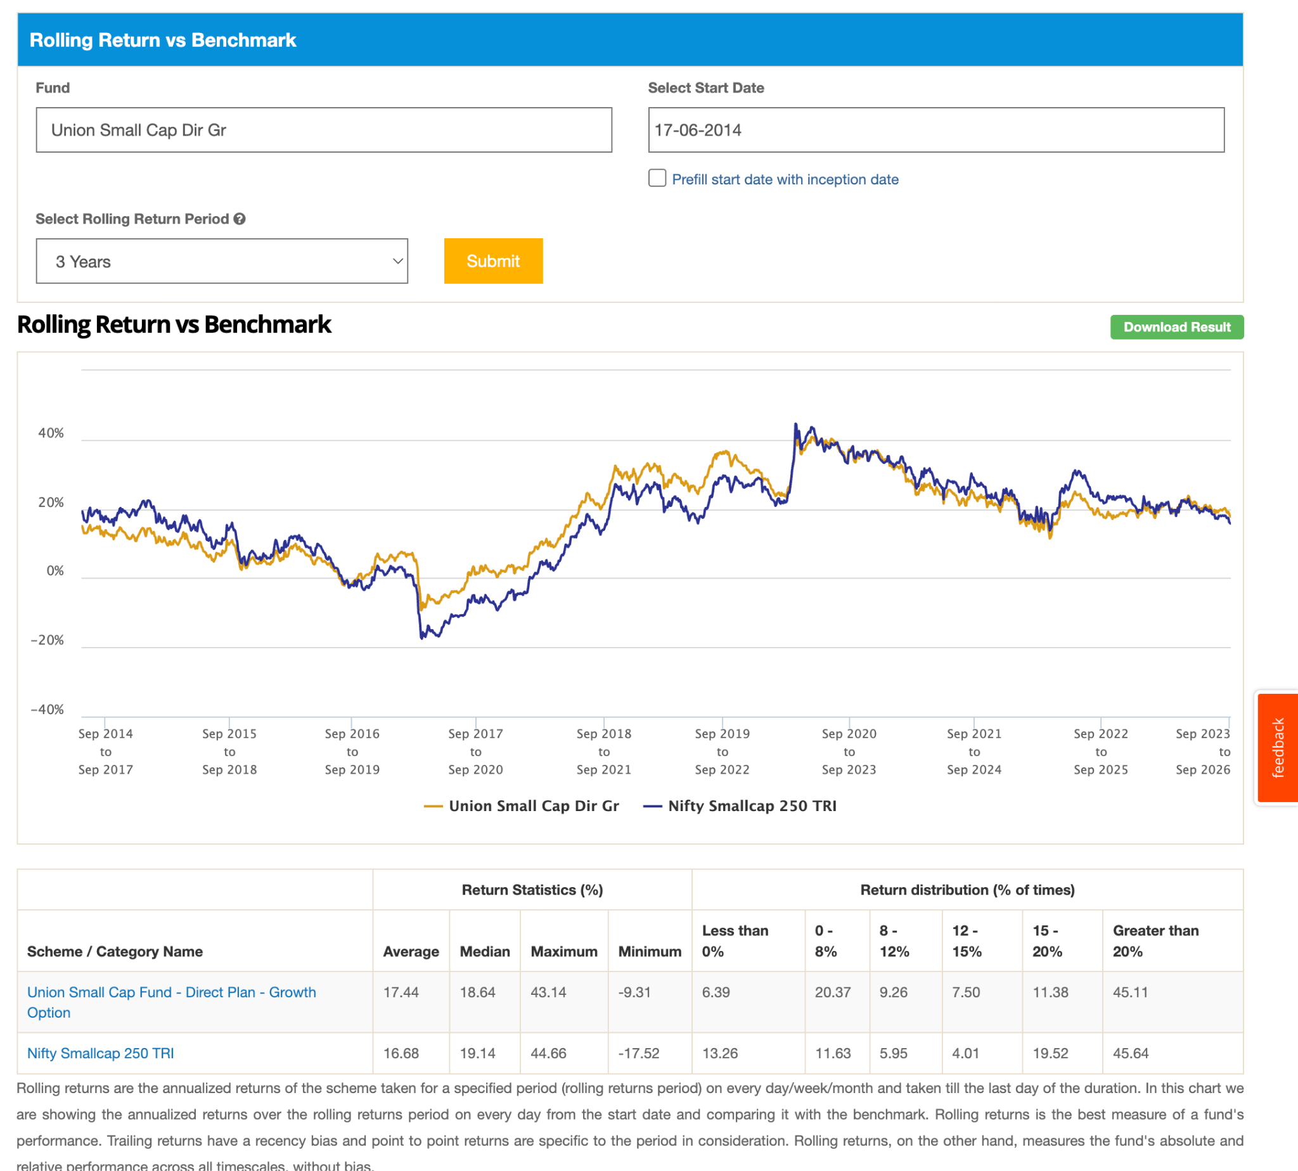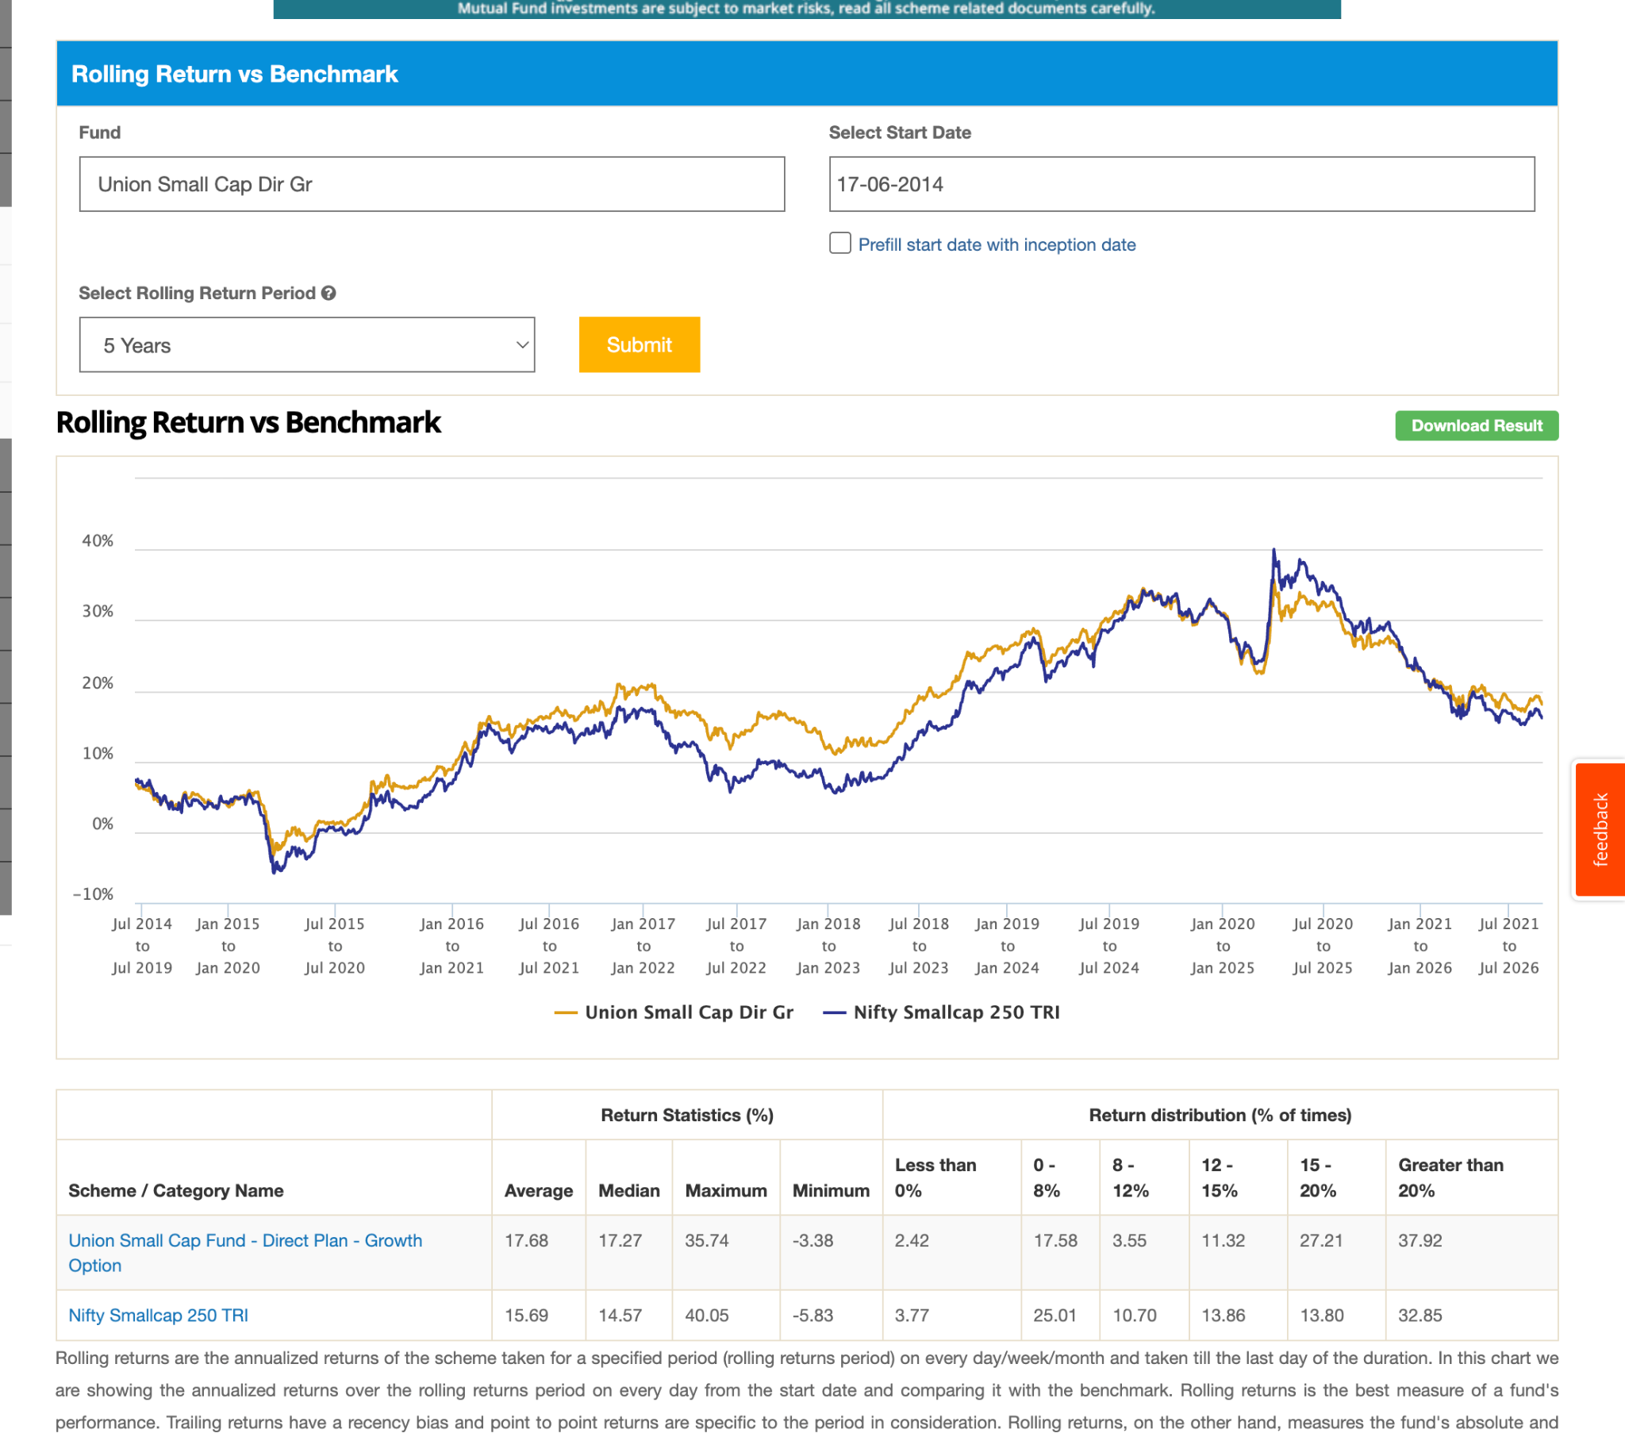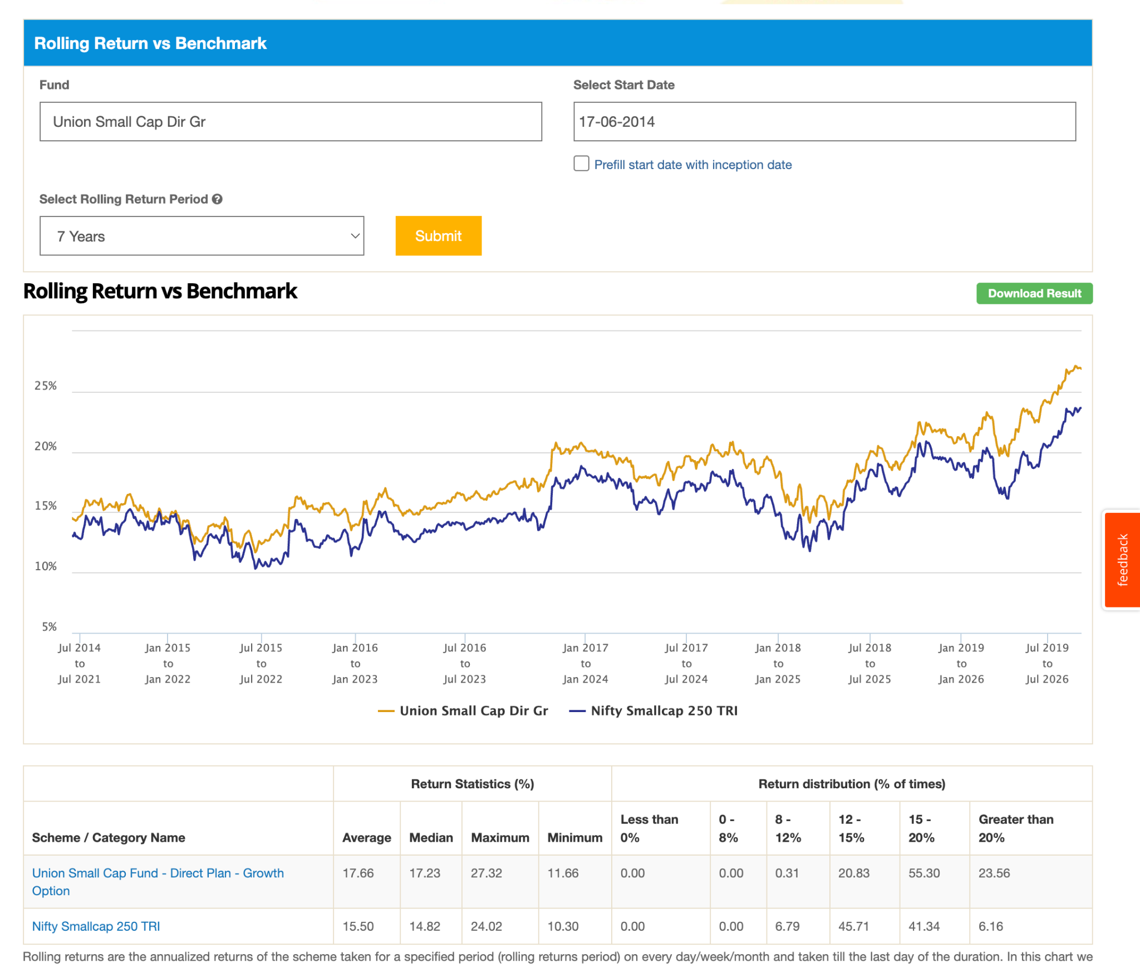

- All fund have good money, means people believing in small cap.
- All have money, it mean people also don't know which will perform and diversification is important in small cpa.
- also indicate people beleive in active since mostly are bealing index excep major are not in last few year .

